Year 4
Term
Autumn 1  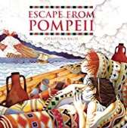 | Driver Text: Escape from Pompeii by Christina Balit
 | Fiction |  | Non Fiction | Poetry
 | Writing Focus  Diary entry- describing the escape from Pompeii.  *Rising Stars Vocabulary Activity- Page 54- Can we talk about how others are feeling?* |  | Writing Focus  Newspaper report- reporting the tragedy of Pompeii.  *Rising Stars Vocabulary Activity- Page 38- How can we talk about speed?* | Writing Focus  Pompeii- Unknown  To write a three-stanza poem about the rumbling, eruption and aftermath.  *Rising Stars Vocabulary Activity- Page 48- Can we find out where words originate from?*
Vocabulary, grammar and punctuation for Year 4 | Word  The grammatical difference between plural and possessive ‘s’  Standard English forms for verb inflections instead of local spoken forms (e.g. we were instead of we was, or I did instead of I done)  Sentence  Noun phrases expanded by the addition of modifying adjectives, nouns and preposition phrases (e.g. the teacher expanded to – the strict maths teacher with curly hair)  Fronted adverbials (e.g. Later that day, I heard bad news)  Text  Use of paragraphs to organise ideas around a theme  Appropriate choice of pronoun or noun with and across sentences to aid cohesion and avoid repetition  Punctuation  Use of inverted commas and other punctuation to indicate direct speech (e.g. a comma after the reporting clause, end punctuation within inverted commas: The conductor shouted, ‘Sit down!’  Apostrophes to mark plural possession (e.g. The girl’s name, the girls’ name)  Use of commas after fronted adverbials
Reading Comprehension Focus | 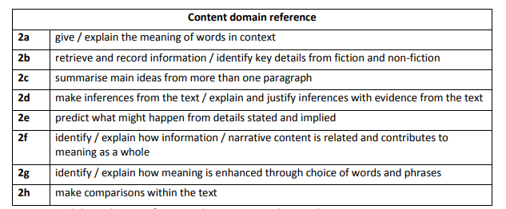
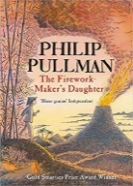  Autumn 2 | Driver Text: The Firework Maker’s Daughter by Philip Pullman
 | Fiction |  | Non Fiction | Poetry
 | Writing Focus  Narrative- short story with a dilemma about a journey.  *Rising Stars Vocabulary Activity- Page 40- Can we examine words and phrases in fiction?* |  | Writing Focus  Explanation – How do Things happen e.g. How do earthquakes happen? How is igneous rock formed?  *Rising Stars Vocabulary Activity- Page 42- Can we use prefixes to change meaning- ‘il, ‘im, and ‘in’?* | Writing Focus  On Bonfire Night- Holly James  To use onomatopoeic words within a repetitive poem.  *Rising Stars Vocabulary Activity- Page 44- Can we analyse how the poet uses vocabulary?*
Vocabulary, grammar and punctuation for Year 4 | Word  The grammatical difference between plural and possessive ‘s’  Standard English forms for verb inflections instead of local spoken forms (e.g. we were instead of we was, or I did instead of I done)  Sentence  Noun phrases expanded by the addition of modifying adjectives, nouns and preposition phrases (e.g. the teacher expanded to – the strict maths teacher with curly hair)  Fronted adverbials (e.g. Later that day, I heard bad news)  Text  Use of paragraphs to organise ideas around a theme  Appropriate choice of pronoun or noun with and across sentences to aid cohesion and avoid repetition  Punctuation  Use of inverted commas and other punctuation to indicate direct speech (e.g. a comma after the reporting clause, end punctuation within inverted commas: The conductor shouted, ‘Sit down!’  Apostrophes to mark plural possession (e.g. The girl’s name, the girls’ name)  Use of commas after fronted adverbials
Reading Comprehension Focus
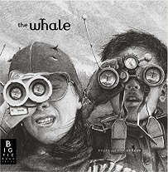  Spring 1 | Driver Text: The Whale by Vita Murrow
 | Fiction |  | Non-Fiction | Poetry
 | Writing Focus  Narrative- creating a setting using descriptive language and imagery. Children to tell the story by using rich language to describe settings and events within the images.  *Rising Stars Vocabulary Activity- Page 56- Can we describe an intelligent predator?* |  | Writing Focus  Information text- Whales, conservation and hunting | Writing Focus  Haiku poetry  The Last Whale- Ron Wilson  *Rising Stars Vocabulary Activity- Page 52- Can we make words and idioms?*
Vocabulary, grammar and punctuation for Year 4 | Word  The grammatical difference between plural and possessive ‘s’  Standard English forms for verb inflections instead of local spoken forms (e.g. we were instead of we was, or I did instead of I done)  Sentence  Noun phrases expanded by the addition of modifying adjectives, nouns and preposition phrases (e.g. the teacher expanded to – the strict maths teacher with curly hair)  Fronted adverbials (e.g. Later that day, I heard bad news)  Text  Use of paragraphs to organise ideas around a theme  Appropriate choice of pronoun or noun with and across sentences to aid cohesion and avoid repetition  Punctuation  Use of inverted commas and other punctuation to indicate direct speech (e.g. a comma after the reporting clause, end punctuation within inverted commas: The conductor shouted, ‘Sit down!’  Apostrophes to mark plural possession (e.g. The girl’s name, the girls’ name)  Use of commas after fronted adverbials
Reading Comprehension Focus
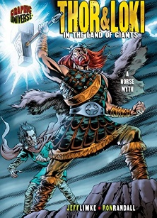  Spring 2 | Driver Text: Thor and Loki in the Land of the Giants: A Norse Myth
 | Fiction |  | Non-Fiction | Poetry
 | Writing Focus  Create a story in the style of a myth using the creatures from Norse myths and legends. |  | Writing Focus  Instructions- How to look after a mythical creature e.g. a troll, a dragon  *Rising Stars Vocabulary Activity- Page 60- Can we explore the origin of words?* | Writing Focus  The Godless- Unknown  Children to tell the tale of Thor and Loki in the style of a free verse poem.
Vocabulary, grammar and punctuation for Year 4 | Word  The grammatical difference between plural and possessive ‘s’  Standard English forms for verb inflections instead of local spoken forms (e.g. we were instead of we was, or I did instead of I done)  Sentence  Noun phrases expanded by the addition of modifying adjectives, nouns and preposition phrases (e.g. the teacher expanded to – the strict maths teacher with curly hair)  Fronted adverbials (e.g. Later that day, I heard bad news)  Text  Use of paragraphs to organise ideas around a theme  Appropriate choice of pronoun or noun with and across sentences to aid cohesion and avoid repetition  Punctuation  Use of inverted commas and other punctuation to indicate direct speech (e.g. a comma after the reporting clause, end punctuation within inverted commas: The conductor shouted, ‘Sit down!’  Apostrophes to mark plural possession (e.g. The girl’s name, the girls’ name)  Use of commas after fronted adverbials
Reading Comprehension Focus
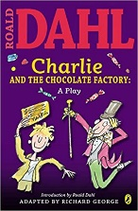  Summer 1 | Driver Text: Charlie and The Chocolate Factory (the play)
 | Fiction |  | Non- Fiction | Poetry
 | Writing Focus  Script writing- write an additional scene to the play script. What happens next… |  | Writing Focus  Letter writing- writing formal letters of complaint | Writing Focus  Veruca Salt Poem  To form a poem about the descent of Veruca Salt going down the shoot.  *Rising Stars Vocabulary Activity- Page 66- Can we explore synonyms poetry?*
Vocabulary, grammar and punctuation for Year 4 | Word  The grammatical difference between plural and possessive ‘s’  Standard English forms for verb inflections instead of local spoken forms (e.g. we were instead of we was, or I did instead of I done)  Sentence  Noun phrases expanded by the addition of modifying adjectives, nouns and preposition phrases (e.g. the teacher expanded to – the strict maths teacher with curly hair)  Fronted adverbials (e.g. Later that day, I heard bad news)  Text  Use of paragraphs to organise ideas around a theme  Appropriate choice of pronoun or noun with and across sentences to aid cohesion and avoid repetition  Punctuation  Use of inverted commas and other punctuation to indicate direct speech (e.g. a comma after the reporting clause, end punctuation within inverted commas: The conductor shouted, ‘Sit down!’  Apostrophes to mark plural possession (e.g. The girl’s name, the girls’ name)  Use of commas after fronted adverbials
Reading Comprehension Focus
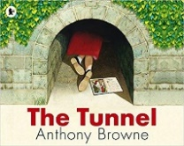  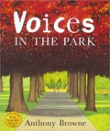  Summer 2 | Driver Text: Voices I the Park by Anthony Browne, The Tunnel by Anthony Browne
 | Fiction |  | Non-Fiction | Poetry
 | Writing Focus  Share the story without the words. Discuss what the chn think is happening and make predictions.  Compare texts linking common themes. Character Study looking at the different characters in each story.  Describe one in detail.  *Rising Stars Vocabulary Activity- Page 50- Can we describe a forest?* |  | Writing Focus  Persuasive writing- creating a leaflet to advertise a local event.  *Rising Stars Vocabulary Activity- Page 46- Can we learn new words from non-fiction writing?* | Writing Focus  Nightmare- Michael Rosen  Children to write a short poem, similar to ‘Nightmare’ about something they are afraid of- using repeated phrases. Eg. I’m…..I’m….I’m…..  There’s…..There’s…..There’s….  *Rising Stars Vocabulary Activity- Page 68- Can we create words and phrases using silence?*
Vocabulary, grammar and punctuation for Year 4 | Word  The grammatical difference between plural and possessive ‘s’  Standard English forms for verb inflections instead of local spoken forms (e.g. we were instead of we was, or I did instead of I done)  Sentence  Noun phrases expanded by the addition of modifying adjectives, nouns and preposition phrases (e.g. the teacher expanded to – the strict maths teacher with curly hair)  Fronted adverbials (e.g. Later that day, I heard bad news)  Text  Use of paragraphs to organise ideas around a theme  Appropriate choice of pronoun or noun with and across sentences to aid cohesion and avoid repetition  Punctuation  Use of inverted commas and other punctuation to indicate direct speech (e.g. a comma after the reporting clause, end punctuation within inverted commas: The conductor shouted, ‘Sit down!’  Apostrophes to mark plural possession (e.g. The girl’s name, the girls’ name)  Use of commas after fronted adverbials
Reading Comprehension Focus
Terminology |  | Determiner  Pronoun, possessive pronoun  adverbial

