Year 3
Term
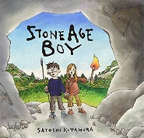  Autumn 1 | Driver Text: Stone Age Boy by Satoshi Kitamura
 | Fiction | Non-Fiction | Poetry
 | Writing Focus  Narrative- A dream story set in the Stone Age.  *Rising Stars Vocabulary Activity- Page 24- Can we describe a landscape? * | Writing Focus  Information writing- A Stone Age Settlement.  *Rising Stars Vocabulary Activity- Page 12- Can we explore words and synonyms in non-fiction? * | Writing Focus  Stone Age Poem- Unknown  Using the same rhythm and rhyme, children to write an abridged version about the Stone Age making subtle changes to the language used.  *Rising Stars Vocabulary Activity- Page 30- Can we talk about civilisation? *
Vocabulary, grammar and punctuation for Year 3 | Word  Formation of nouns using a range of prefixes (e.g. ‘super’, ‘anit’, ‘auto’  Use of the forms ‘a’ or ‘an’ according to whether the next word begins with a consonant or a vowel (e.g. a rock, an open box)  Word families based on common words, showing how words are related in form and meaning (e.g. solve, solution, solver, dissolve, insoluble)  Sentence  Expressing time, place and cause using conjunctions (e.g. when, before, after, while, so, because), adverbs (e.g. then, next, soon, therefore)  Prepositions (e.g. before, after, during, in, because of)  Text  Introduction to paragraphs as a way to group related material  Headings and sub-headings to aid presentation  Use of the present perfect form of verbs instead of the simple past (e.g. He has gone out to play contrasted with- he went out to play)  Punctuation  Introduction to inverted commas to punctuate direct speech
Reading Comprehension Focus | 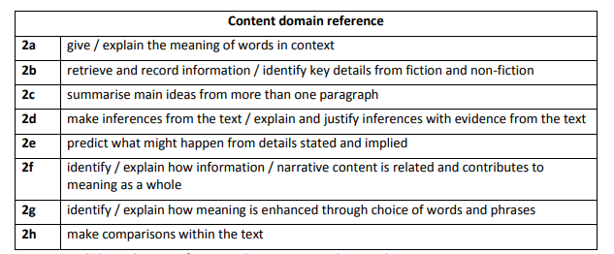
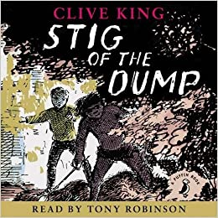  Autumn 2 | Driver Text: Stig of the Dump, by Clive King
 | Fiction | Non-Fiction | Poetry
 | Writing Focus  Narrative creating own imaginary characters based on Stig.  *Rising Stars Vocabulary Activity- Page 10- Can we use words to describe characteristics? * | Writing Focus  Newspaper report on the importance of recycling.  *Rising Stars Vocabulary Activity- Page 20- Can we talk about making things?* | Writing Focus  Plastic Bag Tree- Michael Rosen  Propose changes to poem making links to recycling.  *Rising Stars Vocabulary Activity- Page 22- Can we use prefixes to change meaning?*
Vocabulary, grammar and punctuation for Year 3 | Word  Formation of nouns using a range of prefixes (e.g. ‘super’, ‘anit’, ‘auto’  Use of the forms ‘a’ or ‘an’ according to whether the next word begins with a consonant or a vowel (e.g. a rock, an open box)  Word families based on common words, showing how words are related in form and meaning (e.g. solve, solution, solver, dissolve, insoluble)  Sentence  Expressing time, place and cause using conjunctions (e.g. when, before, after, while, so, because), adverbs (e.g. then, next, soon, therefore)  Prepositions (e.g. before, after, during, in, because of)  Text  Introduction to paragraphs as a way to group related material  Headings and sub-headings to aid presentation  Use of the present perfect form of verbs instead of the simple past (e.g. He has gone out to play contrasted with- he went out to play)  Punctuation  Introduction to inverted commas to punctuate direct speech
Reading Comprehension Focus
Spring 1  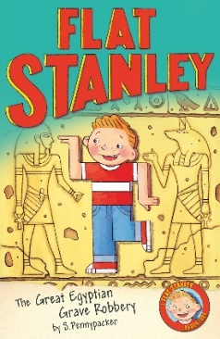 | Driver Text: Flat Stanley: The Great Egyptian Grave Robbery
 | Fiction | Non-Fiction | Poetry
 | Writing Focus  Descriptive writing creating a setting using the senses.  *Rising Stars Vocabulary Activity- Page 26- How do we ‘ly’ words work?- Using adjectives and adverbs to describe characters* | Writing Focus  Non-chronological report -making comparisons between Egypt- ancient and modern day. | Writing Focus  The Ancient Egyptians- Unknown  Collect suitable words and phrases in order to write a poem to write a poem in the shape of a pyramid where the words all link to the topic. Can be single words or sentences.  The words on the page form the pyramid. Do not use an outline.
Vocabulary, grammar and punctuation for Year 3 | Word  Formation of nouns using a range of prefixes (e.g. ‘super’, ‘anit’, ‘auto’  Use of the forms ‘a’ or ‘an’ according to whether the next word begins with a consonant or a vowel (e.g. a rock, an open box)  Word families based on common words, showing how words are related in form and meaning (e.g. solve, solution, solver, dissolve, insoluble)  Sentence  Expressing time, place and cause using conjunctions (e.g. when, before, after, while, so, because), adverbs (e.g. then, next, soon, therefore)  Prepositions (e.g. before, after, during, in, because of)  Text  Introduction to paragraphs as a way to group related material  Headings and sub-headings to aid presentation  Use of the present perfect form of verbs instead of the simple past (e.g. He has gone out to play contrasted with- he went out to play)  Punctuation  Introduction to inverted commas to punctuate direct speech
Reading Comprehension Focus
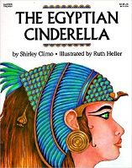  Spring 2 | Driver Text: The Egyptian Cinderella by Shirley Climo
 | Fiction | Non-Fiction | Poetry
 | Writing Focus  Retelling a traditional story using Egypt as the setting.  *Rising Stars Vocabulary Activity- Page 34- Can we explore adverbs in fiction?* | Writing Focus  Fact File on African animals using headings and sub headings. | Writing Focus  Sphinx- Acrostic Poem- Unknown  To write an acrostic poem linked to Ancient Egypt.
Vocabulary, grammar and punctuation for Year 3 | Word  Formation of nouns using a range of prefixes (e.g. ‘super’, ‘anit’, ‘auto’  Use of the forms ‘a’ or ‘an’ according to whether the next word begins with a consonant or a vowel (e.g. a rock, an open box)  Word families based on common words, showing how words are related in form and meaning (e.g. solve, solution, solver, dissolve, insoluble)  Sentence  Expressing time, place and cause using conjunctions (e.g. when, before, after, while, so, because), adverbs (e.g. then, next, soon, therefore)  Prepositions (e.g. before, after, during, in, because of)  Text  Introduction to paragraphs as a way to group related material  Headings and sub-headings to aid presentation  Use of the present perfect form of verbs instead of the simple past (e.g. He has gone out to play contrasted with- he went out to play)  Punctuation  Introduction to inverted commas to punctuate direct speech
Reading Comprehension Focus
Summer 1  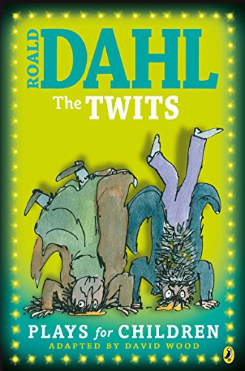 | Driver Text: The Twits Playscript – Roald Dhal
 | Fiction | Non- Fiction | Poetry
 | Writing Focus  Write a play using a familiar story as a starting point. | Writing Focus  Recount a visit to a local place of interest. | Writing Focus  The Railway Carriage- Robert Louis Stevenson  Link to Geography topic and local History topic. Children to write a poem in the style of ‘From a Railway Carriage’ describing what they would see from a railway carriage on the Wirral.
Vocabulary, grammar and punctuation for Year 3 | Word  Formation of nouns using a range of prefixes (e.g. ‘super’, ‘anit’, ‘auto’  Use of the forms ‘a’ or ‘an’ according to whether the next word begins with a consonant or a vowel (e.g. a rock, an open box)  Word families based on common words, showing how words are related in form and meaning (e.g. solve, solution, solver, dissolve, insoluble)  Sentence  Expressing time, place and cause using conjunctions (e.g. when, before, after, while, so, because), adverbs (e.g. then, next, soon, therefore)  Prepositions (e.g. before, after, during, in, because of)  Text  Introduction to paragraphs as a way to group related material  Headings and sub-headings to aid presentation  Use of the present perfect form of verbs instead of the simple past (e.g. He has gone out to play contrasted with- he went out to play)  Punctuation  Introduction to inverted commas to punctuate direct speech
Reading Comprehension Focus
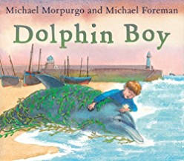  Summer 2 | Driver Text: Dolphin Boy by Michael Morpurgo and Michael Foreman
 | Fiction | Non-Fiction | Poetry
 | Writing Focus  Adventure Stories. Write an alternative ending/ next chapter to this adventure story.  *Rising Stars Vocabulary Activity- Page 16- Can we describe how animals move?* | Writing Focus  Letter writing.  Write a persuasive letter about dolphin conservation. | Writing Focus  The River by Valarie Bloom.  Write own river poems- pick four qualities/characters of a river. Use metaphors.  *Rising Stars Vocabulary Activity- Page 36- Can we explore vocabulary in adventure stories?*
Vocabulary, grammar and punctuation for Year 3 | Word  Formation of nouns using a range of prefixes (e.g. ‘super’, ‘anit’, ‘auto’  Use of the forms ‘a’ or ‘an’ according to whether the next word begins with a consonant or a vowel (e.g. a rock, an open box)  Word families based on common words, showing how words are related in form and meaning (e.g. solve, solution, solver, dissolve, insoluble)  Sentence  Expressing time, place and cause using conjunctions (e.g. when, before, after, while, so, because), adverbs (e.g. then, next, soon, therefore)  Prepositions (e.g. before, after, during, in, because of)  Text  Introduction to paragraphs as a way to group related material  Headings and sub-headings to aid presentation  Use of the present perfect form of verbs instead of the simple past (e.g. He has gone out to play contrasted with- he went out to play)  Punctuation  Introduction to inverted commas to punctuate direct speech
Reading Comprehension Focus
Terminology |  | Adverb, preposition, conjunction  Word family, prefix  Clause, subordinating clause  Direct, speech  Consonant, consonant letter vowel, vowel letter  Inverted commas (or speech marks)

