Year 2
Term
Autumn 1  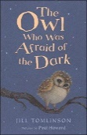 | Driver Text: The Owl Who was Afraid of the Dark by Jill Tomlinson
 | Fiction | Non Fiction | Poetry
 | Writing Focus  Narrative – creating a setting using descriptive language.  *Rising Stars Vocabulary Activity- Page 68- Can you describe the landscape? * | Writing Focus  Information- create a fact file about owls.  *Rising Stars Vocabulary Activity- Page 66- Which habitat? Words associated with animals and habitats* | Writing Focus  After Dark by Michael Rosen  To compose a poem about after dark using the same repetitive phrase as Michael Rosen.  *Rising Stars Vocabulary Activity- Page 42- What sound does it make?*
Vocabulary, grammar and punctuation for Year 2 | Word  Formation of nouns using suffixes such as ‘ness’, ‘er’ and by compounding (for example. Whiteboard, superman)  Formation of adjectives using suffixes such as ‘ful’, ‘less’ (more suffixes found on the spelling LTP)  Use of suffixes ‘er’ and ‘est’ in adjectives and use of ‘ly’ in standard English to turn adjectives into adverbs.  Sentence  Subordination (using when, if, that, because) and co-ordination (using or, and, but)  Expanded noun phrases for description and specification (for example, the blue butterfly, plain flour, the man in the moon)  How grammatical patterns in a sentence indicate its function as a statement, question, exclamation or command  Text  Correct choice and consistent use of present tense and past tense throughout writing.  Use of progressive form of verbs in the present and past tense to mark actions in progress (e.g. she is drumming, he was shouting)  Punctuation  Use of capital letters, full stops, question marks and exclamation marks to demarcate sentences  Commas to separate items in a list  Apostrophes to mark where letters are missing in spelling and to mark singular possession in nouns (e.g. the girl’s name)
Reading Comprehension Focus | 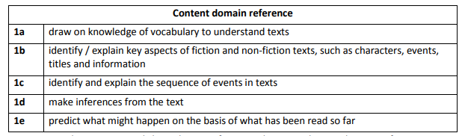
Autumn 2  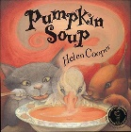 | Driver Text: Pumpkin Soup by Helen Cooper
 | Fiction | Non Fiction | Poetry
 | Writing Focus  Retelling the story from the duck’s point of view. Concentrating on the character’s feelings and behaviour.  *Rising Stars Vocabulary Activity- Page 58- How do you eat your food?* | Writing Focus  Instructions – recipes write own recipes for making soup.  *Rising Stars Vocabulary Activity- Page 70- How do we grow tomato plants?* | Writing Focus  Cats by Eleanor Farjeon  Write a simple rhyming poem about cats.  *Rising Stars Vocabulary Activity- Page 62-How ca we use descriptive words in rhymes?*
Vocabulary, grammar and punctuation for Year 2 | Word  Formation of nouns using suffixes such as ‘ness’, ‘er’ and by compounding (for example. Whiteboard, superman)  Formation of adjectives using suffixes such as ‘ful’, ‘less’ (more suffixes found on the spelling LTP)  Use of suffixes ‘er’ and ‘est’ in adjectives and use of ‘ly’ in standard English to turn adjectives into adverbs.  Sentence  Subordination (using when, if, that, because) and co-ordination (using or, and, but)  Expanded noun phrases for description and specification (for example, the blue butterfly, plain flour, the man in the moon)  How grammatical patterns in a sentence indicate its function as a statement, question, exclamation or command  Text  Correct choice and consistent use of present tense and past tense throughout writing.  Use of progressive form of verbs in the present and past tense to mark actions in progress (e.g. she is drumming, he was shouting)  Punctuation  Use of capital letters, full stops, question marks and exclamation marks to demarcate sentences  Commas to separate items in a list  Apostrophes to mark where letters are missing in spelling and to mark singular possession in nouns (e.g. the girl’s name)
Reading Comprehension Focus
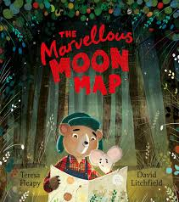  Spring 1 | Driver Text: The Marvellous Moon Map by Teresa Heapy
 | Fiction | Non-Fiction | Poetry
 | Writing Focus  Adventure story – create a new adventure in an alternative setting for Mouse and Bear. | Writing Focus  Travel leaflets- writing information leaflets to advertise different world destinations. | Writing Focus  The Moon- Robert Louis Stevenson  To write a short free verse poem about what the moon sees.
Vocabulary, grammar and punctuation for Year 2 | Word  Formation of nouns using suffixes such as ‘ness’, ‘er’ and by compounding (for example. Whiteboard, superman)  Formation of adjectives using suffixes such as ‘ful’, ‘less’ (more suffixes found on the spelling LTP)  Use of suffixes ‘er’ and ‘est’ in adjectives and use of ‘ly’ in standard English to turn adjectives into adverbs.  Sentence  Subordination (using when, if, that, because) and co-ordination (using or, and, but)  Expanded noun phrases for description and specification (for example, the blue butterfly, plain flour, the man in the moon)  How grammatical patterns in a sentence indicate its function as a statement, question, exclamation or command  Text  Correct choice and consistent use of present tense and past tense throughout writing.  Use of progressive form of verbs in the present and past tense to mark actions in progress (e.g. she is drumming, he was shouting)  Punctuation  Use of capital letters, full stops, question marks and exclamation marks to demarcate sentences  Commas to separate items in a list  Apostrophes to mark where letters are missing in spelling and to mark singular possession in nouns (e.g. the girl’s name)
Reading Comprehension Focus
Spring 2  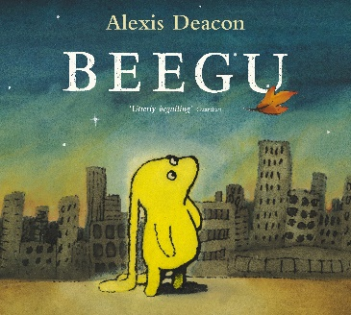 | Driver Text: Beegu by Alexis Deacon
 | Fiction | Non-Fiction | Poetry
 | Descriptive writing.  Describe character and setting.  *Rising Stars Vocabulary Activity- Page 32- Can we launch a rocket?* | Report- write report about major events in space exploration. | The Rubbish Tip Alien- Pie Corbett  To write a three stanza poem about what their rubbish tip alien is made from.
Vocabulary, grammar and punctuation for Year 2 | Word  Formation of nouns using suffixes such as ‘ness’, ‘er’ and by compounding (for example. Whiteboard, superman)  Formation of adjectives using suffixes such as ‘ful’, ‘less’ (more suffixes found on the spelling LTP)  Use of suffixes ‘er’ and ‘est’ in adjectives and use of ‘ly’ in standard English to turn adjectives into adverbs.  Sentence  Subordination (using when, if, that, because) and co-ordination (using or, and, but)  Expanded noun phrases for description and specification (for example, the blue butterfly, plain flour, the man in the moon)  How grammatical patterns in a sentence indicate its function as a statement, question, exclamation or command  Text  Correct choice and consistent use of present tense and past tense throughout writing.  Use of progressive form of verbs in the present and past tense to mark actions in progress (e.g. she is drumming, he was shouting)  Punctuation  Use of capital letters, full stops, question marks and exclamation marks to demarcate sentences  Commas to separate items in a list  Apostrophes to mark where letters are missing in spelling and to mark singular possession in nouns (e.g. the girl’s name)
Reading Comprehension Focus
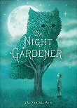  Summer 1 | Driver Text: The Night Gardener by The Fan Brothers
 | Fiction | Non- Fiction | Poetry
 | Writing Focus  Diary- write a series of diary entries describing William’s experiences.  *Rising Stars Vocabulary Activity- Page 60- Explore adjectives to describe setting- using a fairy tale as an example* | Writing Focus  Explanation- Why do trees lose their leaves? | Writing Focus  Trees- Harry Behn  To write a short poem describing the changes to trees in each season.  *Rising Stars Vocabulary Activity- Page 72-What is he doing in the garden?*
Vocabulary, grammar and punctuation for Year 2 | Word  Formation of nouns using suffixes such as ‘ness’, ‘er’ and by compounding (for example. Whiteboard, superman)  Formation of adjectives using suffixes such as ‘ful’, ‘less’ (more suffixes found on the spelling LTP)  Use of suffixes ‘er’ and ‘est’ in adjectives and use of ‘ly’ in standard English to turn adjectives into adverbs.  Sentence  Subordination (using when, if, that, because) and co-ordination (using or, and, but)  Expanded noun phrases for description and specification (for example, the blue butterfly, plain flour, the man in the moon)  How grammatical patterns in a sentence indicate its function as a statement, question, exclamation or command  Text  Correct choice and consistent use of present tense and past tense throughout writing.  Use of progressive form of verbs in the present and past tense to mark actions in progress (e.g. she is drumming, he was shouting)  Punctuation  Use of capital letters, full stops, question marks and exclamation marks to demarcate sentences  Commas to separate items in a list  Apostrophes to mark where letters are missing in spelling and to mark singular possession in nouns (e.g. the girl’s name)
Reading Comprehension Focus
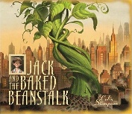  Summer 2 | Driver Text: Jack and the Baked Beanstalk by Colin Stimpson
 | Fiction | Non-Fiction | Poetry
 | Writing Focus  Narrative plot and setting- compare this story with the traditional tale. Create a new setting and a new twist to the tale.  *Rising Stars Vocabulary Activity- Page 38- How do we use –er and -est?* | Writing Focus  Persuasive letter – write a letter to the council to persuade them not to demolish Birkenhead Priory. | Writing Focus  Ten Things Found in a Wizard’s Pocket- Ian McMillan  To write a short poem about ten things found in a wizard’s pocket- link to driver text.
Vocabulary, grammar and punctuation for Year 2 | Word  Formation of nouns using suffixes such as ‘ness’, ‘er’ and by compounding (for example. Whiteboard, superman)  Formation of adjectives using suffixes such as ‘ful’, ‘less’ (more suffixes found on the spelling LTP)  Use of suffixes ‘er’ and ‘est’ in adjectives and use of ‘ly’ in standard English to turn adjectives into adverbs.  Sentence  Subordination (using when, if, that, because) and co-ordination (using or, and, but)  Expanded noun phrases for description and specification (for example, the blue butterfly, plain flour, the man in the moon)  How grammatical patterns in a sentence indicate its function as a statement, question, exclamation or command  Text  Correct choice and consistent use of present tense and past tense throughout writing.  Use of progressive form of verbs in the present and past tense to mark actions in progress (e.g. she is drumming, he was shouting)  Punctuation  Use of capital letters, full stops, question marks and exclamation marks to demarcate sentences  Commas to separate items in a list  Apostrophes to mark where letters are missing in spelling and to mark singular possession in nouns (e.g. the girl’s name)
Reading Comprehension Focus
Terminology | Noun, noun phrase  Statement, question, exclamation, command  Compound, adjective, verb  Suffix  Adverb  Tense (past, present)  Apostrophe, comma

