Year 1
Term
Autumn 1  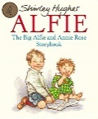 | Driver Texts: Alfie and Annie Rose Stories by Shirley Hughes
 | Fiction |  | Non Fiction | Poetry
 | Writing Outcome:  Sequencing events from the text.  Retelling important events from own experiences.  Rising Stars Vocabulary Activity- Page 34- How energetic do we feel? Discovering new words to describe different states of energy |  | Writing Outcome:  Fact file – writing facts ‘all about me’. | Writing Outcome  ‘Cold’ – Out and About by Shirley Hughes  To write a short Autumnal poem.
Vocabulary, grammar and punctuation focus: | Word:  Regular plural noun suffixes- ‘s’ or ‘es’ (for example, dog, dogs, wish, wishes, including the effects of these suffixes on the meaning of the noun.  Suffixes that can be added to verbs where no change is needed in the spelling of root words (helping, helped, helper)  How the prefix ‘un’ changes the meaning of verbs and adjectives (negation for example, unkind, undoing- untie)  Sentence:  How words can combine to make sentences  Joining words and clauses using the word ‘and’  Punctuation:  Separation of words with spaces  Introduction to capital letters, full stops, question marks and exclamation marks to demarcate sentences.  Capital letters for names and for the personal pronoun ‘I’
Reading Comprehension Focus: | 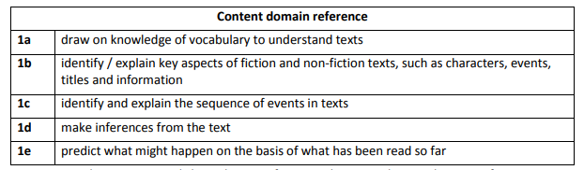
Autumn 2  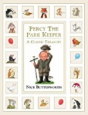 | Driver Text: Percy the Park Keeper stories by Nick Butterworth
 | Fiction |  | Non Fiction | Poetry
 | Writing Outcome:  Character description – Percy the Park Keeper |  | Writing Outcome:  Information writing – To write factual sentences about the dangers to hedgehogs and how we can keep them safe.  Rising Stars Vocabulary Activity- Page 50- What shall we choose in the playground? | Writing Outcome:  Oh No! There’s a Queue! – Clare Bevan  Change the animals in the poem and add different sounds or movements that they make.  Rising Stars Vocabulary Activity- Page 56- How does the poet make us laugh? Using the Dentist and the Crocodile*
Vocabulary, grammar and punctuation focus: | Word:  Regular plural noun suffixes- ‘s’ or ‘es’ (for example, dog, dogs, wish, wishes, including the effects of these suffixes on the meaning of the noun.  Suffixes that can be added to verbs where no change is needed in the spelling of root words (helping, helped, helper)  How the prefix ‘un’ changes the meaning of verbs and adjectives (negation for example, unkind, undoing- untie)  Sentence:  How words can combine to make sentences  Joining words and clauses using the word ‘and’  Punctuation:  Separation of words with spaces  Introduction to capital letters, full stops, question marks and exclamation marks to demarcate sentences.  Capital letters for names and for the personal pronoun ‘I’
Reading Comprehension Focus:
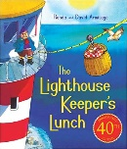  Spring 1 | Driver Text: The Lighthouse Keeper’s Lunch by Ronda and David Armitage
 | Fiction |  | Non-Fiction | Poetry
 | Writing Outcome:  Narrative/ plot  Create a story map and retell the story in own words. |  | Writing Outcome:  Instructions – How to make a lighthouse sandwich  Rising Stars Vocabulary Activity- Page 36- What is the material like? | Writing Outcome:  Pirate Pete- James Carter  To write a stanza starting and ending with the same line as Pirate Pete poem making changes to the rhyming words
Vocabulary, grammar and punctuation focus: | Word:  Regular plural noun suffixes- ‘s’ or ‘es’ (for example, dog, dogs, wish, wishes, including the effects of these suffixes on the meaning of the noun.  Suffixes that can be added to verbs where no change is needed in the spelling of root words (helping, helped, helper)  How the prefix ‘un’ changes the meaning of verbs and adjectives (negation for example, unkind, undoing- untie)  Sentence:  How words can combine to make sentences  Joining words and clauses using the word ‘and’  Punctuation:  Separation of words with spaces  Introduction to capital letters, full stops, question marks and exclamation marks to demarcate sentences.  Capital letters for names and for the personal pronoun ‘I’
Reading Comprehension focus:
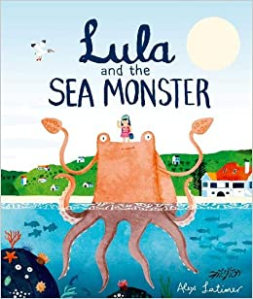  Spring 2 | Driver Text: Lula and the Sea Monster
 | Fiction |  | Non-Fiction | Poetry
 | Writing Outcome:  Descriptive writing/ creating pictures with words - describe the underwater setting. Describe the sea monster.  Rising Stars Vocabulary Activity- Page 40- How do you describe a mythical creature? |  | Writing Outcome:  Labelling/explanation – adding labels and writing simple explanations.  ‘The Big Book of the Blue’ (non-fiction) can be used to supplement this.  Rising Stars Vocabulary Activity- Page 76- What is the myth of Demeter and Persephone? | Writing Outcome:  Voices of Water- Tony Mitton  Children to continue a poem in the style of Voice of Water.  The water in the tap goes….  The water down the drain goes..
Vocabulary, grammar and punctuation focus: | Word:  Regular plural noun suffixes- ‘s’ or ‘es’ (for example, dog, dogs, wish, wishes, including the effects of these suffixes on the meaning of the noun.  Suffixes that can be added to verbs where no change is needed in the spelling of root words (helping, helped, helper)  How the prefix ‘un’ changes the meaning of verbs and adjectives (negation for example, unkind, undoing- untie)  Sentence:  How words can combine to make sentences  Joining words and clauses using the word ‘and’  Punctuation:  Separation of words with spaces  Introduction to capital letters, full stops, question marks and exclamation marks to demarcate sentences.  Capital letters for names and for the personal pronoun ‘I’
Reading Comprehension Focus:
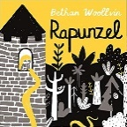  Summer 1 | Driver Text: Rapunzel by Bethan Woollvin
 | Fiction |  | Non- Fiction | Poetry
 | Writing Outcome:  Narrative- create an alternative ending for a familiar traditional tale.  *Rising Stars Vocabulary Activity- Page 24- How do we know if it is a traditional tale?* |  | Writing Outcome:  Create a factfile about a local castle- link to the story of Rapunzel being locked away in a tall tower.  *Rising Stars Vocabulary Activity- Page 44- Who ae the villains and heroes?* | Writing Outcome:  Witch, Witch- Rose Fyleman  Continue poem- keeping repeated phrase ‘Witch, Witch- but changing the following line using new rhyming words.
Vocabulary, grammar and punctuation focus: | Word:  Regular plural noun suffixes- ‘s’ or ‘es’ (for example, dog, dogs, wish, wishes, including the effects of these suffixes on the meaning of the noun.  Suffixes that can be added to verbs where no change is needed in the spelling of root words (helping, helped, helper)  How the prefix ‘un’ changes the meaning of verbs and adjectives (negation for example, unkind, undoing- untie)  Sentence:  How words can combine to make sentences  Joining words and clauses using the word ‘and’  Punctuation:  Separation of words with spaces  Introduction to capital letters, full stops, question marks and exclamation marks to demarcate sentences.  Capital letters for names and for the personal pronoun ‘I’
Reading Comprehension Focus:
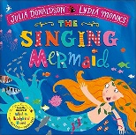  Summer 2 | Driver Text: The Singing Mermaid by Julia Donaldson and Lydia Monks
 | Fiction |  | Non-Fiction | Poetry
 | Writing Outcome:  Adventure story- write own adventure story describing an escape.  *Rising Stars Vocabulary Activity- Page 46- Can we compare a fish and a duck?* |  | Writing Outcome:  Recount- write a letter or postcard as a recount of a day trip to the seaside.  *Rising Stars Vocabulary Activity- Page 54- How many ways can you walk?* | Writing Outcome:  Mr Brown, the Circus Clown- Kenn Nesbitt  Children to form one stanza- 6 lines- keep the first two lines the same, children to change the next four using the AABB rhyming rule.  *Rising Stars Vocabulary Activity- Page 30- How do we use our voices?*
Vocabulary, grammar and punctuation focus: | Word:  Regular plural noun suffixes- ‘s’ or ‘es’ (for example, dog, dogs, wish, wishes, including the effects of these suffixes on the meaning of the noun.  Suffixes that can be added to verbs where no change is needed in the spelling of root words (helping, helped, helper)  How the prefix ‘un’ changes the meaning of verbs and adjectives (negation for example, unkind, undoing- untie)  Sentence:  How words can combine to make sentences  Joining words and clauses using the word ‘and’  Punctuation:  Separation of words with spaces  Introduction to capital letters, full stops, question marks and exclamation marks to demarcate sentences.  Capital letters for names and for the personal pronoun ‘I’
Reading Comprehension Focus:
Terminology |  | Letter, capital letter  Word, singular, plural  Sentence  Punctuation, full stop, question mark, exclamation mark

