Year 5
Term
Autumn 1  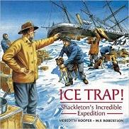 | Driver Text: Ice Trap! Shackleton’s Incredible expedition by Meridith Hooper
 | Fiction | Non Fiction | Poetry
 | Writing Focus  Diary entry- write a diary entry as one of the crew from the Endurance.  *Rising Stars Vocabulary Activity- Page 6- Can we explore words associated with speed? * | Writing Focus  Information text – Shackleton’s expedition.  Biographies  *Rising Stars Vocabulary Activity- Page 8- Can we use prefixes to change meaning? * | Writing Focus  The Ant Explorer- C.J. Dennis  Form a short poem in the style of the Ant Explorer describing his journey to Antarctica.  *Rising Stars Vocabulary Activity- Page 10- Can we talk about hope? *
Vocabulary, grammar and punctuation for Year 5 | Word  Converting nouns or adjectives into verbs using suffixes (e.g. ‘ate’, ‘ise’, ‘ify’)  Verb prefixes (e.g. ‘did’, ‘de’, ‘mis’, ‘over’, and ‘re’)  Sentence  Relative clauses beginning with who, which, where, when, whose, that or an omitted relative pronoun  Indicating degrees of possibility using adverbs (e.g. perhaps, surely) or modal verbs (e.g. might, should, will, must)  Text  Devices to build cohesion within a paragraph (e.g. then, after, that, this, firstly)  Linking ideas across paragraphs using adverbials of time (e.g. later), place (e.g. nearby) and number (e.g. secondly) or tense choices (e.g. he had seen her before)  Punctuation  Brackets, dashes or commas to indicate parenthesis  Use of commas to clarify meaning or avoid ambiguity
Reading Comprehension Focus | 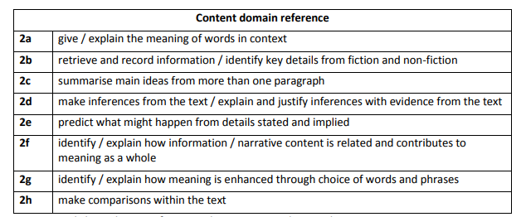
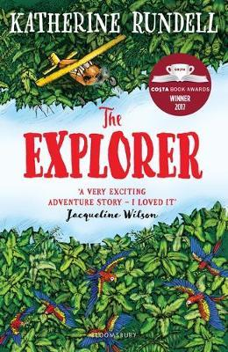  Autumn 2 | Driver Text: The Explorer Katherine Rundell
 | Fiction | Non Fiction | Poetry
 | Writing Focus  Survival Narrative- write an adventure story of wild camping.  *Rising Stars Vocabulary Activity- Page 20- How can words bring a place to life? * | Writing Focus  Instructions- How to… based on instructions from the text e.g. How to build a shelter, how to build a fire. | Writing Focus  The Explorer- Unknown  Write similes and metaphors linked to movement.  Generate ideas for a stanza poem focusing on movement of each.  1st -The explorer….  2nd- The river  3rd- Animals  Include similes and metaphors  *Rising Stars Vocabulary Activity- Page 12- How can we use friend to create new phrases? *
Vocabulary, grammar and punctuation for Year 5 | Word  Converting nouns or adjectives into verbs using suffixes (e.g. ‘ate’, ‘ise’, ‘ify’)  Verb prefixes (e.g. ‘did’, ‘de’, ‘mis’, ‘over’, and ‘re’)  Sentence  Relative clauses beginning with who, which, where, when, whose, that or an omitted relative pronoun  Indicating degrees of possibility using adverbs (e.g. perhaps, surely) or modal verbs (e.g. might, should, will, must)  Text  Devices to build cohesion within a paragraph (e.g. then, after, that, this, firstly)  Linking ideas across paragraphs using adverbials of time (e.g. later), place (e.g. nearby) and number (e.g. secondly) or tense choices (e.g. he had seen her before)  Punctuation  Brackets, dashes or commas to indicate parenthesis  Use of commas to clarify meaning or avoid ambiguity
Reading Comprehension Focus
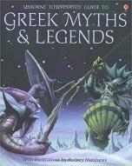  Spring 1 | Driver Text: Greek Myths and Legends (e.g. Theseus and the Minotaur, Perseus and the Gorgons Head)
 | Fiction | Non-Fiction | Poetry
 | Writing Focus  Write an alternative ending to a myth. Use the traditional structure of a myth.  *Rising Stars Vocabulary Activity- Page 28- Can we talk about courage? * | Writing Focus  To write a Newspaper Report.  *Rising Stars Vocabulary Activity- Page 38- Can we describe ancient ruins? * | Writing Focus  Mercury Rising- King of Limericks  Children to choose a Greek God or Goddess. Generate ideas and vocabulary associated with their chosen God.  Children to form a Limerick about their chosen Greek God or Goddess.  *Rising Stars Vocabulary Activity- Page 26- Can we use prefixes to change meaning? *
Vocabulary, grammar and punctuation for Year 5 | Word  Converting nouns or adjectives into verbs using suffixes (e.g. ‘ate’, ‘ise’, ‘ify’)  Verb prefixes (e.g. ‘did’, ‘de’, ‘mis’, ‘over’, and ‘re’)  Sentence  Relative clauses beginning with who, which, where, when, whose, that or an omitted relative pronoun  Indicating degrees of possibility using adverbs (e.g. perhaps, surely) or modal verbs (e.g. might, should, will, must)  Text  Devices to build cohesion within a paragraph (e.g. then, after, that, this, firstly)  Linking ideas across paragraphs using adverbials of time (e.g. later), place (e.g. nearby) and number (e.g. secondly) or tense choices (e.g. he had seen her before)  Punctuation  Brackets, dashes or commas to indicate parenthesis  Use of commas to clarify meaning or avoid ambiguity
Reading Comprehension Focus

Spring 2 | Driver Text: The Adventures of Odysseus by Hugh Lupton
Spring 2 | Fiction | Non-Fiction | Poetry
Spring 2 | Writing Focus  Write a scene for a play script based on one of the adventures.  *Rising Stars Vocabulary Activity- Page 32- Can we explore vocabulary in fiction? * | Writing Focus  Information -create a leaflet on the benefits of a Mediterranean diet. | Writing Focus  Homer- Unknown  Explore the poem ‘Homer’ with the children- ask the children to write a short poem explaining what the Odyssey told us about Odysseus and his journey.  *Rising Stars Vocabulary Activity- Page 24- Can we analyse words in poetry? *
Vocabulary, grammar and punctuation for Year 5 | Word  Converting nouns or adjectives into verbs using suffixes (e.g. ‘ate’, ‘ise’, ‘ify’)  Verb prefixes (e.g. ‘did’, ‘de’, ‘mis’, ‘over’, and ‘re’)  Sentence  Relative clauses beginning with who, which, where, when, whose, that or an omitted relative pronoun  Indicating degrees of possibility using adverbs (e.g. perhaps, surely) or modal verbs (e.g. might, should, will, must)  Text  Devices to build cohesion within a paragraph (e.g. then, after, that, this, firstly)  Linking ideas across paragraphs using adverbials of time (e.g. later), place (e.g. nearby) and number (e.g. secondly) or tense choices (e.g. he had seen her before)  Punctuation  Brackets, dashes or commas to indicate parenthesis  Use of commas to clarify meaning or avoid ambiguity
Reading Comprehension Focus
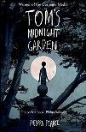  Summer 1 | Driver Text: Tom’s Midnight Garden by Philippa Pearce
 | Fiction | Non- Fiction | Poetry
 | Writing Focus  Write a detailed setting description of the garden.  *Rising Stars Vocabulary Activity- Page 2- Can we talk about feelings? * | Writing Focus  Writing a persuasive argument -Should we have a Royal family?  Should the queen be head of state in the Commonwealth countries. | Writing Focus  Do you have fairies in the bottom of your garden? – Betsy Williams  Children to write a 3-stanza poem describing what the fairies might do at morning, noon and night in Tom’s Midnight garden.  *Rising Stars Vocabulary Activity- Page 30- Can we use whisper to create phrases? *
Vocabulary, grammar and punctuation for Year 5 | Word  Converting nouns or adjectives into verbs using suffixes (e.g. ‘ate’, ‘ise’, ‘ify’)  Verb prefixes (e.g. ‘did’, ‘de’, ‘mis’, ‘over’, and ‘re’)  Sentence  Relative clauses beginning with who, which, where, when, whose, that or an omitted relative pronoun  Indicating degrees of possibility using adverbs (e.g. perhaps, surely) or modal verbs (e.g. might, should, will, must)  Text  Devices to build cohesion within a paragraph (e.g. then, after, that, this, firstly)  Linking ideas across paragraphs using adverbials of time (e.g. later), place (e.g. nearby) and number (e.g. secondly) or tense choices (e.g. he had seen her before)  Punctuation  Brackets, dashes or commas to indicate parenthesis  Use of commas to clarify meaning or avoid ambiguity
Reading Comprehension Focus
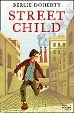  Summer 2 | Driver Text: Street Child by Berlie Doherty
 | Fiction | Non-Fiction | Poetry
 | Writing Focus  Character study. Questioning and hot seating. Write a character description.  *Rising Stars Vocabulary Activity- Page 14- Can we describe emotions and conflict? * | Writing Focus  Non-chronological report – Life in the Victorian workhouse  *Rising Stars Vocabulary Activity- Page 16- Can we describe disappointment and sadness? * | Writing Focus  The Street Child Poem  Using first person, form a short poem about the conditions and how you feel as a street child. e.g. lonely, cold, hungry, sad, hopeless.  *Rising Stars Vocabulary Activity- Page 18- How do co, com and cor words work? *
Vocabulary, grammar and punctuation for Year 5 | Word  Converting nouns or adjectives into verbs using suffixes (e.g. ‘ate’, ‘ise’, ‘ify’)  Verb prefixes (e.g. ‘did’, ‘de’, ‘mis’, ‘over’, and ‘re’)  Sentence  Relative clauses beginning with who, which, where, when, whose, that or an omitted relative pronoun  Indicating degrees of possibility using adverbs (e.g. perhaps, surely) or modal verbs (e.g. might, should, will, must)  Text  Devices to build cohesion within a paragraph (e.g. then, after, that, this, firstly)  Linking ideas across paragraphs using adverbials of time (e.g. later), place (e.g. nearby) and number (e.g. secondly) or tense choices (e.g. he had seen her before)  Punctuation  Brackets, dashes or commas to indicate parenthesis  Use of commas to clarify meaning or avoid ambiguity
Reading Comprehension Focus

Terminology | Modal verb, relative pronoun  Relative clauses  Parenthesis, bracket, dash  Cohesion, ambiguity
