Food Diary  Keep a food diary for the week.  See if you can identify which of the main food groups your food belongs to: carbohydrates, vitamins and minerals, protein, fats, dairy. Search online for the ‘’Eatwell Plate’’ to help you!  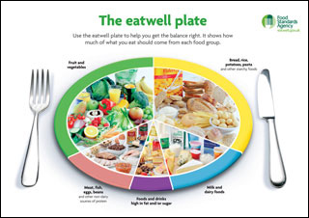 | The ‘’No Hands Get Up’’  Sit down on the ground with your legs crossed and try and stand up WITHOUT using your hands or arms!  (TRICKY!!)   | Socks in the basket!  Ball up some pairs of socks and use a bucket or washing basket. Start by taking one step back from the basket and underarm throw the socks into it. Then, take two steps back and so on!  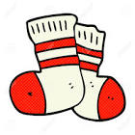 | Juggling  Learn how to juggle! Juggling is great for boosting your brain development. Watch this video for some top tips:  https://www.youtube.com/watch?v=k5gA2RWDujY  If you do not have juggling balls, you could use tennis balls, or rolled up socks!  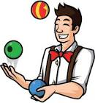
Homemade Javelin  Take an empty kitchen roll tube and place some rolled up socks in one end. Feel free to decorate it first. Create a starting line and see how far you can throw it. If you are on your own, try and beat your distance each time! | Cosmic Kids Yoga!  Cosmic Kids Yoga has some brilliant yoga sequences for children to follow, along with a story:  https://www.youtube.com/watch?v=on_9AhPQigE  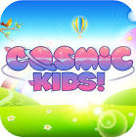 | Trolls Dance Party!  Trolls Dance Party  Follow along to a Trolls Dance!  https://www.youtube.com/watch?v=KhfkYzUwYFk  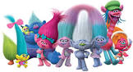 | ‘’Kick Up’’ Challenge  Learn how to do a Kick Up here: https://www.youtube.com/watch?v=GcCv9MeGqS0  Challenge yourself to see how many you can do in a row!  