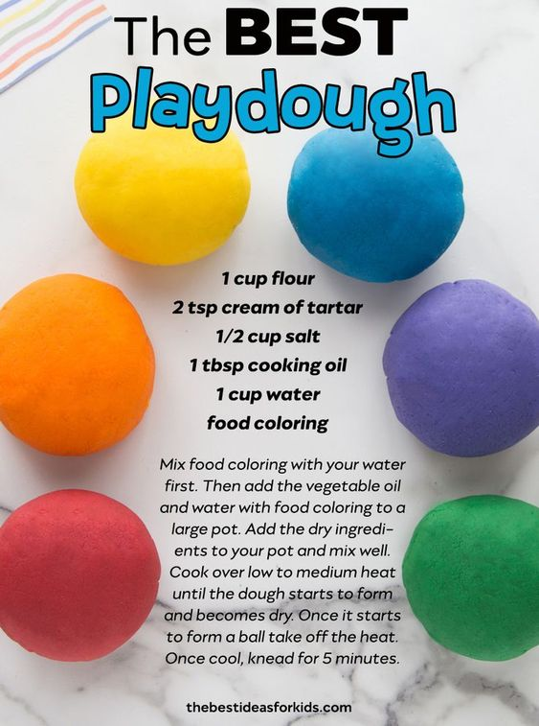
2 cups of flour
3 tsp cream of tartar
1 cup of salt
2 tbsp cooking oil
2 cups of water
Food colouring

