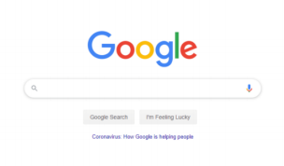
How to login
- To access your Google Classroom account, open an internet browser and navigate to Google. In the search bar, type ‘Google Classroom’ and click on the link.

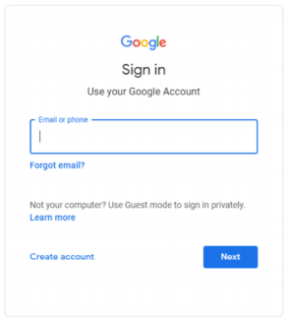
- You will then have the following page displayed.

- You should then enter your login details. These consist of your child’s ‘RCSAT’ email address (assigned to them from school) and password.

- You may be prompted to click on ‘student’ or ‘teacher’. Please click on ‘student’.
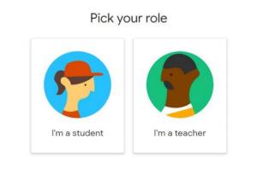

How to access work
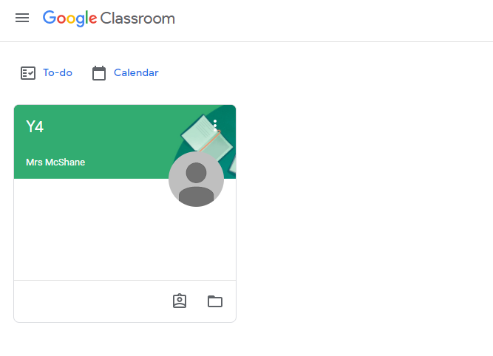
- Click on your child’s Google Classroom to open it.

- One in the Classroom, click on the ‘Classwork’ tab at the top to access the topics.
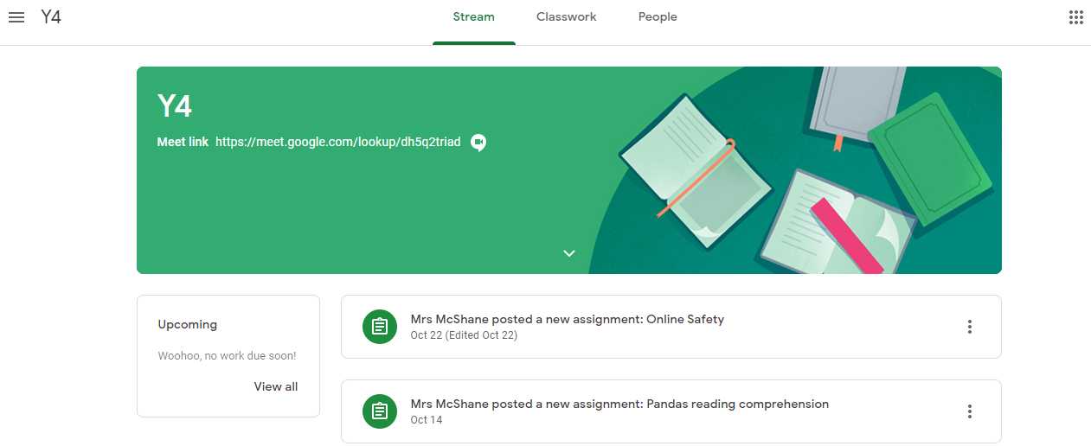

- This will open the topics list. From here, you can open individual assignments by clicking on them and clicking the ‘view assignment’ button.
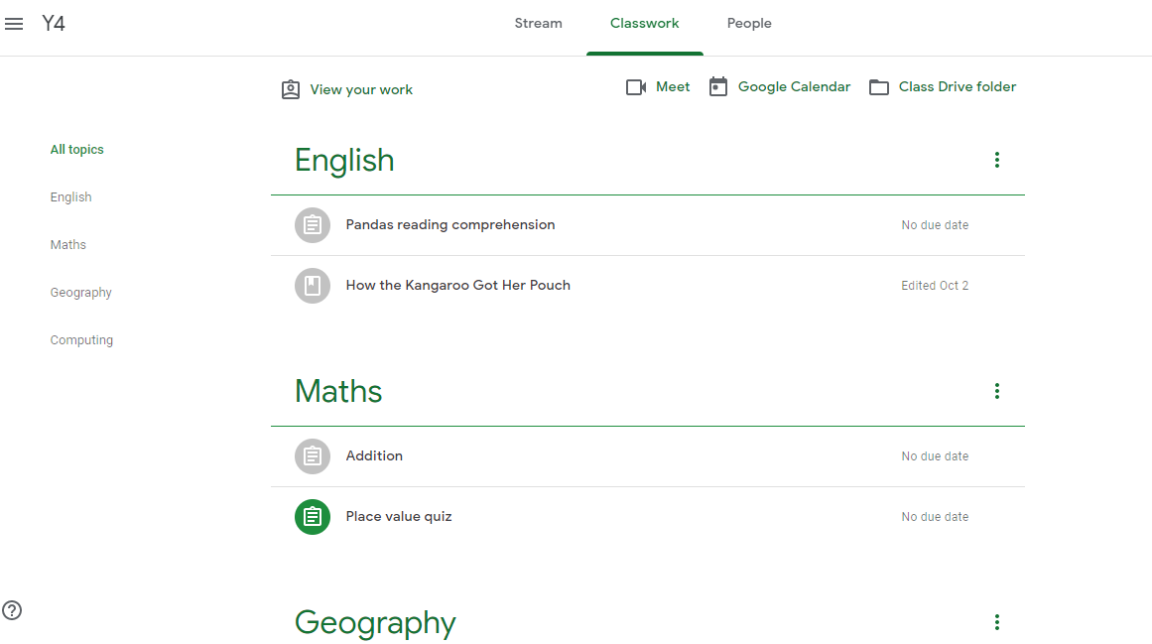
How to hand in work
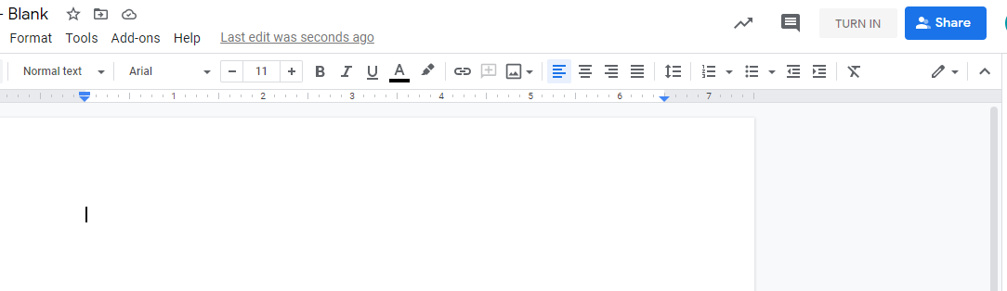
- When you have completed your work, you will find the ‘turn in’ button at the top of the document.

- This pop up will then appear in a new tab. Make sure you click ‘turn in’ again.
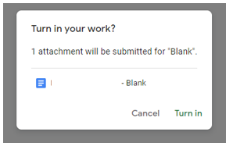

- If the ‘turn in’ button is not available at the top of the document, you can also find it by going back to the classwork page and clicking ‘view assignment’.
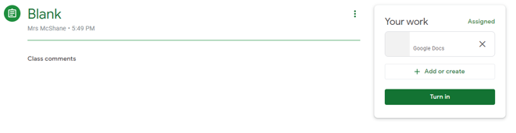
- Under ‘view assignment’ is also where you can find your mark or any comments from your teacher.

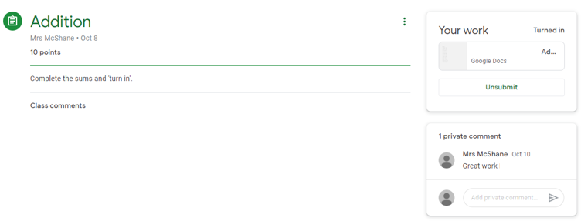

How to get on Google Meet
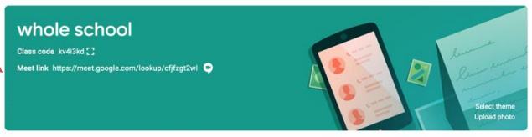
To access live lessons, you will need to click on the ‘meet link’ on the virtual classroom homepage. The live lessons will correspond with the timetable as shared in our Remote Learning Procedure. A copy of this procedure can be found under the Covid Tab on the school website.

