W/C 05.07.20

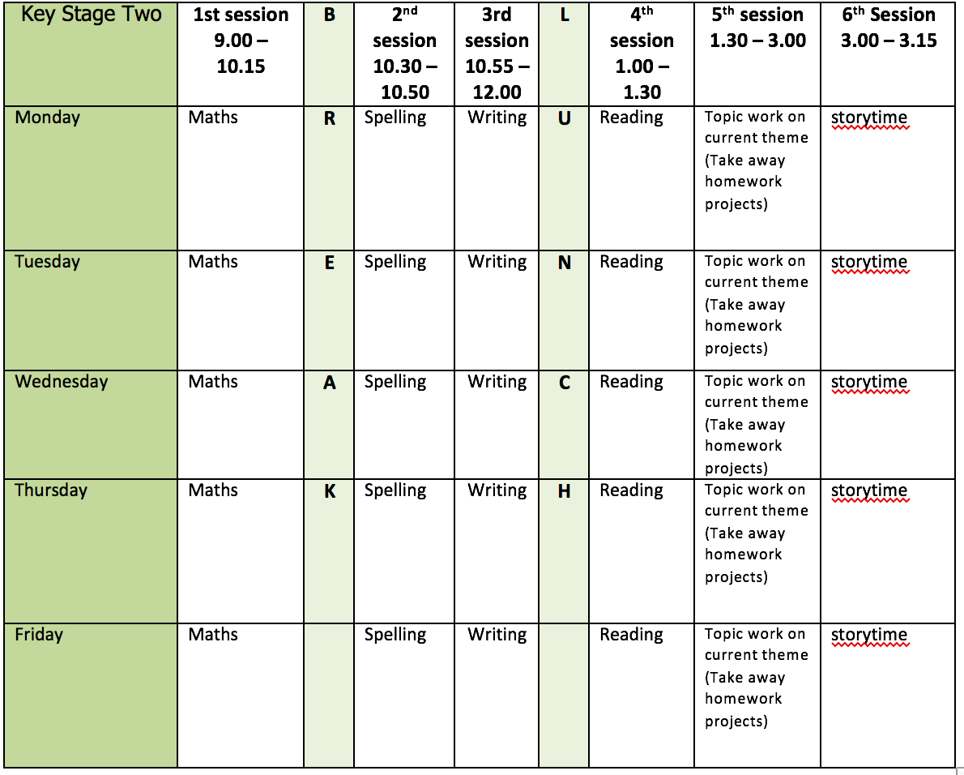
Mental health and well being
Wildlife trusts 30 days wild (resources included)

English writing activities for the week: Flotsam
Monday: Watch Flotsam session 8. Pause the session at 5 minutes and 35 seconds and write your own draft version of the first paragraph of Jetsam - the sequel to Flotsam! Make sure you start with a fronted adverbial of time to tell the reader when this is happening and come up with a name for the girl in your story. Once you have written the first paragraph finish watching the session and write your draft of the second paragraph. Can you use an adverbial of manner this time to start your paragraph to tell the reader how something is done/happens? e.g. As quick as a flash/Without hesitation

Tuesday: Watch Flotsam session 9. Pause the session at 6 minutes and 42 seconds and, using your storyboard, draft your own version of the first part of the 3rd paragraph. Continue watching the session, pausing at 13 minutes and 18 seconds. Now, finish drafting the paragraph by writing all about what your character can see in the photographs using lots of powerful verbs and well-chosen adjectives. Finish watching the session and draft your own version of the next paragraph where the girls discovers that there is a photo within a photo!

Wednesday: Watch Flotsam session 10, pausing at 4 minutes and 13 seconds. Now draft the next part of the story, think carefully about the verbs you use and what type of punctuation you need if you are using an adverb at the start of a sentence. Continue watching the session. Now write the final part of your story. Can you use an adverbial of place that tells the reader where the action is happening to open the last part of your story? Pause the session at 9 minutes and 30 seconds and draft the final paragraph of your story.

Thursday: Resume session 10 at 9 minutes 30 seconds – where you left it yesterday – and watch up to 11 minutes and 45 seconds. If possible, read your work out loud to an adult or a sibling and think about any parts that think you need to edit or change. The person you have read to can also help you by making suggestions for how you can improve and adapt you story. Focus on repetition. Are there any words you are saying repeatedly? Can you come up with a new noun/naming word for them to make your writing more interesting for your reader? Finally, make the changes and improvements you have decided on.

Friday: Today you are going to publish your finished draft! I know you have been working hard all week making your book and creating illustrations, so now is the time to put it all together! Before you start writing, make sure you plan where you are going to include illustrations. Instead of writing straight onto the pages, use a black waterproof pen/biro to write on a separate piece of lined paper (templates provided). You could then paint over it with water colour in blues/greens and purples. Try sprinkling salt of different sizes on and watch what happens! You could rip around the edges or cut your paper into circles like bubbles to make it more interesting. However you choose to publish your book, make it interesting and original!

Reading:

Alongside the release of ‘The Ickabog’, JK Rowling’s publishers have started a competition for children to illustrate the book! Each week I am going to set you a new illustration to complete. If you would like to enter any of your illustration ask an adult to find out a little bit more about it for you https://www.theickabog.com/competition/

Monday: Read Chapter 9 of the Ickabog, https://www.theickabog.com/home/
Find out what the following words mean:
- Impertinence
- Tottered
- Straggly
- Imitated
Are there any other words that you do not understand the meaning of? Can you work out their meaning by reading the information around them? Can use a dictionary to find out or ask an adult?
Based on what you have read today, why do you think the King decided to listen to the Shepard?

Tuesday: Read to end of the second paragraph of Chapter 10 of the Ickabog https://www.theickabog.com/king-freds-quest/ and illustrate a portrait of King Fred that could be hung on the walls of his palace.

Wednesday: Read the rest of Chapter 10 of ‘The Ickabog’ https://www.theickabog.com/king-freds-quest/. If possible, talk to an adult about your impressions of King Fred (what you think about him/what he is like) based only on this chapter and give your reasons/evidence to support your opinion. Complete the table provided giving your impressions and evidence to support them.

Thursday: Read Chapter 11 of the Ickabog https://www.theickabog.com/the-journey-north/ to the end of chapter 6 which ends with – ‘Once they’d dusted Spittleworth off and put the cushion back on his bottom, and Fred had stopped laughing, the party proceeded.’ Write a prediction about what you think will happen next in the story based on what has happened in the story so far and what you have learnt about the characters so far.

Friday: Finish reading Chapter 11 of the Ickabog https://www.theickabog.com/the-journey-north/. Authors often use the weather to help set the scene in a story and signal a change in mood/atmosphere. Find out what the word foreboding means using a dictionary or ask an adult. At the end of the chapter, how does J.K Rowling creates a sense of foreboding? Discuss it with an adult.

Spelling:

What sound does the ‘ou’ make in each of the words above?
Notice the ‘f’ sound at the end of the word rough made by the ‘gh’, this is a very unusual example.
- Write each of the words and practice them using one of the strategies provided.
- Can you apply them by using them in a sentence?

Continue practise of words from Y3/4 list (3 days) using the strategies provided.

Maths activities for the week:
Monday: Measure mass
Tuesday: Compare mass
Wednesday: Add and subtract mass
Thursday: Measure capacity
Friday: Revision of anything tricky from week/Mathletics/Times Tables Rock Stars/Purple Mash maths games

Topic work
Monday: Make your own book ready for Friday when we are going to write our own version of Flotsam! There is a great link here https://clpe.org.uk/powerofpictures/creative-approaches/bookmaking with three different types of book to choose from. You may well need to ask an adult to help you to do this!

Tuesday: Design and create a front cover of your book. Remember the job that a front cover needs to do! It includes a title and gives the reader some clues about what to expect in the book - it makes the reader want to look inside. I have included a seaweed/art collage idea that you could use, or you can come up with your own ideas.

Wednesday: Wellbeing Wednesday - Complete one of the Random Acts of wildness from the wildlife trusts 30 days wild or have a go at an audio relaxation from cosmic kids https://www.youtube.com/watch?list=PL8snGkhBF7njO0QvtE97AJFL3xZYQSGh5&v=XAgUMTexJVs&feature=emb_title

Thursday and Friday: You are going to create illustrations for your version of Flotsam. You can use any style you like and any materials you like, but you must illustrate the pictures beautifully with care and pride that you imagined the girl would find on the camera. When these are complete, you are ready to assemble your finished book – I can’t wait to see them!

