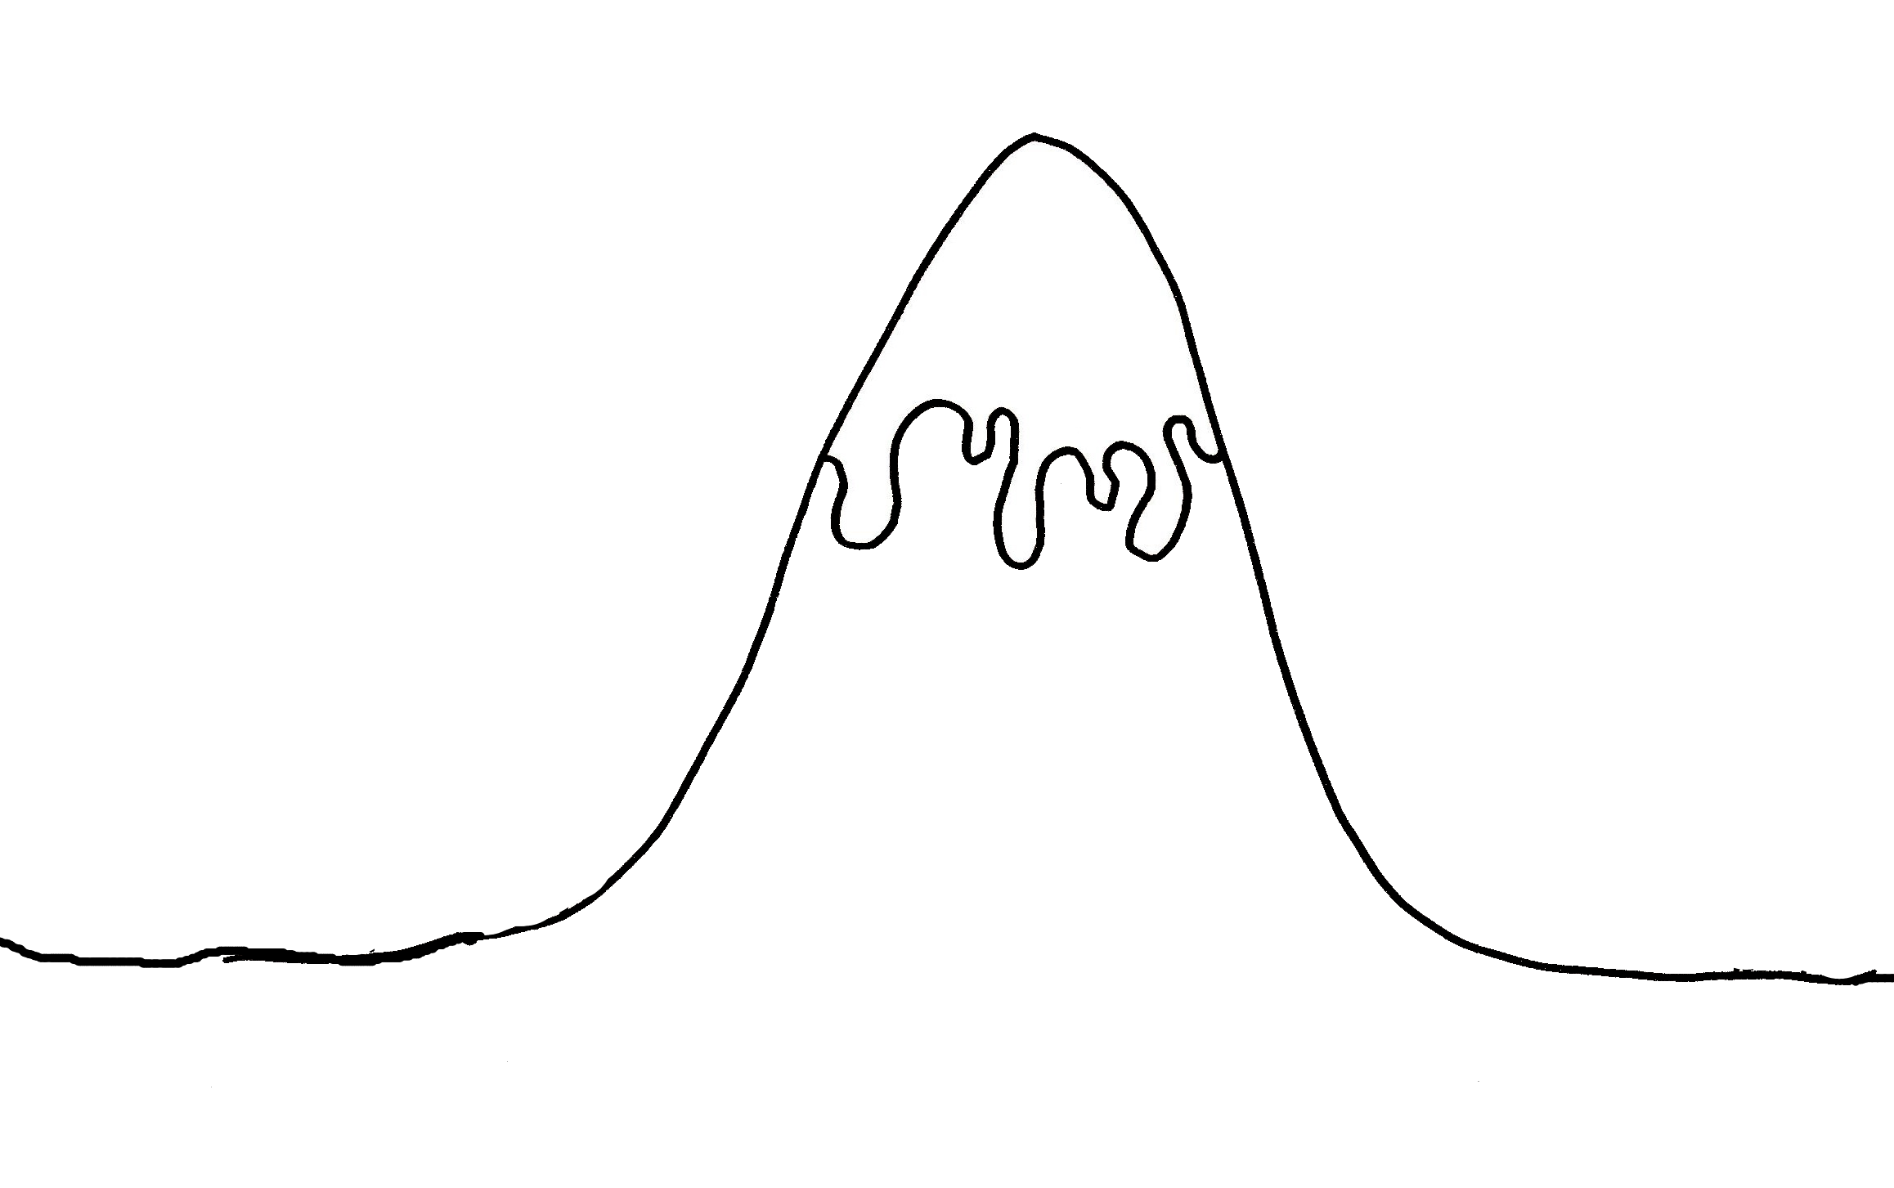

Resolution

Problem

Ending

Introduction

Build up

The Story Mountain
The Story Mountain

