Homework: Friday 7th May
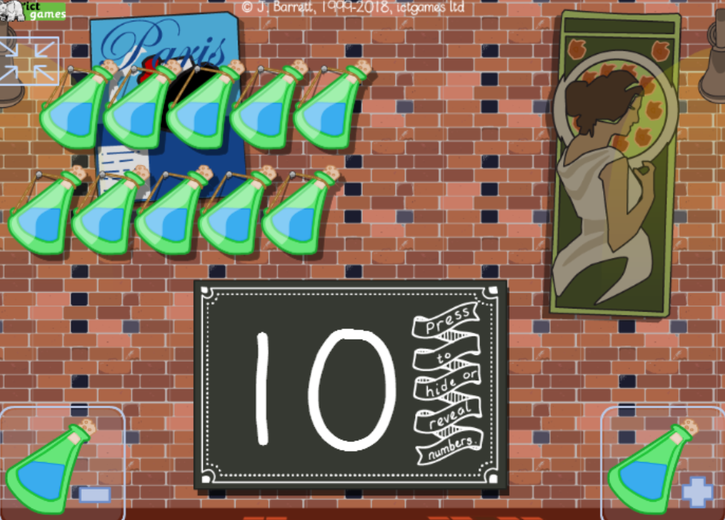
https://ictgames.com/mobilePage/bottleTakeAway/index.html

This week the homework is an online game which can be found using the link above. The children have been working on finding 1 less this week. In the game the children can make a set using the – and + bottles images at the bottom of the page. The children can then work out what 1 less than that number will be and check they are right by clicking on one of the bottles (and listening to the loud crash!).

Please start with numbers to 10 and go to larger numbers if your child is confident with these.

