Frances Hatch

Iceberg Collages

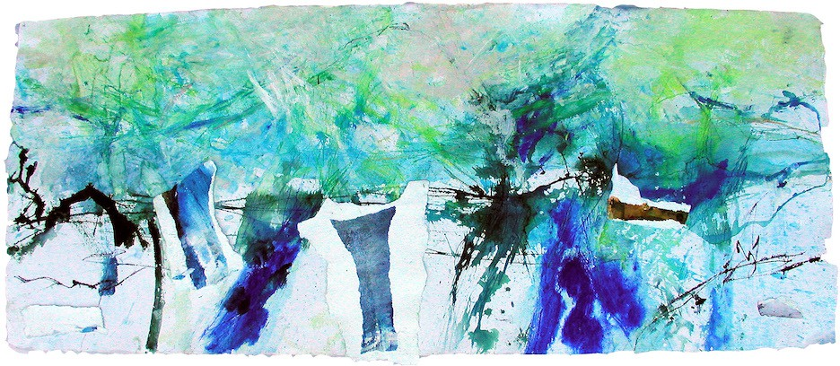

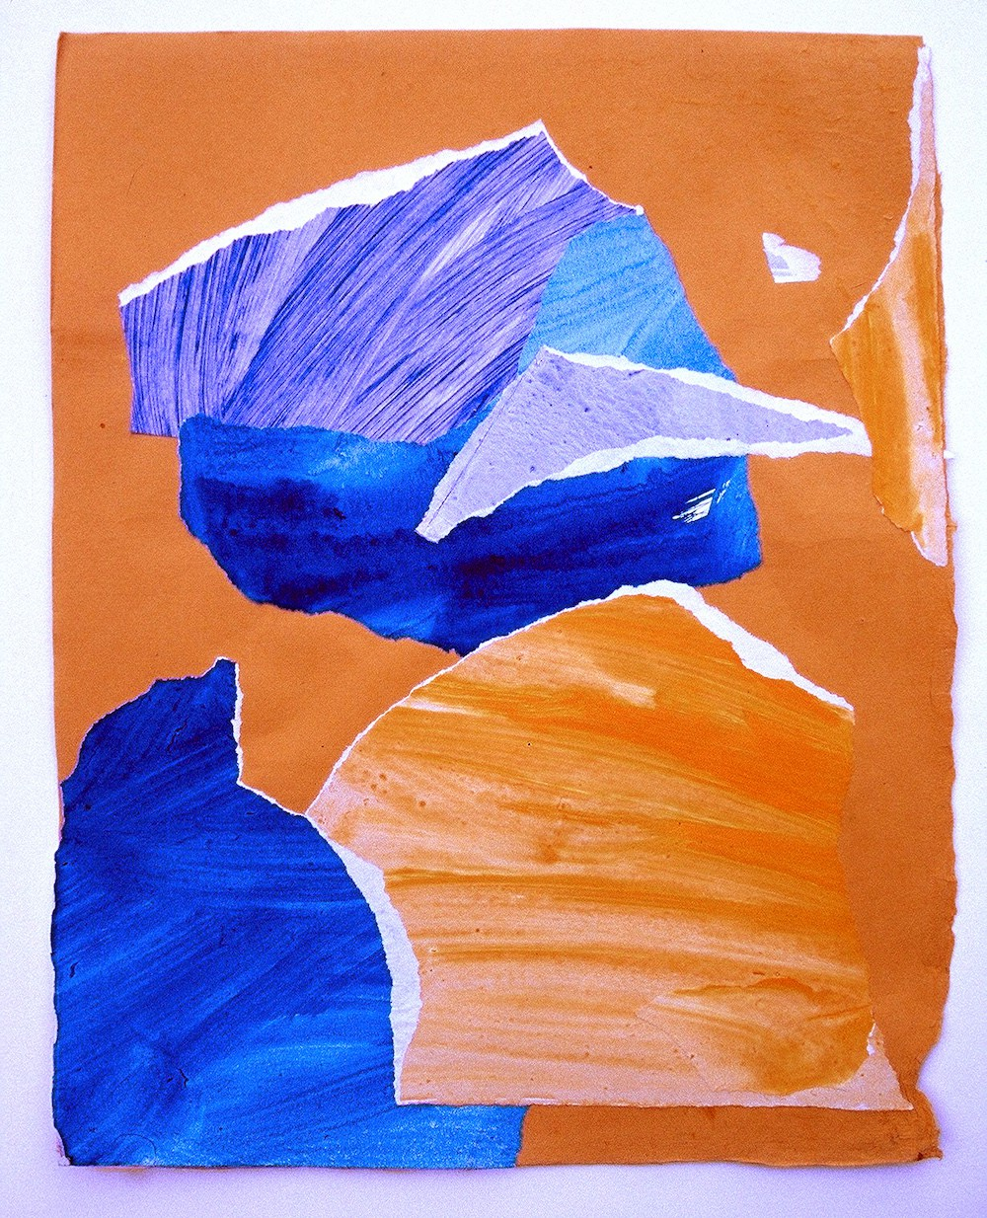

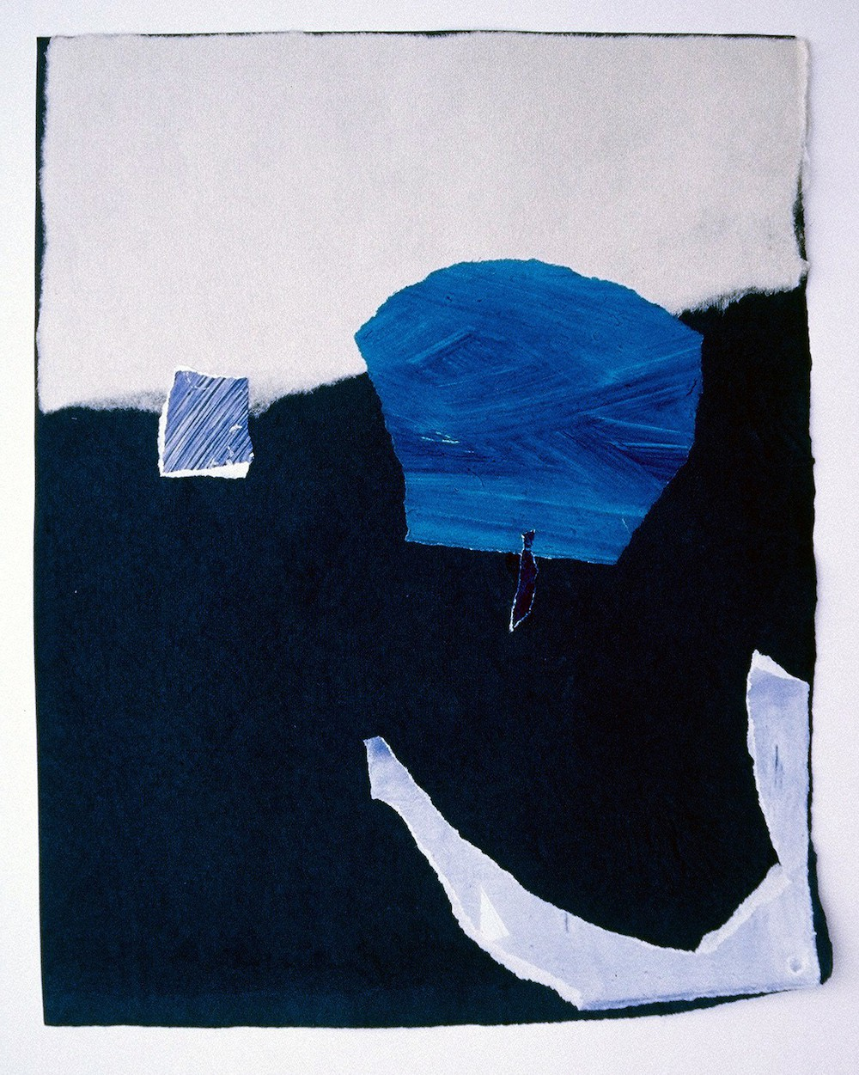
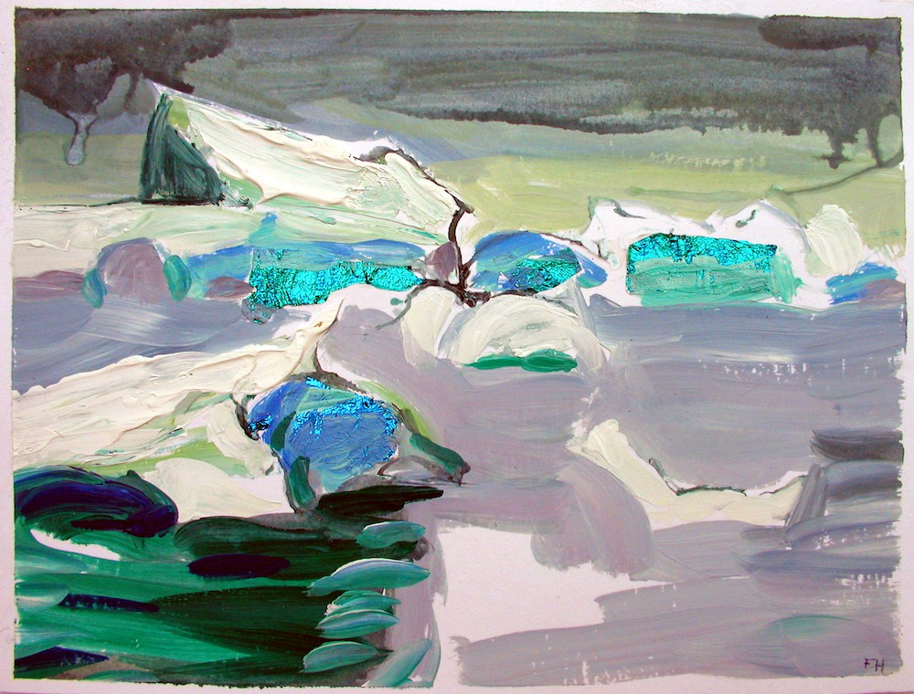

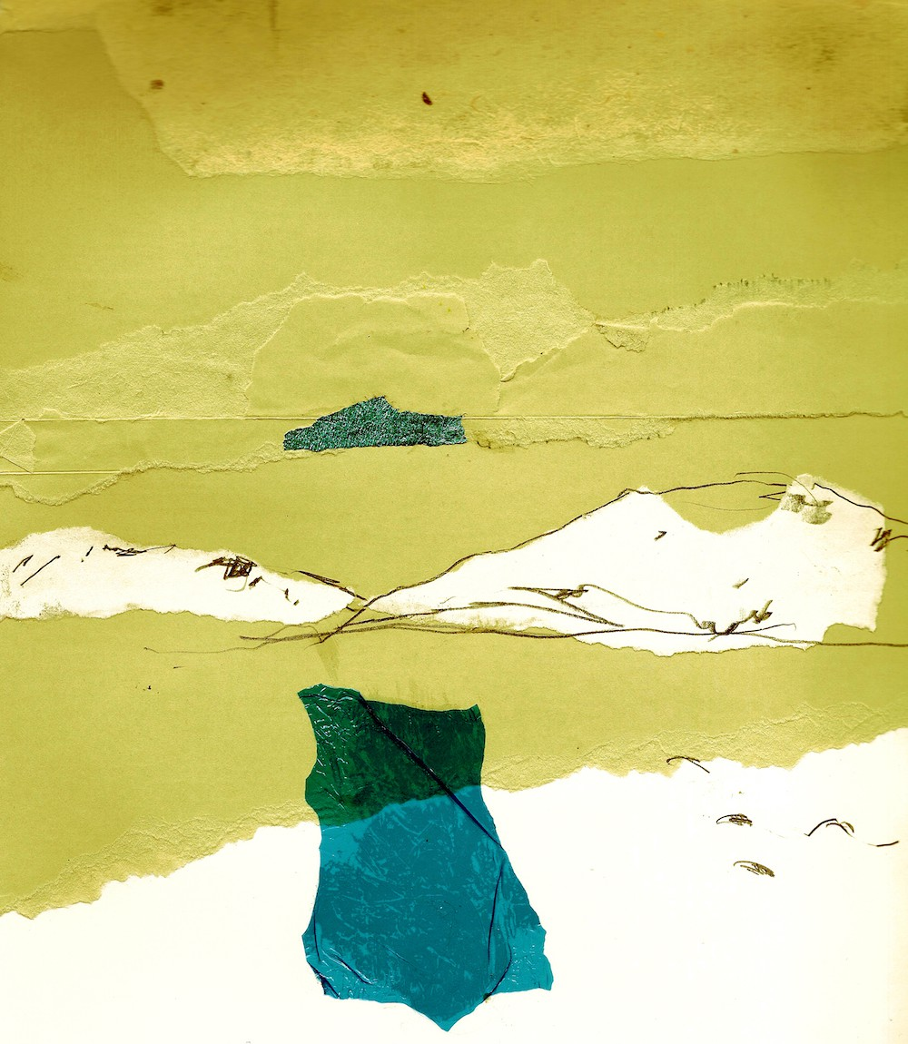

Questions
What colours and shapes can you see?
What time of day might it have been when Frances made the collage? Why do you think that?

How do you feel when you look at the artwork?
Compare two of the artworks. What are the differences and similarities? Which do you prefer and why?

Water
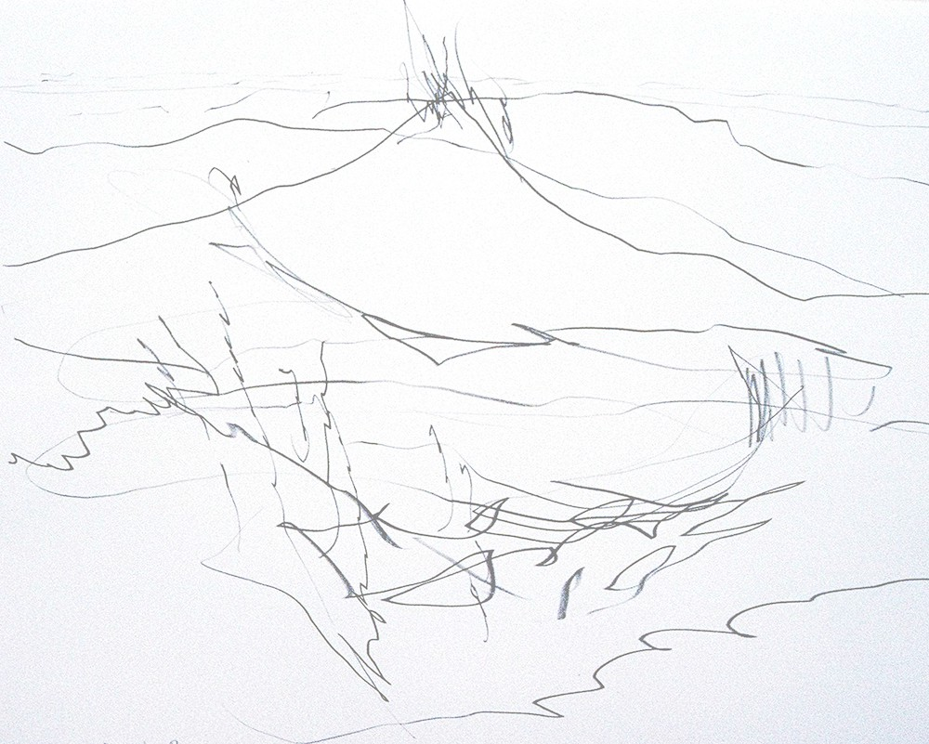

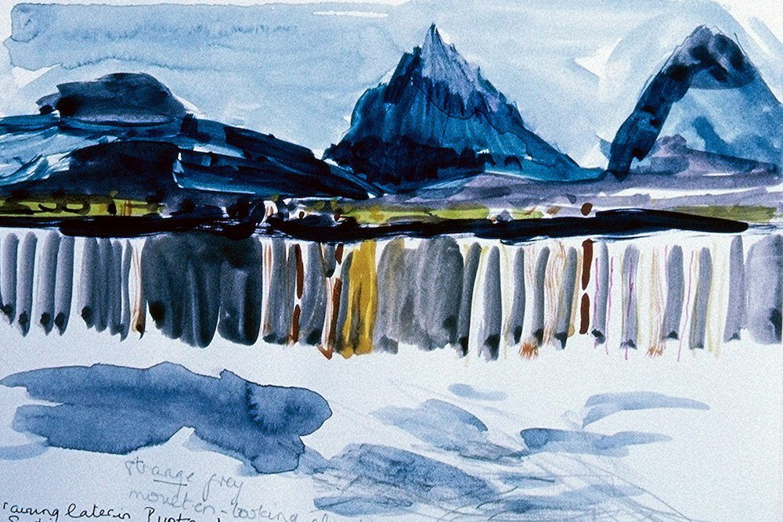

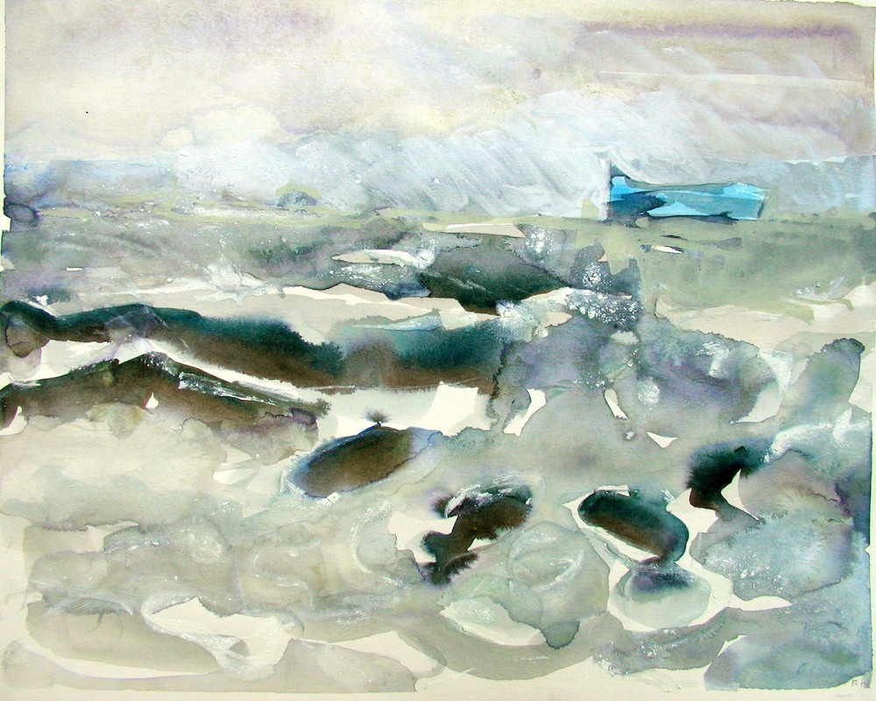

Questions
What colours can you see in the water? What different marks can you see?
Why do you think there are so many colours in the water?
What do you think the weather was like that day?
Imagine you are in the painting. What can you hear, smell, feel?
Which is your favourite and why?

Penguins

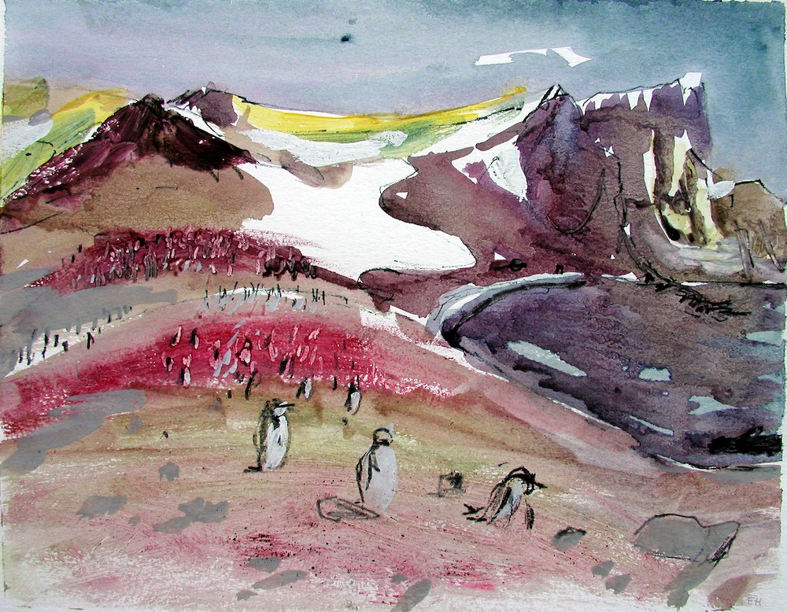
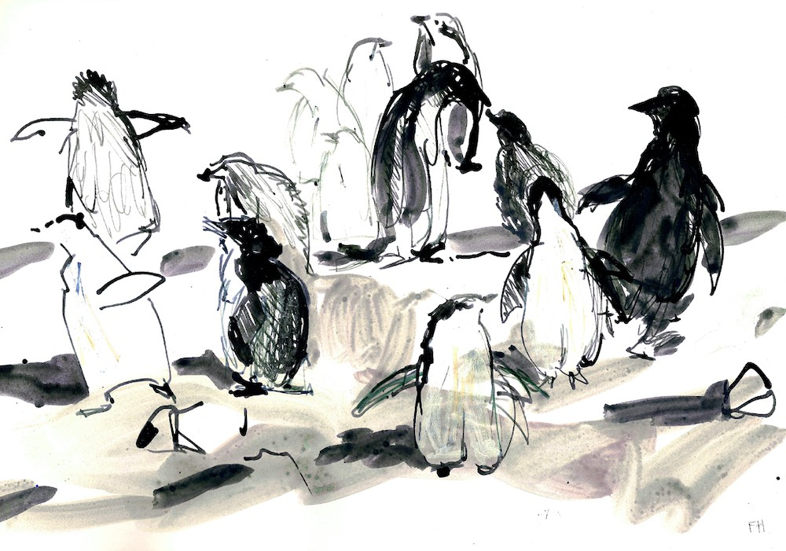

Questions
What different lines and marks can you see?
Is this a landscape you’d expect to see penguins in? Why?
How has Frances captured perspective?
How has Frances captured a sense of movement in the drawing?

