

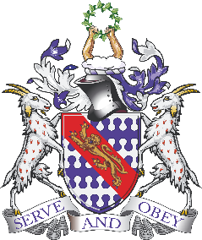
Individual Liberty:
Pupil voice surveys where children are asked to respond and reflect on teaching and learning across different topics and subjects.
Choosing takeaway homework
Choices around participation in extra-curricular activities
Responsibilities – corridor monitors, team points, sports ambassadors, maths champion.
School ethos
Young Leaders Award

British Values at Bunbury Aldersey CE Primary School
Democracy:
Pupils influence school life through school council
Vote for school the two council members from each year group reflects our British electoral system and demonstrates democracy in action: candidates make speeches, pupils consider characteristics important for an elected representative, pupils vote
Children vote for the rights associated with their Class Charter at the beginning of each school year. All children contribute.
Applications, interviews and vote for Head boy/girl and Deputy boy/girl
Decision-making/voting – dragons den finalists
Election Day and mock voting
The Rule of the Law:
Links with Community Police Officers – presence at school to raise the profile of parking safely.
Visits from authorities such as the police and fire service
School rules and each class’ Class Charter, a set of principles that are clearly understood by all and seen to be necessary to ensure that every class member is able to learn in a safe and ordered environment.
Junior Safety Officers
KiVA
Cycling proficiency
During other subjects where there is respect and appreciation for different rules – for example in PE lessons.
Tolerance of those with different faiths and beliefs:
Faith days
Festivals, celebrations and traditions from other cultures (taught through our Global topics such as ‘Atlas of Adventures’)
Friday Worship – different religions speakers
Books and resources – cover a wide range of religions and cultures.

Mutual Respect:
PHSE
RRSA activities
Celebration assembly
Showing takeaway homework
Buddies
Mission statement encompasses all and is embedded in all aspects of school life: “a caring Christian family where we grow together” and “let your light shine”.
Teamwork in residentials
Sporting events
Global and local charities

