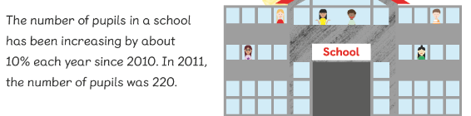

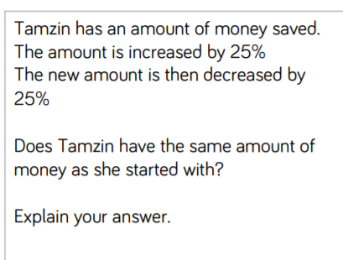
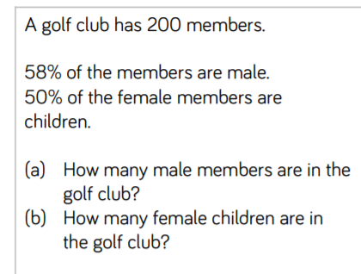
At a concert 4/10 are children. The rest are adults. There are twice as many men as women at the concert. What percentage are men?

Faith has read 20% of her book. Her sister read 2/5 of it to her. Her mum read the rest. How much did her mum read to her?
