World Book Day author & illustrator videos for schools  Watch some of the videos in the author and illustrator academy to learn all about how different authors and illustrators do their jobs. There are also extracts to read and activities to try. | 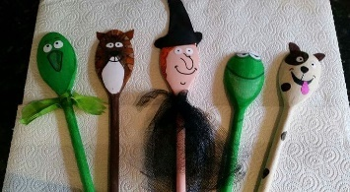  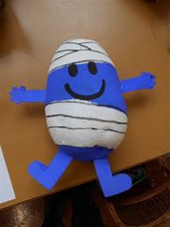  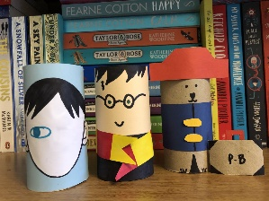  Take either a wooden spoon, a toilet roll or a potato and turn it into your favourite book character! | Take part in our Bunbury Book Cover Hunt. Take your map of the village with you and mark on it any book covers that you spot in people’s windows.
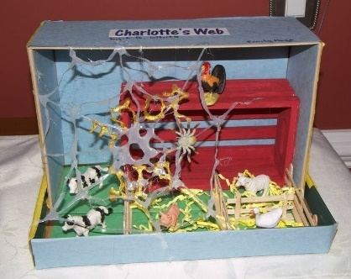  Have a go at creating a ‘Book Nook’ for your bookshelves or turning an old shoe box into a setting from your favourite story book. | Share a story with a friend or family member on a video call. | Listen to one of the free audiobooks here:  World Book Day Audiobooks
2021s-1-books (worldbookday.com)  Take a sneak peak inside this year’s World Book Day books and decide which one you might like to spend your voucher on when you can! | Fit a book cover on to the size of a 2p (harder than you might think!).  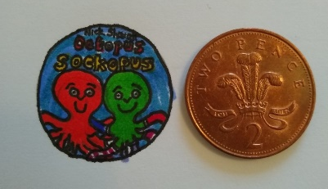 | 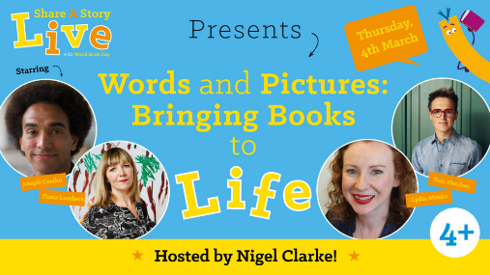  This live event starts at 10.30.  Words & Pictures: Bring Reading to Life - World Book Day
