Year 4
Autumn 1 Newsletter 2022

Meet the Team

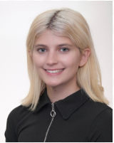
Miss Smith Miss Akpinar

TEACHING ASSISTANTS AND SUPPORT STAFF
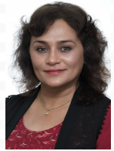
Mrs Ghaffur Miss Khan Mr Akhram Mrs Raitskin

Topic Overview & Key Texts
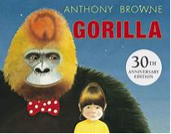
Gorilla is the classic story of a lonely girl, a friendly gorilla and their amazing night out, written by multiple award winner Anthony Browne. Children explore features of a narrative and then innovate the text to write their own.

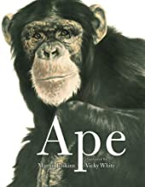
Ape by Martin Jenkins is a non-fiction book describing four different types apes, accompanied by beautiful close-up portraits. The children will use Ape to help gather facts for their non-chronological report on gorillas.

Year 4

Maths
This term we will focus on:

Place Value- recap on numbers to 1000 and move onto understanding 4 digit numbers.
Rounding – rounding numbers to the nearest 10 and 100.
Addition – using the formal column method to add up to 4 digits.
Subtraction – using the formal column method to subtract up to 4 digits.
Regular times table practise with also be a focus.

Writing
We will be using two books as our main texts this term: Gorilla and Ape. Children will explore features of a narrative in Gorilla and learn to use fronted adverbials and noun phrases. Ape will be another model text used to learn about features of non-fiction texts.

Reading
Each day we will use high quality texts to build the children’s reading skills. Where possible we will relate these to our animals in captivity topic. At the start of the term we will focus on building the children’s reading stamina and decoding skills while developing their comprehension skills though discussion about the text. These texts will explore the lives of primates and their habitats around the world.

Year 4
Dates & Routines

Mondays | Tuesdays | Wednesdays | Thursdays | Fridays
Reading book: checked for comment | Reading book  Swimming lessons begin on 13th September. Please bring correct kit; towel, swimming kit, swimming cap (girls)  Spelling Test and new spellings given – see seesaw | Reading book: checked for comment | Reading book: checked for comment | Reading book: checked for comment  Praise Postcard Assembly  Green Treat in school!

Homework
Due to the success of Seesaw, we will continue to use it this year to set maths and spellings homework every week.
Your child will receive a home reading book on their first day back. We expect children to read every day and write in their reading journal at least 3 times a week.

Key Dates:

We would like to welcome parents to meet their class teacher on either Monday 5th September or Tuesday 6th September at 9am or 3pm.

Last day for this half term: Friday 21st October 2022.

