Year Reception
Autumn 1 Newsletter 2022

Meet the Team
Teachers




Mrs Jeffery Mrs Ajaz Mrs Burnell



Mr Ahmed Miss McGovern Mrs Tabassum
Teaching Assistants

Entering School
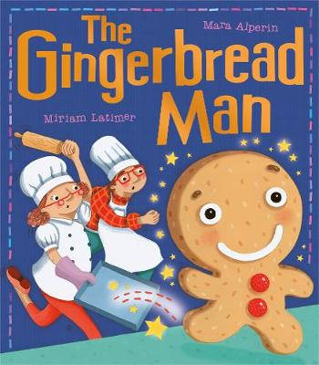
Reception children will use the rear car park gate near the school nursery.

Topic Overview & Key Text

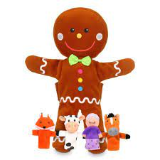
The cheeky little gingerbread man is having so much fun! He scurries away from Mr and Mrs Baker and all the hungry animals, but then he meets a crafty fox … Will the gingerbread man meet a sticky end?
We will learn the story and perform it with actions! We will make gingerbread people by following a recipe. We will talk about the characters and their feelings from our story.

Autumn/Harvest
We will be looking at the changes in our local environment and observe and talk about the seasonal changes in Autumn. What can we see outside? How does it feel? What has changed?
We will also be learning about the Harvest festival. ‘What is Harvest and how do we celebrate it? and ‘How is Harvest celebrated in the UK?



Maths
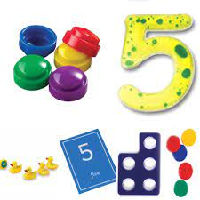
We will explore early number concepts through play using practical resources to help us explain what we know. We will focus on:
Number Recognition
Place value of numbers to 5
Addition and subtraction to 5
Time- sequencing my week

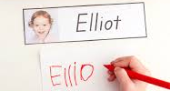
Please see the ‘End of Year Expectations’ on our website for a full list of maths concepts that will be taught this year.

Writing
The children will be practising to write their name and making sure each letter is correctly formed. Help your child to write their name at home and celebrate their effort.
The children will be drawing a story map to retell the main events of ‘The Gingerbread Man Story’ and adding labels or initial sounds with support.

Reading
The children will be practising their set
Set 1 sounds and blending the sounds to say a word. E.g. c-a-t ‘cat’.

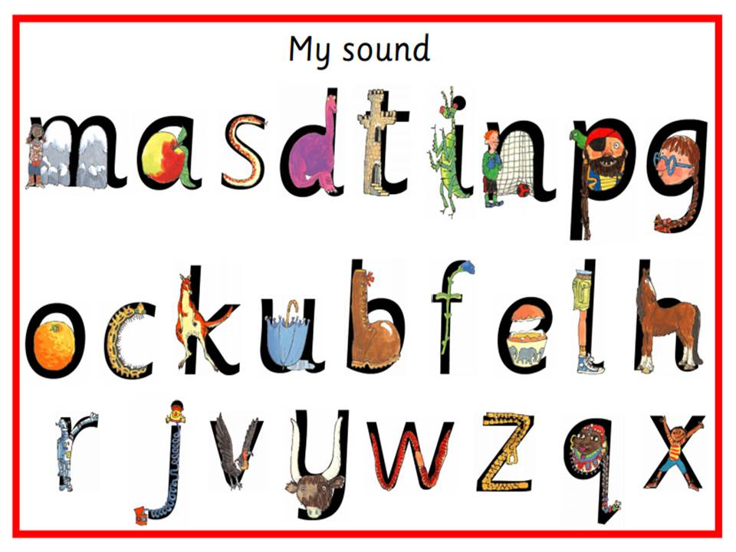

Linked texts we will be reading:
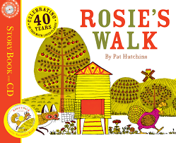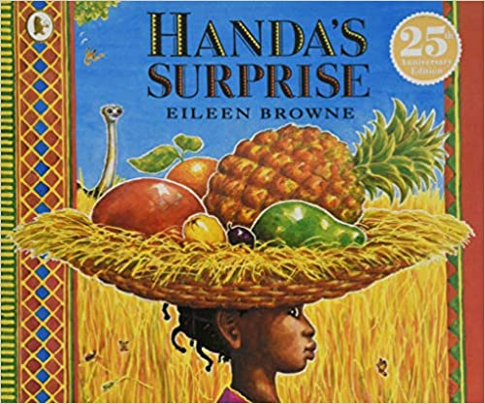

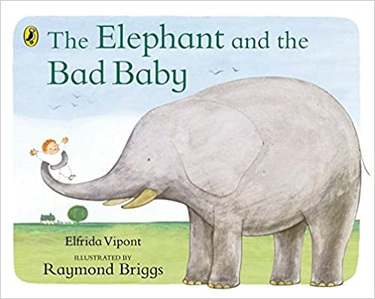

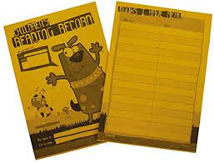
Homework
Your child will get a book to take home, this is for you to read to your child. Please write a comment in their home reading record and encourage them to tell you what they have enjoyed about the book.
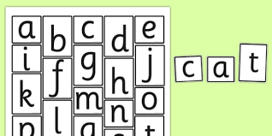
They will also get a set of letter sounds to practise making cvc words at home.

Reception
Date & Routines

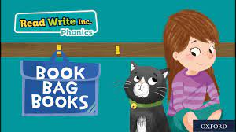

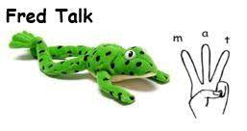

+

School opens for all pupils on Thursday 1st September 2022

Mondays | Tuesdays | Wednesdays | Thursdays | Fridays
PE- A PE kit will not be required for the first half term. |  | Stay and Play  8:40 a.m. – 9:10 a.m.  Forest School  with  Mr McCarthy | Forest School with  Mr McCarthy | Homework task is set on SeeSaw    (online learning platform)

Key Dates

Autumn Term

Thursday 1st September 2022 School Re-opens at 8:40 am
Wednesday 21st September 2022 Stay and Play starts (weekly)
Friday 21st October 2022 School closes at 3:15 pm

Half Term

Monday 31st October 2022 Staff Training Day
Tuesday 1st November 2022 School Re-opens at 8:40 am
Friday 16th December 2022 School closes at 3:15 pm

