Year 4
Autumn 1 Newsletter 2022

Meet the Team


Ms Alsopp Mrs Jusab

TEACHING ASSISTANTS AND SUPPORT STAFF
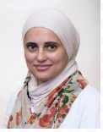
Miss Dokyi Mrs Farajallah Mr Watson Miss Climance

Topic Overview & Key Texts
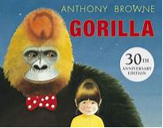
Gorilla is the classic story of a lonely girl, a friendly gorilla and their amazing night out, written by multiple award winner Anthony Browne. Children explore features of a narrative and then innovate the text to write their own.
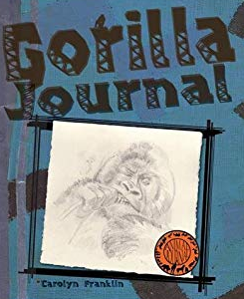
Gorilla Journal by Carolyn Franklin uses an imaginative approach to learning about wild animals, as it takes the reader on an exciting African safari. The lives of gorillas are revealed in their natural habitats and documented in an engaging narrative that includes diary accounts, fun facts, sketches, and photos that mimic the look of a real-life journal.

Year 4 Maths
This term we will focus on:

Place Value- recap on numbers to 1000 and move onto understanding 4 digit numbers.
Rounding – rounding numbers to the nearest 10 and 100.
Addition – using the formal column method to add up to 4 digits.
Subtraction – using the formal column method to subtract up to 4 digits.
Regular times table practise with also be a focus.

Writing
We will be using two books as our main texts this term: Gorilla and Gorilla Journal. Children will explore features of a narrative in Gorilla and learn to use fronted adverbials and noun phrases. Gorilla Journal will be another model text used to learn about features of non-fiction texts.

Reading
Each day we will use high quality texts to build the children’s reading skills. Where possible we will relate these to our animals in captivity topic. At the start of the term we will focus on building the children’s reading stamina and decoding skills while developing their comprehension skills though discussion about the text. These texts will explore the lives of primates and their habitats around the world.

Reading Books
Children are still expected to read every day. Reading records and reading books need to be brought back to school every day and will be checked on Mondays, Wednesdays and Fridays for comments.

Year 4
Dates & Routines
School opens for all pupils on Thursday 1st September 2022

Mondays | Tuesdays | Wednesdays | Thursdays | Fridays
Reading book: checked for comment | Reading book  Swimming lessons begin on Tuesday 13th September. Please bring correct kit; towel, swimming kit, swimming cap (girls) | Reading book: checked for comment | Reading book | Reading book: checked for comment  Spelling Test and new spellings given – see seesaw  Praise Postcard Assembly  Green Treat in school!

Homework
Due to the success of Seesaw, we will continue to use it this year to set maths and spellings homework every week.
Your child will receive a home reading book on their first day back. We expect children to read every day and write in their reading journal at least 3 times a week.

Key Dates:

Last day for this half term: Friday 21st October 2022.

Meet the teacher meetings : Monday 5th September and Tuesday 6th September 9am and 3pm – Please choose a convenient for you.

