Year 3
Autumn 1 Newsletter 2022

Meet the Team
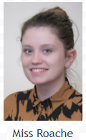
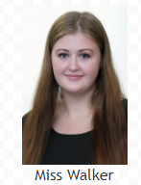
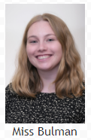
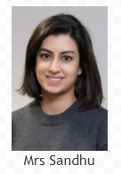
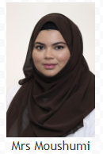
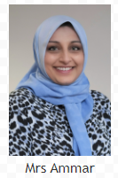

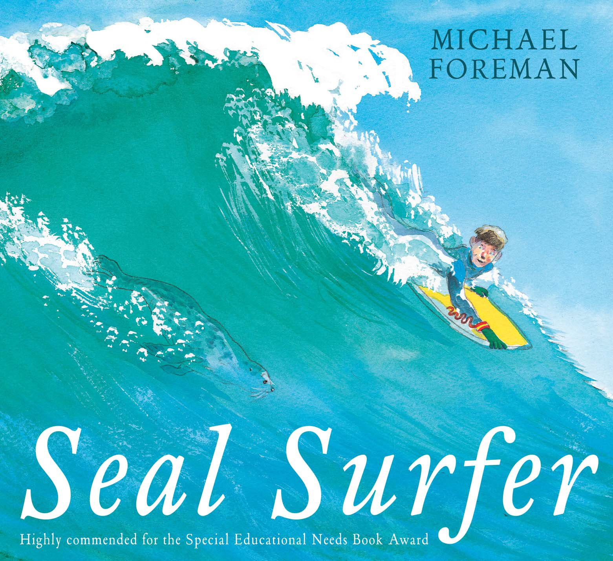
Topic Overview & Key Text

Our key text for this half term is Seal Surfer.
A boy and his grandfather watch as a baby seal is born on the rocks near their home and from that day a special friendship is forged between them. This powerful book demonstrates friendship flourishing across generations, species and abilities.

Maths
In Maths, we will begin the year by learning all about place value. We will approach this in a very ‘hands on’ concrete style of learning where the children will have the opportunity to physically make numbers and represent them visually. This will provide the children with a firm foundation for when we move onto addition and subtraction.

Writing
In English we will be writing a warning story based on our key text, Seal Surfer. We will also write a non-chronological report about seals and will explore the different features required.

Within the writing unit we will be learning and embedding multiple skills such as: participating in discussions and role play, building our vocabulary, articulating and justifying answers, group related ideas into paragraphs, using prepositions and beginning to use inverted commas.

Reading
Within the reading unit we will be learning and embedding skills such as: retrieving information, drawing inferences, making predictions and asking questions to improve our understanding of the text. We will look at a new text every week to ensure we explore a range of different books.

Homework
We will be using SeeSaw to set homework. Homework will be issued and should be returned on Mondays. It will include spellings and Maths. Children are also expected to read every day at home.

Year 3
PE takes place every Monday. Please make sure your child has their full PE kit every week.

We will be continuing with our thematic curriculum, which creates meaningful links between the children’s learning in English, science, humanities and creative arts with our key text as the main driver.

Science: Animals including Humans – We will learn what animals and humans need to survive. We will also learn what skeletons and muscles are for.
Art: Observational and still life drawings – We will use our sketchbooks to explore different drawing techniques and will sketch shells.
Geography: ‘How does city living compare to the coast?’ – We will be learning about the human and physical features around Longsight compared with the coastal town of Formby.
PSHE: British Values – We will learn about why people wear uniforms, why it is important to have different rules in different places and who is in charge of the school.

Year 3
Date & Routines

Dates for your diary:

Meet the Teacher event
We would like to welcome parents to meet their class teacher on either Monday 5th September or Tuesday 6th September at 9am or 3pm.
This will be an opportunity to discuss the coming year and to answer any questions you may have.

Mondays | Tuesdays | Wednesdays | Thursdays | Fridays
PE – please bring correct kit: black shorts or jogging bottoms |  |  |  | Green Treat  Praise Postcard  Homework given out

School closes for half term on Friday 21st October 2022.

School reopens at 8.40am on Tuesday 1st November 2022.

