Year 1
Autumn 1 Newsletter 2022

Meet the Team

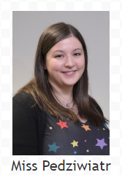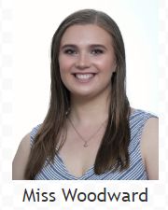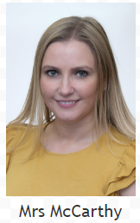

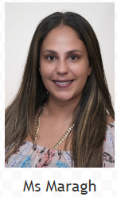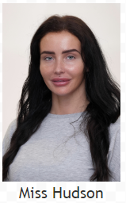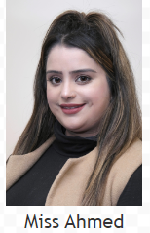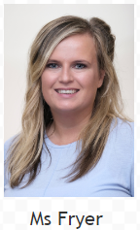

Topic Overview & Key Text
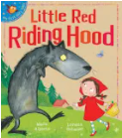
Our key text this term will be ‘Little Red Riding Hood’. In this story we will meet Little Red and a big, hungry wolf. We will be learning the names of different animal classifications in our science lessons, in preparation for innovating our key text. In geography, we will be focusing on maps and learning directional language, as well as exploring the local area.

Maths
In this half term we will be focussing on embedding number and place value knowledge. We will be counting forwards and backwards, finding 1 more and 1 less. We will be using mathematical language, such as equal to, more than and less than. We will be adding and subtracting one and two digit numbers.

Writing
In English we will be working towards writing a warning story based on our key text ‘Little Red Riding Hood’. We will be reading and retelling the story, whilst exploring the text as a reader and a writer. Along the way we will be building our knowledge of composing and structuring sentences. We will be using exciting vocabulary linked to the text and participating in class discussions.

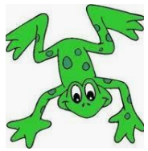

Reading
All of the children in Year 1 will attend daily phonics lessons using the Read Write Inc. phonics programme. Your child will be issued with a new reading book every Tuesday and Friday. Children are expected to read their book at home every day. Please ensure that your child has their reading book and reading record in their book bag every day.

Homework
We will use the online platform Seesaw to set a Friday and it should be completed by the following Wednesday. Homework will consist of a maths task linked to the maths objective that has been taught that week. A weekly spelling task will be sent out on Monday these will be tested the following Monday. Your child should read their reading book every day at home too.

Year 1
We will be continuing with our thematic curriculum that creates meaningful links between the children’s learning in English, science, humanities and creative arts with our key text as the main driver.

Science: Classifying animals.
Art: Drawing still life images.
Geography: Exploring the school grounds and surrounding area.
PSHE: British Values
RE: Christianity
Computing: Creating a film

Meet the Teacher

We would like to welcome parents to meet their class teacher on either Monday 5th September or Tuesday 6th September at 9am or 3pm.

Year 1
Date & Routines

School opens for all pupils on Thursday 1st September 2022

Mondays | Tuesdays | Wednesdays | Thursdays | Fridays
 |  |  | New homework given out on Seesaw

Meet the Teacher

We would like to welcome parents to meet their class teacher on either Monday 5th September or Tuesday 6th September at 9am or 3pm.

School closes for half term on Friday 21st October 2022 and reopens on Tuesday 1st November 2022.

