  - Year 1
What should I already know?
- I can use this equipment safely…
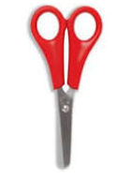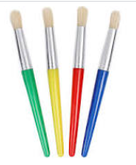
- I can draw a closed shape. 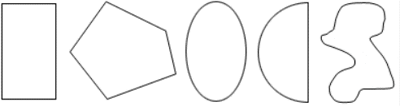
- I can name these colours… 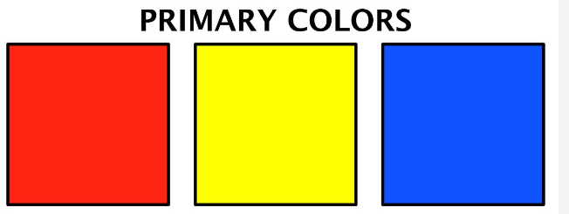

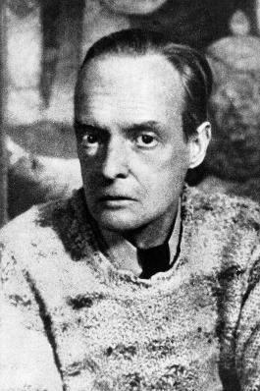
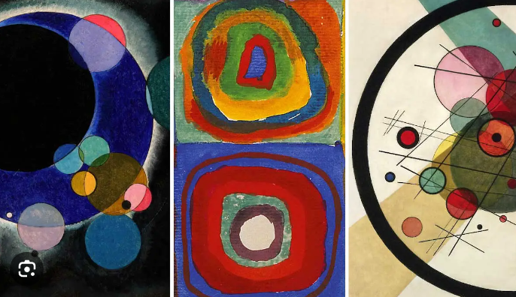
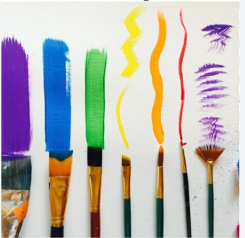
My key artist: Paul Klee
- Paul Klee was born in Switzerland.
- His style is influenced by colour theory.
- He liked creating paintings with fantasy worlds, shapes, symbols, colours and lines.
Different brush strokes
Words I might need…
thick
thin
primary colours
secondary colours
warm colours
cold colours
watercolours

Year 2
What should I already know?
- I know what primary and secondary colours are.
- I know how to mix colours that I need.
- I know that different paintbrushes create a different effect.

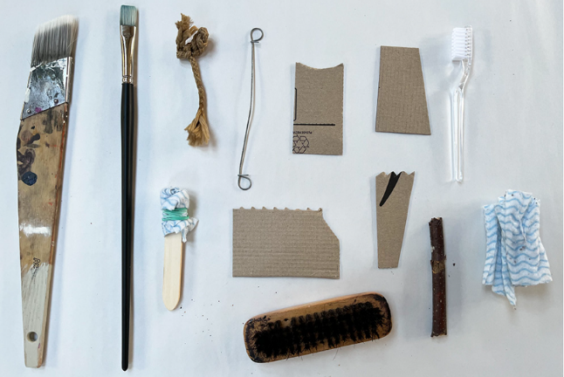
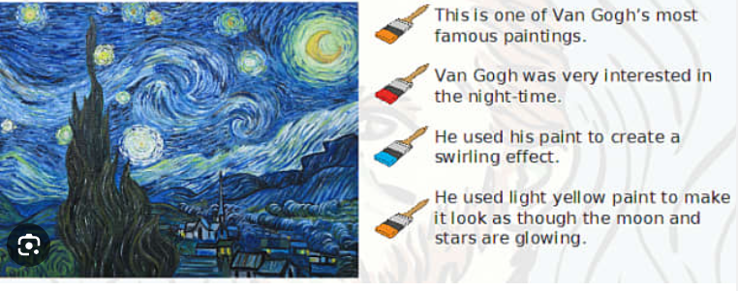
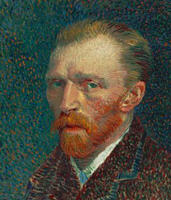
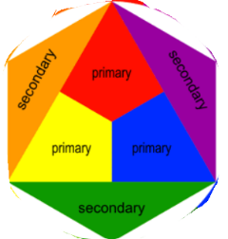
Materials I might explore.
Words I might need…
primary colours
secondary colours
bold
soft
warm
cold

My key artist: Van Gogh
- He was a Dutch painter.
- He only became famous in the last
- years of his life.
- He cut off his ear after arguing with another painter.
- He liked to use swirling and short brush strokes.
  - Year 3
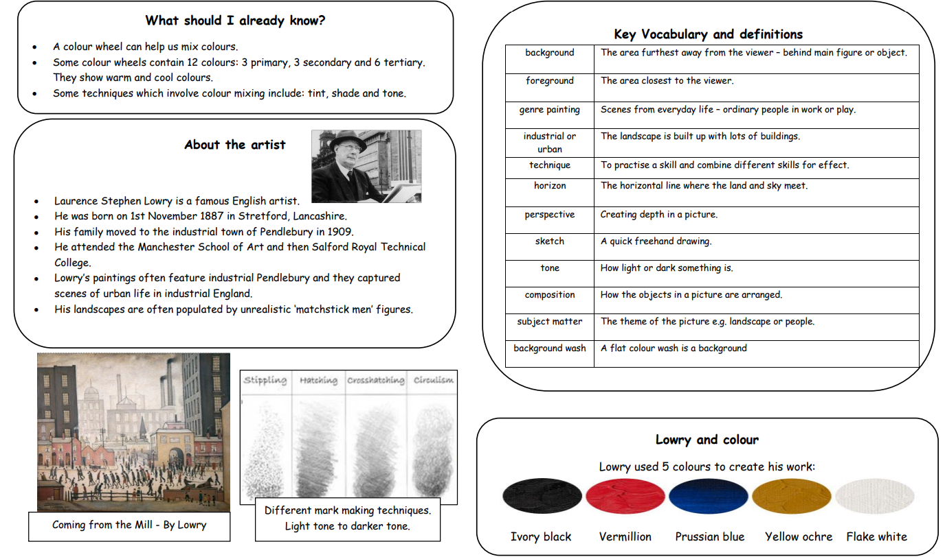
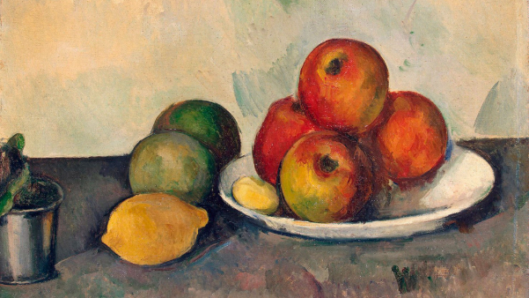
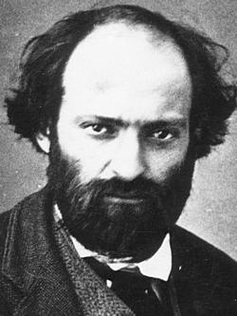
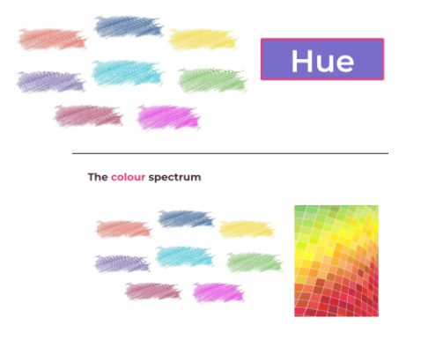
Year 4
Cezanne uses heavy brushstrokes and layering to create a sense of density to make the fruit look realistic.
My key artist: Paul Cezanne
- Paul Cezanne was a French Post-Impressionist painter.
- He used repetitive, explorative brushstrokes.
- He used small brushstrokes to build up his artwork.
- Paul Cezanne used shape, colour and lighting.
- He experimented with shape, colour and lighting.
- Cezanne was very skilled at observing, often painting fruit and jars.
Key vocabulary and definitions
tone
darker
lighter
hue
mood
composition
landscape

What should I already know?
- Describe a range of colours and how they are mixed.
- Name and use a range of materials in order to make interesting brush strokes.
- Know how to lighten and darken a colour to change the shade and tone of paint.

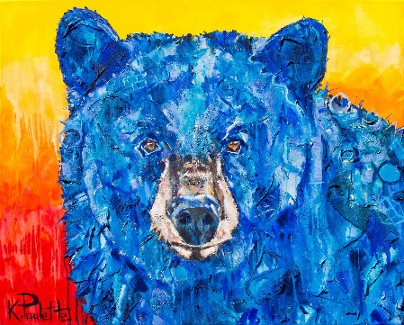
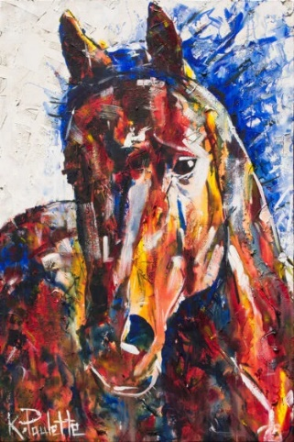
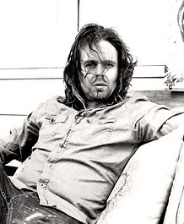
Year 6
Kent uses a rough texture in his pieces. This textured effect is achieved by using a brush to apply many layers of paint.
Key vocabulary and definitions
hue
contrast
abstract
composition
figurative
muted
Pointillism

My key artist: Kent Paulette
- Was a self-taught artist from North Carolina
- Uses uninhibited energetic brush strokes to create his paintings
- Finds inspiration in the natural world around him.
- He paints to help figure out his emotions rather than achieve a specific result.
What should I already know?
- I can use tints and shades to paint an object in 3D.
- I can paint with care and control to make recognisable objects.
- I can discuss real life experiences and how colours can appear differently.

Year 5
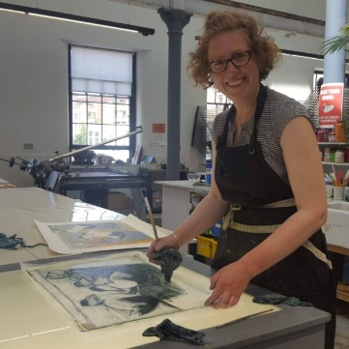
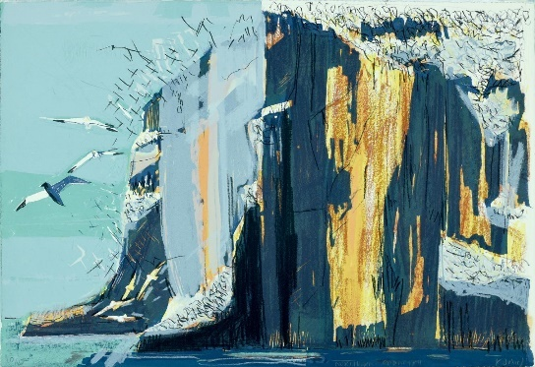
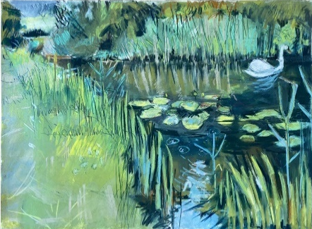
Kittie uses rough hand-drawn marks to create dramatic backgrounds, she uses layers of colour to make her paintings graphic.
Key vocabulary and definitions
botanical
tone
observation
composition
foreground
background
contrast

My key artist: Kittie Jones
- Kittie Jones is a fine based in Edinburgh.
- She is inspired by the full sensory experience of time spent outdoors, mostly along the coast of Scotland.
- Most of her work is completed outside.
- Jones’ focuses on drawing and printmaking, producing mixed media drawings on paper out in different landscapes.
What should I already know?
- I can alter colours using grey, black and white.
- I can discuss why colours may have been used.
- I can discuss my knowledge of artists and how they may influence other’s work.

