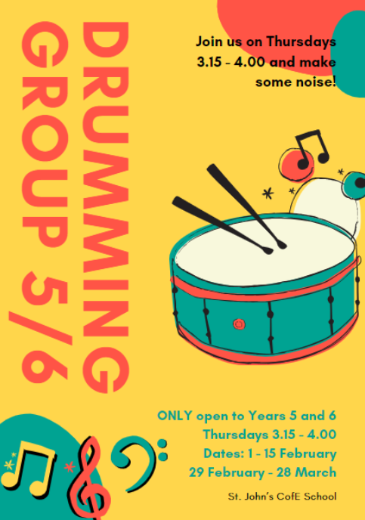
Music in KS2 Spring
A drumming group was offered to 30 Year 5 & 6 children in throughout the Spring term.


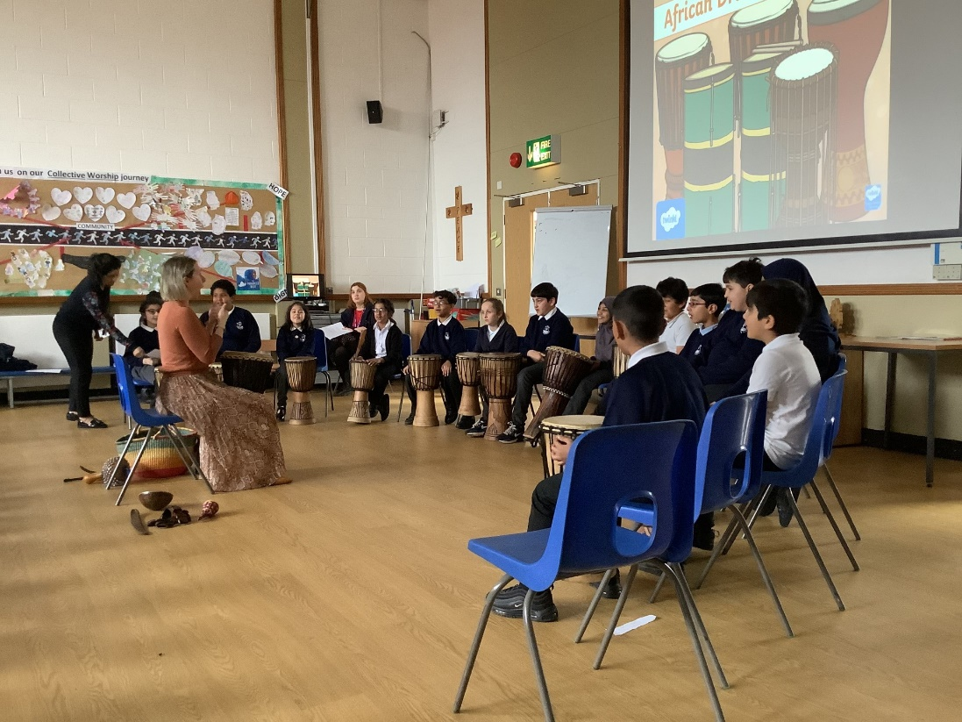
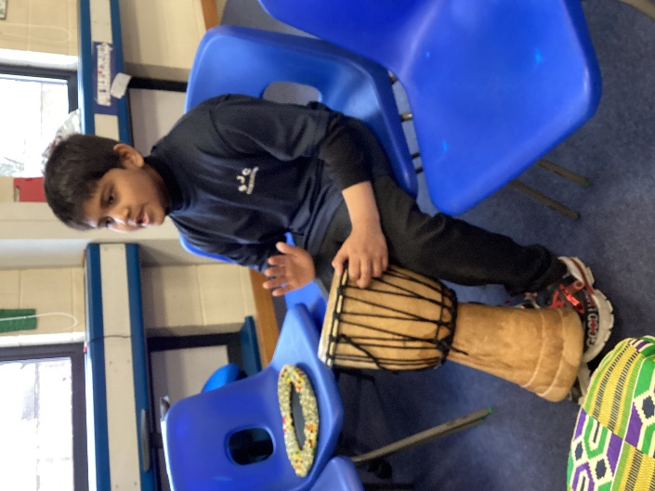
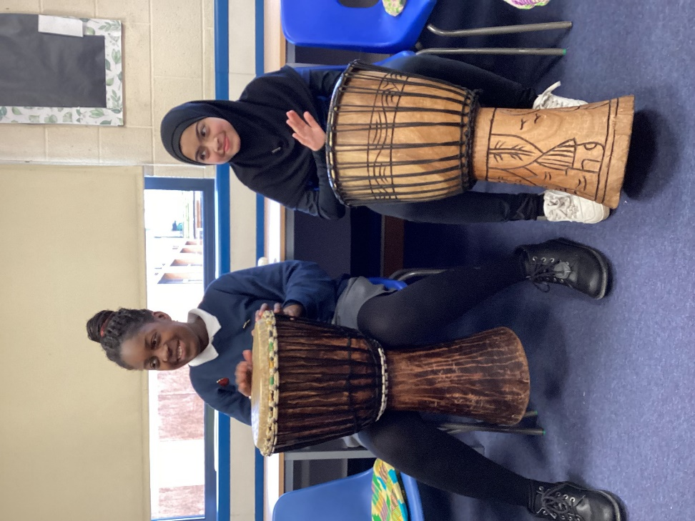
Community
Year 5 have been learning about African drumming and rhythm patterns in their music lessons and used their new skills when performing for parents in their class assembly.

