 | Autumn 1  (8 weeks) | Autumn 2  (7 weeks) | Spring 1  (6 weeks) | Spring 2  (5 weeks) | Summer 1  (5 weeks, 4 days) | Summer 2  (7 weeks)
Whole School Events | Roald Dahl Day – 15th September  National Poetry Day – 2nd October | Non-Fiction November (All Nov) | National Storytelling Week (Jan 30th to Feb 7th) | World Book Day (5th March) | National share a story month (May in classes) | Book World Cup!  (Books linked to countries/culture)
Competitions / Challenges | 500 words BBC & School Competition | Non-Fiction Challenge (All Nov) | International Book Giving Day (14th Feb) | World Book Day & Competition | National Writing Day Competition (25th June) | Book World Cup!  (Books linked to countries/culture)
Clubs | Fantastic Book Awards (Y6 Sept to March) & Brilliant Book Awards (Y2 Jan to May) led by JN
Nursery  English | ‘I am …unique’ | ‘I am …creative | ‘I am… kind’ | ‘I am…growing | ‘I am…discovering’ | ‘I am…ready’
Nursery  English | Literacy- Writing  • Write some familiar letters accurately  • Orally segment words with single sounds and identify the initial sound in words  • Apply some print knowledge to writing including writing own name
Nursery  Reading | 1:1 reading | 1:1 reading | 1:1 reading | 1:1 reading | 1:1 reading | 1:1 reading
Nursery  Reading | Literacy- Reading  - Identify some familiar letters  - Orally segment words with single sounds and identify the initial sound in words  - Apply some print knowledge to writing including writing own name
Reception  English- Core Texts | 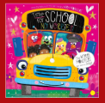  Fiction-Time for school no worries  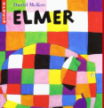  Fiction- Elmer  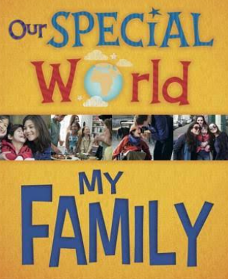  Non Fiction- Our Special world  My Family  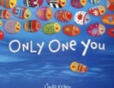  Only one you |   Poetry/Rhyme- Bonfire Night Poem  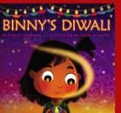Fiction- Binny’s Diwali  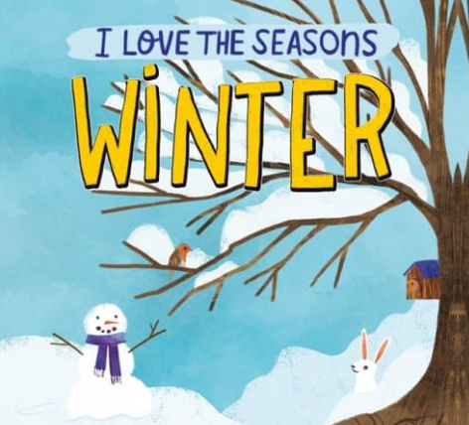  Non-Fiction- I love the seasons  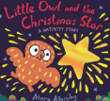  Fiction- Little Owl and the Christmas Star | 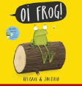Poetry/Rhyme- Oi Frog  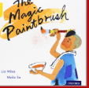  Cultural fiction- The magic paintbrush (Chinese NY link)  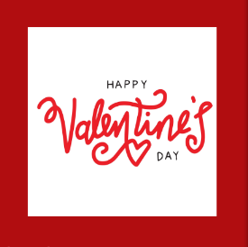  Fiction- I love you more than apple sauce- Valentines day link | 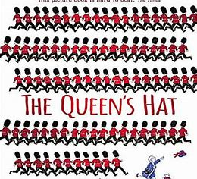  Fiction- The Queens Hat  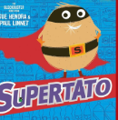  Fiction- Supertato  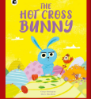  Poetry/Rhyme- Hot cross Bunny | 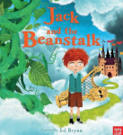  Fiction- Jack and the Beanstalk  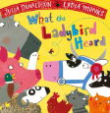  Poetry/Rhyme-What the ladybird heard  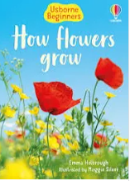  Non-Fiction- Usborne How flowers grow (Science Link) |   Fiction- We’re all wonders  Avocado baby  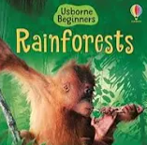  Non- Fiction- Usborne Rainforests (science link)  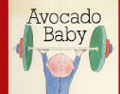  Fiction- Avocado Baby
Whole Class Shared Reading | The Colour Monster  Happy in our own skin  Super worm | Stick Man  The Night Before Christmas  Room on the broom  Funny Bones | The Gruffalo  The runaway Wok  We’re going on a bear hint | Oliver’s vegetables  Oliver’s fruit salad  Kitchen Disco  Mr wolfs pancakes | How to catch a star  Rosie’s Walk  Who’s in the loo | The rainbows fish  Marvellous me  Dear Teacher
Year 1  Talk Units | Bridging Unit:  Harry the Happy Mouse  (6-7 weeks)  Poetry, Songs and Rhymes  Stories with Familiar Settings  Information Texts | Genres/book:  Supertato  (6-8 weeks)  Integrated Unit:  Story as a Theme  Poems on a Theme  Instructions | Genres/book:  Penguins Possums and Pigs  (6 weeks)  Story as a Theme  Poems on a Theme  Information Texts | Genres/book:  Peter Rabbit  (6 weeks)  Information Texts:  Author Focus  Classic Stories  Traditional Rhymes | Genres/book:  The Great Outdoors  (5-6 weeks)  Stories with Familiar Settings  Non-fiction Texts:  Booklets  Traditional Rhymes | Genres/book:  How to Train a Train Unit  (6-7 weeks)  Integrated Unit:  Non-fiction texts:  Information, Instructions and Persuasion  Stories with Familiar settings  Traditional Songs and Rhymes
Year 1  Whole Class Shared Reading | Key texts, 1:1 reading & specific shared reading focus on Rooster Wore Skinny Jeans by Jessie Miller and Barbara Bakos. | Key texts & 1:1 reading & specific shared reading focus on Dog’s Don’t Do Ballet by Anna Kemp. | Key texts, 1:1 reading & specific shared reading focus on Be More Bernard by Simon Phillip & Kate Hindley. | Key texts, 1:1 reading & specific shared reading focus on Carnival of the Clocks by Nick Sharratt. | Key texts, 1:1 reading & specific shared reading focus on The Pencil by Allan Ahlberg. | Key texts, 1:1 reading & specific shared reading focus on Fairy Tale Pets by Tracey Corderoy and Jorge Martin.
Year 2  Talk Units | Bridging Unit:  The Way Home for Wolf  (6-7 weeks – extend writing to make 8 weeks)  Integrated Unit:  Information Poster  Non-Chronological Reports  Animal Adventure Stories | Genres/book:  Twisted Traditional Tales Unit  (5 weeks)  Traditional tales  Traditional Tales with a Twist  Suggested Unit  (2 weeks)  Instructions from Fighting Fit LPDS Unit | Genres/book:  Amazing Birds!  (11 weeks)  Non-Chronological Reports with integrated Riddles  Story as a Theme  Persuasion: Leaflets |  | Genres/book:  The Wind in the Willows  (6-7 weeks)  Classic Stories  Recount: Letters | Genres/book:  Aladdin Unit  (5 weeks, 4 days)  Integrated Unit:  Setting Description  Opinion of Characters  Recount: Diaries  Persuasion: Letters  Poem based on Lyrics  Three Wishes Composition  Persuasion: Poster, Flyer or Leaflet  Thought Paragraph  Narrative Chapter
Year 2  Whole Class Shared Reading | Key texts, 1:1 reading and specific shared reading focus on A Squash and a Squeeze by Julia Donaldson and Alex Scheffler. | Key texts, 1:1 reading and specific shared reading focus on Hansel and Gretel by Beth Woolvin. | Key texts, 1:1 reading and specific shared reading focus on Cottonwool Colin by Jeanne Willis and Tony Ross. | Key texts & 1:1 reading and specific shared reading focus on The Clockwork Dragon by Jonathan Emmett. | Key texts & 1:1 reading & specific shared reading focus on The Tear Thief by Carol Ann Duffy and Nicoletta Ceccoli. | Key texts & 1:1 reading & specific shared reading focus on Clean Up by Nathan Byron.
Year 3  LPDS English & Talk for writing units | Genres:  Narrative and information leaflets  (6 weeks)  Key Texts:  A bear called Paddington by Michael Bond | Genres:  Talk Unit: Folk Tales  (5 weeks)  Talk Unit: Letters  (2 weeks)  Key Texts:  The Greenling – Levi Pinfold  The Green Children by J Anderson Coats.  The Night Gardener  by Terry Fan  Various examples | Genres:  Talk Unit: Novel as a theme: Iron Man  (6 weeks)  Recounts: Diaries (incorporated in to Talk Unit)  Key Texts:  Iron Man by Ted Hughes  Various diary examples. | Genres:  Talk Unit: Historical Story, Non-Fiction & Narrative  (12 weeks)  Key Texts:  Queen of Darkness by Tony Bradman |  | Genres:  Talk Unit: Narrative Poetry  (6 weeks)  Key Texts:  Spider and the Fly by Mary Howitt.  Other various poems.
Year 3  Whole Class Shared Reading | Key texts, 1:1 reading and specific shared focus of The Proudest Blue by Ibtihaj Muhammad and S.K. Al. | Key texts, 1:1 reading and specific shared reading focus on The Hodgeheg by Dick King-Smith. | Key texts, 1:1 reading & specific shared reading focus on Stone Age Boy by Satoshi Kitamura. | Key texts, 1:1 reading and specific shared reading focus on James and the Giant Peach. | Key texts, 1:1 reading and specific shared reading focus on How to Train your Dragon by Cressida Cowell.
Year 4  LPDS English & Talk for writing units | Genres:  Bridging unit:  Non-fiction – The Loch Ness Monster  (4 weeks)  Explanation  (2 weeks)  Playscript  (2 week)  Key Texts:  How to fight a dragon’s fury by Cressida Cowell  Variety of explanation texts.  Playscripts. | Talk 4 Unit  Genres:  Tradition tales with Poetry  (7 weeks)  Key Texts:  Rumaysa: A Fairytale  By Radiya Hafiza  Various example texts. | Genres:  Stories with issues and dilemmas (4 weeks)  Persuasion  (2 weeks)  Key Texts:  Wallace and Gromit themed  A matter of loaf and death by Penny Worms  Variety of websites, adverts and texts. | Talk 4 Unit  Genres:  Documentary  including  explanation,  persuasion  and poetry  3-4 weeks  Narrative  Story  Openings  1-2 weeks  Key Texts:  Various non-fiction  The Last Bear by Hannah Gold | Genres:  Stories with a theme (3 weeks)  Poems with a structure  (1 week)  Information booklets  (2 weeks) *can link poems and information booklets with foundation subjects*  Key Texts:  The Mousehole cat by Antonia Barber  The Fisherman by Abbie Farwell Brown  Information books, leaflets and websites. | Talk 4 Unit  Genres:  Poetry  (3 weeks)  Newspaper reports (4 weeks)  Key Texts:  Macavity
Year 4  Whole Class Shared Reading | Key texts, 1:1 reading & specific shared reading focus on My Name Is Not Refugee by Kate Milner. | Key texts, 1:1 reading & specific shared reading focus on Malala’s Magic Pencil by Malala Yousafzai. | Key texts, 1:1 reading & specific shared reading focus on Young, Gifted and Black by Jamia Wilson. |  | Key texts, 1:1 reading & specific shared reading focus on The Secret of Platform 13 by Eva Ibbotson.
Year 5  LPDS English Units | Genres/books:  Bridging Unit:  The Lion, The Witch and The Wardrobe  (7 weeks)  Key Texts:  The Lion, the Witch and the Wardrobe by C.S. Lewis | Genres/books:  Legends  (7 weeks)  Key Texts:  The Legend of Gelert | Genres/books:  Earthlings  (6 weeks)  Key Texts:  Various extracts from Science Fiction texts. | Genres/books:  Suggested Unit:  'Inventors and Inventions'  or  Teacher’ choice of theme/text (TBC)  (5 weeks) | Genres/books:  Suggested Unit:  'Amazon Adventure'  or  Teachers’ choice of theme/text  (6 weeks) | Genres/books:  Jabberwocky  (7 weeks)  Key Texts:  Jabberwocky – Lewis Carroll  The Return of the Jabberwock - Oakley Graham
Year 5  Whole Class Shared Reading | Key texts, 1:1 reading & specific shared reading focus on Anglo-Saxon Boy by Tony Bradman. | Key texts, 1:1 reading & specific shared reading focus on Street Child by Berlie Doherty. | Key texts, 1:1 reading & specific shared reading focus on Kensuke’s Kingdom by Michael Morpurgo. | Key texts, 1:1 reading & specific shared reading focus on Cogheart by Peter Bunzl. | Key texts, 1:1 reading & specific shared reading focus on The Boy at the Back of the Class by Onjali Rauf
Year 6  Talk Units | Genres/books:  Bridging Unit:  The Nowhere  Emporium  (7 weeks) | Genres/books:  Biography Unit  (7 weeks) | Genres/books:  Classic Fiction Unit  Classic Fiction: Wizard  of Oz  (6 weeks) | Genres/books:  Older Literature Romeo and Juliet  (5 weeks) | Genres/books:  Last Push Pack/s: Wonder  Summer 1 (6 weeks)  Summer 2 (7weeks)
Year 6  Whole Class Shared Reading | Key texts, 1:1 reading & specific shared reading focus on There’s A Boy In The Girls’ Bathroom by Louis Sachar |  | Kick: Mitch Johnson |  | Key texts, 1:1 reading & specific shared reading focus on Wonder by RJ Palacio

