Curriculum Overview 2025-2026
Year: Reception
Subject |  | Autumn 1  7 weeks 3 days | Autumn 2  7 weeks | Spring 1  6 weeks | Spring 2  5 weeks | Summer 1  6 weeks | Summer 2  7 weeks
Topic |  | ‘We are…Special’ | ‘We are…Creative’ | ‘We are…Caring’ | ‘We are…Strong’ | ‘We are…Explorers’ | ‘We are…Growing’
Literacy  Drawing club |  | The Colour Monster  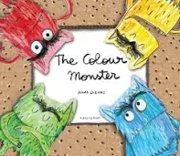  Elmer  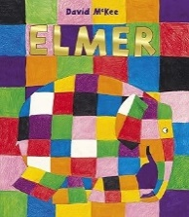  Only One You  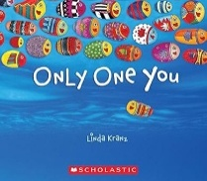  Binny’s Diwali  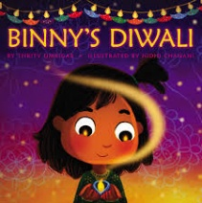 | The Hairy Toe  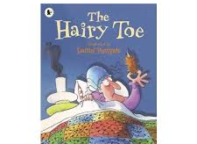  Whatever Next  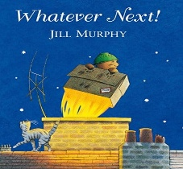  The Gingerbread Man  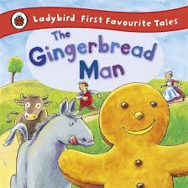  The Gruffalos Child  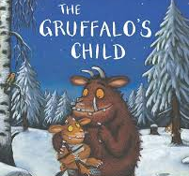  The Snowman (Video)  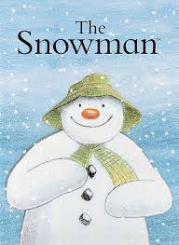  The Christmas Pine  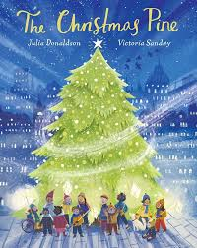 | The Lighthouse Keepers Lunch  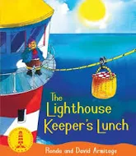  The Queens Hat  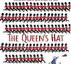  The Tiger who came to tea  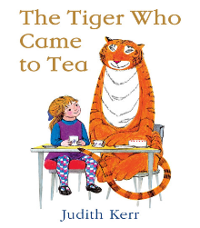  Stuck  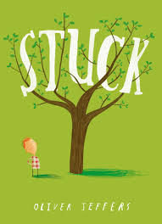  #  The Heart and the Bottle  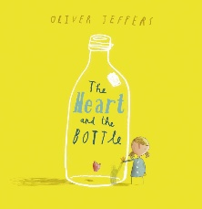  The Lion Inside  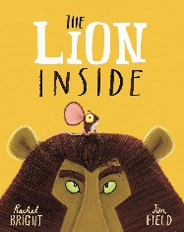 | Superworm  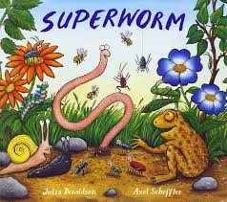  The Enormous Turnip  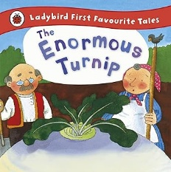  POPEYE- Video clip    What the Ladybird Heard  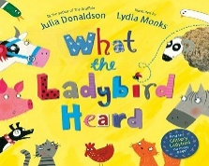  A little bit brave  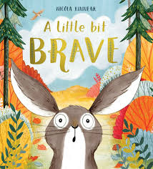 | The Way Back Home  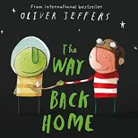  Beegu  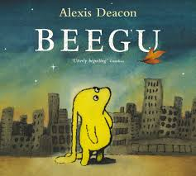  Aliens wear underpants  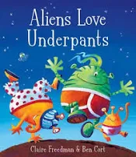  Going on a bear hunt  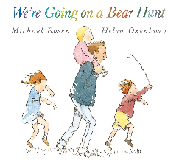  100 Decker Bus  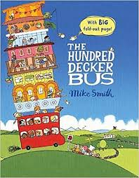  The Clangers (Video)  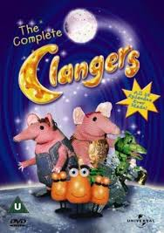 | Jack and the beanstalk  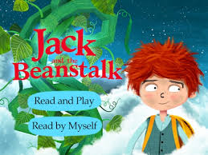  The Tiny Seed  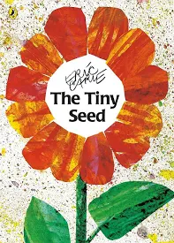  Bill and Ben (Video)  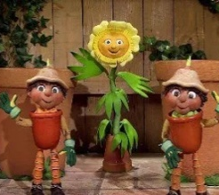  Oliver’s Vegetables  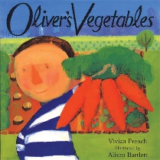  Little red hen  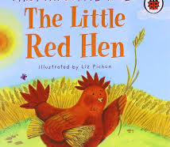  Titch  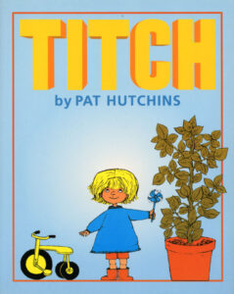
Phonics |  | Phase 2  Unit 1 s,a,t,p  Unit 2 i,n,m,d  Unit 3 g,o,c,k  Tricky words I, to, no | Phase 2  Unit 4 ck,e,u,r  Unit 5 h,b,f,ff, l,ll,ss  Tricky words go, the, into  Phase 2 consolidation  Phase 3  Unit 6 j,v,w,x | Phase 3  Unit 7 y,z,zz,qu  Unit 8 ch,sh,th,ng  Unit 9 ai,ee,igh,oa,oo,oo  Tricky words he, she, we,  me, be | Phase 3  Unit 10 ar,or,ur,ow,oi  Unit 11 ear, air, ure, er  Phase 3 consolidation  Tricky words was, my,  you, they, her, all, are | Phase 4  Unit 12 cvcc, ccvc, cccvc,  Cccvcc  Recap of Phase 2, 3, 4  phonemes as necessary- Interventions  Tricky words said, so,  have, like, some, come,  were, there, | Phase 4 consolidation  Recap of Phase 2, 3, 4  phonemes as necessary- Interventions  Tricky words little, one,  do, when, out, what
Reading |  | Daily 1:1 reading | Daily 1:1 reading  Guided reading groups | Daily 1:1 reading  Guided reading groups | Daily 1:1 reading  Guided reading groups | Daily 1:1 reading  Guided reading groups | Daily 1:1 reading  Guided reading groups
Maths-  Maths Mastery & White Rose Maths |  | Maths Mastery  Subitising  Counting-cardinality and ordinality  Composition  Subitising  Comparison | Maths Mastery  Counting, ordinality and cardinality  Comparison  Composition  Composition  Counting, ordinality and cardinality  White Rose Maths  Match, Sort and Compare  Measure and Pattern  2D Shapes | Maths Mastery  Subitising  Counting, ordinality and cardinality  Composition  Composition  Comparison  White Rose Maths  Mass and Capacity | Maths Mastery  Counting, ordinality and cardinality  Comparison  Composition  Composition  Composition | Maths Mastery  Cardinality, ordinality and counting  Subitising  Composition  Composition  Comparison  White Rose Maths  Length, height and time | Maths Mastrey  Review and assess Focus: Comparison  Review and assess Focus: Counting beyond 20  Review and assess Focus: Patterns within numbers to 10 Review and assess Focus: Automatic recall  Review and assess Focus: Understanding of numbers to 10  Review and assess Focus: Subitising on a rekenrek  White Rose Maths  Exploring 3D shapes  Visualise Build and Map
RE |  | Special People  WF Link – Islam, Buddhism, Sikhism | Christmas  WF Link – Hinduism – Diwali | Stories Jesus Heard | Easter | Prayer | Stories Jesus Told
Festivals and Celebrations |  | Diwali – 20th October 2025 – Hindu Festival  Stand- alone unit - Children to create Rangoli patterns/Diwali Divas/re-enact the story of Rama and Sita with a lit up path in the hall. |  | EYFS & Y6 (Buddies)  Holi – 4th March 2026 – Hindu Festival  Taught as a stand-alone lesson – Children to bring a white t-shirt into school – powder paint etc.
PSED  SCARF |  | Me and My Relationships | Valuing Difference | Keeping Safe | Rights and Respect | Being my Best | Growing and Changing
Understanding the world | Science | Humans |  | Living things and their habitats |  | Earth and Space
Understanding the world |  | Seasonal Changes
Understanding the world | History | My family | Remembrance Day  Bonfire Night | Homes | Nursery Rhymes | The Moon | Growing up
Understanding the world | Geography
Expressive Art and Design  KAPOW  Seasonal Units | Art | Autumn craft: Nature wreaths | Winter/Christmas craft: Threaded snowflakes & Salt dough decorations | Spring craft: Petal mandala suncatchers | Easter craft: Egg threading | Summer craft: Salt painting
Expressive Art and Design  KAPOW  Seasonal Units | Design Technology | Autumn: Hibernation boxes | Christmas: Sliding Santa Chimneys | Spring: Flower threading | Easter: Hanging eggs | Summer: Designing a rainbow Salad | Summer: Making a rainbow salad
Expressive Art and Design  KAPOW  Seasonal Units | Music | Exploring sound |  | Music and Movement |  | Musical Stories
Physical Development | Fine motor | Dough Disco  Squiggle Whilst you Wiggle  Funky Fingers
Physical Development | Gross Motor  PE | EYFS- Fundamental Skills | EYFS- Super worm | EYFS-Seaside | Swimming | EYFS- Jack and the beanstalk | EYFS- How to catch a star
 |  |  | Gymnastics | Dance- Circus | Swimming | Dance- Nursery Rhymes | Gymnastics

Trips and enrichments

