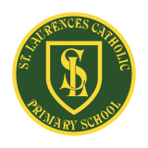
St Laurence’s Catholic Primary School Newsletter – Friday 16th October

Website: www.stlaurences.co.uk
Email: stlaurence@knowlsey.gov.uk
Instagram: www.instagram.com/stlaurencescps
Telephone: 0151 546 4733

Developing our gifts and talents for the good of all

This week at St Laurence’s
It has been a very busy week once again at St Laurence’s with a lot of fantastic activities and amazing learning taking place. We’ve had a lovely year 6 liturgy on ‘courage’ yesterday afternoon with some very important messages on different ways in which we can all show courage, we’ve had a group of children representing St Laurence’s at a local cross-country race with a number of brilliant performances and we’ve had 1G parents in school to work with their children on phonics. A quick reminder that next week is our last before half term, and that Friday next week is our annual Spooky Spell Day. Please read on for more information and enjoy your weekend.

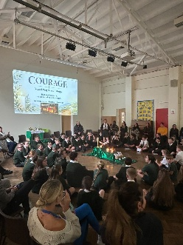
Year 6 Liturgy
A huge ‘well done’ to our year 6 children who made our liturgy such a special occasion yesterday afternoon. Having looked at courage in Monday’s assembly, it was a lovely way the end the week. I particularly liked the prayers at the end, asking God to help us with being courageous in lots of different situations. Thank you also to our brilliant year 6 staff who worked so hard to organise and practice this week, and to so many parents, carers and babies in prams who genuinely make these moments a special celebration.


1G Phonics Drop-In
It has been really great to see so many parents coming into school over these last few weeks to learn alongside their children over phonics. As we all know, early reading – and learning how to read well – is a huge part of every child’s education. This week it was the turn of Mr Gibson’s class and looking at the cutting, sticking and reading practice I saw and heard when I popped into the hall, it was a really enjoyable hour for everyone involved. Thank you to everyone who managed to call in and take part, and thank you to AnnMaria Miller for her continued support in this work.

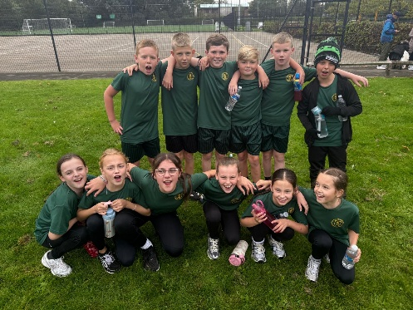
Cross Country
As everyone in Kirkby knows, the sporting talent on show at St Laurence’s is of the highest calibre. This week, a new string to our bow came in the shape of a local cross country race. In the boy’s section of the race, out of a field of around 130, our very own Blake Murphy came 2nd – an amazing effort given that this was our first cross country race of the season. In the girl’s section of the race, again out of a large field of around 80, Monica Dempsey stormed home to a top 10 finish. Cross country is often an event that children find quite tough, but as you can see from these two results, and from the brilliant efforts of our other runners, at St Laurence’s we are achieving outstanding results. A huge thank you to our staff, Mrs Purchase and Mr Grant, who give up their time to give our children the chance to take part. And of course a huge well done to all of the children who took part – we are very proud of you all.

27/28 School Dates
We have set our school dates for next academic year 2027 – 2028. They will follow the pattern we have had in place this year, with INSETs at the start of autumn and spring terms as well as in the middle of our longer half terms (autumn 1, autumn 2 and spring 2). Please make a note of these and ensure that any holidays are not taken during times when the children are expected in school. These dates will be sent out on school spider alongside this newsletter and will be on the school website also.

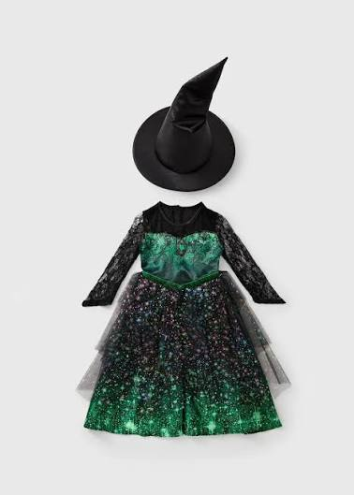
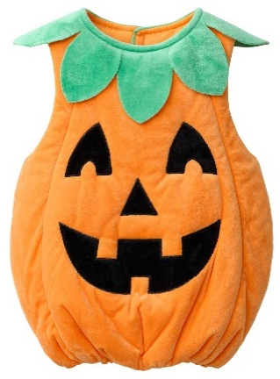
Spooky Spell Day
Our annual ‘Spooky Spell Day’ will take place next Friday 23rd October, and we are looking forward to a fun way to celebrate the end of the half term. Children are welcome to come dressed in their spooky-themed costumes and bring their £1 on the day. As this is a whole-school event involving children from nursery to year 6, we kindly ask parents and carers to choose costumes carefully. Please ensure outfits are fun and suitable for all ages, avoiding anything overly frightening and any costume props such as knives, axes, swords or other weapons. Thank you for your continued support in helping us make Spooky Spell Day a fun, inclusive and enjoyable celebration for everyone in our school community.

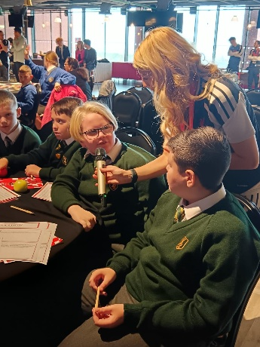
United Nations Schools Event at Anfield
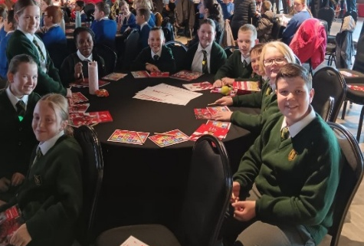
We were incredibly proud of our School Leaders who recently represented our school at a United Nations sustainability and climate change event at Anfield, organised by the LFC Foundation. Throughout the day, our children demonstrated outstanding leadership, sharing thoughtful ideas about how we can care for our world and create a more sustainable future. They contributed confidently to discussions, worked collaboratively and showed a real passion for making a positive difference. Their maturity, enthusiasm and commitment to helping others were a wonderful reflection of our school values, and they were excellent ambassadors for our school community. Well done to all involved on representing us so brilliantly, and thank you to Mr Cushion and Mrs Faulkner for taking the children along.

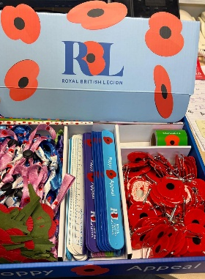
Poppy Appeal Next Week
As we approach Remembrance Day, we are proud to support our annual Poppy Appeal charity collection. Poppies and remembrance items will be available to buy after school from the main office next week, and any donation, no matter how small, will be gratefully received. Supporting this important cause is a wonderful way that we at St Laurence’s live out our Catholic ethos by showing compassion, generosity and care for others. Thank you for helping us remember those who have served and sacrificed, while supporting the valuable work carried out by the charity.

Dates for the Diary
Wed 21st Oct | Class 1B phonics parent drop-ins – 2pm
Fri 23rd Oct | School closes for half term at 3.15pm
Mon 2nd Nov | School returns
Wed 4th Nov | RL Maths parent drop in – 2pm
Fri 6th Nov | Immunisations for whole school
Sat 7th Nov | Year 4 Super Saturday @All Saints
Wed 11th Nov | RK Maths Parent drop in – 2pm
Thur 12th Nov | Year 5 Liturgy (Love) – 2:45pm
Fri 13th Nov | Children in Need – Own clothes (£1 donation)
Wed 18th Nov | 1G Maths drop in – 2pm
Wed 25th Nov | 1B Maths drop in – 2pm
Fri 27th Nov | Class photographs
Mon 30th Nov | INSET Day – School Closed
Thur 3rd Dec | EYFS/KS1 Christmas play – 10am & 2pm
Tue 8th Dec | Nursery Christmas play – 10am & 2pm
Thur 10th Dec | Christmas Bingo – 5pm – 6:30pm
Fri 11th Dec | KS2 Carol concert – 9:30am & 2pm
Mon 14th Dec | EYFS/KS1 Christmas Dinner
Tue 15th Dec | KS2 Christmas Dinner
Wed 16th Dec | Christmas Jumper Day
Fri 18th Dec | School closes for Christmas – 1:15pm: Own clothes day (£1)

School Clubs
Monday | Dodgeball: Years 3 & 4  3.15pm – 4.15pm  (Mr Cushion)
Tuesday | Football: Years 3 – 6 Girls  3.15pm – 4.15pm  (Mr Grant)
Wednesday | Choir: Years 3 – 6 (lunch)  12.25pm – 12.55pm  (Mrs Faulkner)
Thursday | Football: Years 5 & 6 Boys  3.15pm – 4.15pm  (Liverpool Foundation & Mr Grant)

Weekly Award Winners





 | Star of the Week | Kirkby Child | Gospel Values
Nur | Jaxon McGowan | Emilyrose Dowman | Esmae Holiday-Smith
RK | Harper Dempster | Dotty-Jo Kendrick | Soraya Farrell
RLM | Joni Locke | Gracie Green | Elsie-Mae Keating
1B | Renaya Halliday | Elsie Bowers-Jones | Sydnee Taylor
1G | Kai Sullivan | David Madubuike | Cecilia Stelfox
2O | Kyrah Okorode | Finley Howard | Nicolas Placedino
2R | Rosie Molyneux | Emily Teske Guithi | Alfie Marshall
3MB | Emilia Richardson | Lillie-Rose Brooks-Coletta | Oliver Kenny
3R | Star Balmer | Iris McGorian | Thomas Davies
4B | Rosa Flaherty | Charlotte Lally | Maria Nascimento
4G | Oliver Austin | Lillian Sproule | Esme Hedges
5F | Davy Baines | Isaac Reynolds | Ivy Spencer
5P | Joel Jevons | Mia-Maria Goodwin | Harrison Warwick
6H | James Dunne | Blake Murphy | Lewis Slade
6K | Joshua Kearns | Leo Nolan | Lois Martin

Kirkby Child Award highlights children who are: respectful, honest and truthful, show a positive attitude, resilient, confident, a good communicator, polite, committed and hardworking, aspirational and ambitious.

We hope you have a fantastic weekend, and we will see you all bright and early on Monday morning

From St Laurence’s staff

