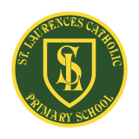
St Laurence’s Catholic Primary School Newsletter – Friday 9th October

Website: www.stlaurences.co.uk
Email: stlaurence@knowlsey.gov.uk
Instagram: www.instagram.com/stlaurencescps
Telephone: 0151 546 4733

Developing our gifts and talents for the good of all

This week at St Laurence’s
As we hurtle towards half term the pace of life has certainly quickened this week in school with all sorts of amazing activities taking place. We’ve had our year 2 football team going deep into a tough competition at Finch Farm, we’ve had some brilliant parents in school learning about phonics and of course we’ve had our first parents evening which was attended fantastically well. Please make a note of the dates for your diary – in particular that the first school photographs day is on Wednesday 14th so get those hair appointments booked! Also please note that at a couple of clubs are not taking place next week as staff are attending other events. Other than that, lots of information to find out about so please read on for all the latest!


Year 5 musicians rock the top corridor
We would like to thank Miss Wright from All Saints for delivering a fantastic music lesson to our year 5 children this week. The children thoroughly enjoyed the experience and embraced every opportunity to develop their musical skills and confidence. It was wonderful to see so much enthusiasm and talent on display, with some great young musicians really shining throughout the session. The lesson was a huge success, and the children are already looking forward to welcoming Miss Wright back for another session next week. Thank you to everyone involved in making this such a positive and inspiring opportunity for our pupils.

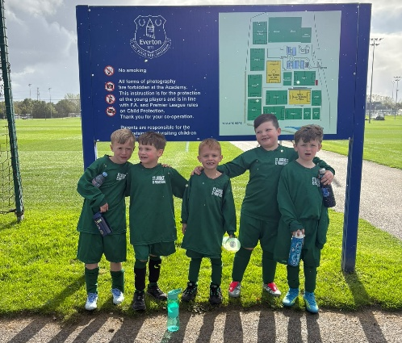
Year 2 football team
We would like to congratulate our year 2 football team for their fantastic performance at the recent competition held at Finch Farm. The children showcased some amazing football skills throughout the tournament, demonstrating great teamwork, determination and sportsmanship. A special mention must go to Axel Gordon, who stole the show with goals galore and played a key role in the team's success. Although the team just fell at the final hurdle in the semi-finals, they should be incredibly proud of their achievements. If this competition was anything to go by, the future of St Laurence football is certainly in safe hands (and feet)!


Thank you, parents
Thank you to all the parents and carers who attended our Parents’ Evening. It was wonderful to have the opportunity to talk together about your children’s learning, progress and wellbeing. We know that children achieve their best when we in partnership, supporting and encouraging them. Your engagement is invaluable, and we are grateful for the positive relationships we continue to build together. Thank you for helping us ensure that every child has the opportunity to succeed.


Front gate closed
Safeguarding is the most important part of our work here at school. As such this is a kind request, that all parents and carers to ensure that the main entrance gate is fully closed after entering or leaving the school site. Keeping this gate closed is an important safeguarding measure and helps us maintain a secure environment for all children, staff and visitors. While it may only take a moment, this simple action plays a vital role in supporting the security of our school throughout the day. We appreciate your cooperation and thank you for working with us to help keep our school community safe.

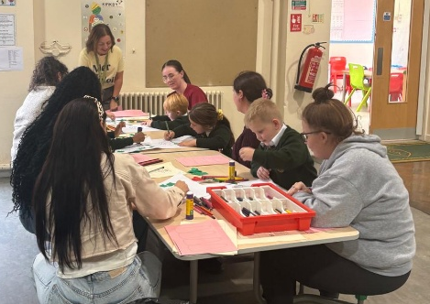
RK Parents Drop-in
We were delighted to welcome so many RK parents and carers to our recent Phonics Drop-In Session with AnnMarie Miller. Thank you to everyone who attended and took the time to see how we teach early reading in school. Learning to read is one of the most important skills a child will ever develop, and the support children receive both at home and at school makes a huge difference to their success. It was wonderful to see such strong engagement from our families and the enthusiasm shown for supporting children's reading journeys. We loved seeing so many of you there and look forward to continuing to work together to help every child become a confident and successful reader. Next week it is the turn of 1G, we look forward to welcoming you along.

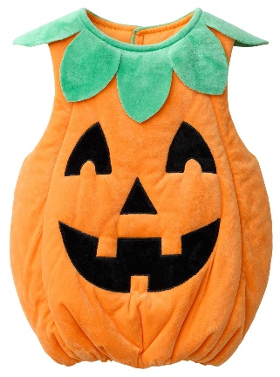
Spooky Spell Day
An early reminder that Spooky Spell Day will take place on Friday 23rd October for £1 as we are looking forward to a fun end to the half term. We would ask parents and carers to choose costumes carefully, remembering that our youngest children will also be taking part in the day. Costumes should be spooky and enjoyable rather than frightening, so please avoid terrifying outfits and masks, blood and gore, or any inappropriate outfits. We also ask that children do not bring props such as knives, axes or other weapons, even as part of a costume. Thank you for your support in helping us ensure that the day is fun, inclusive and appropriate for all members of our school community.

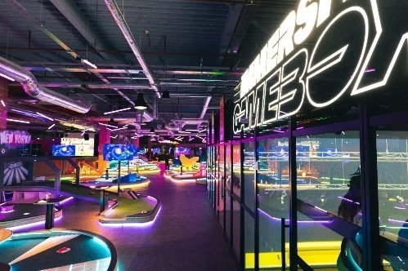
Gravity Max Attendance Competition
We know that attendance is key to a successful education, so we have set up a fantastic competition to end the half term. Over the next two weeks, every child who achieves 100% attendance and is in school every day during this period will be entered into a draw, which will take place on Friday 23rd October, with prizes awarded that day. We are delighted to offer tickets to Gravity Max, providing free entry and access to activities for our lucky winners. Attendance is such an important part of school life, helping children to make the most of their learning, build positive relationships and develop good habits for the future. Let's all make a big effort over the next two weeks and give every child the chance to be included in the draw!
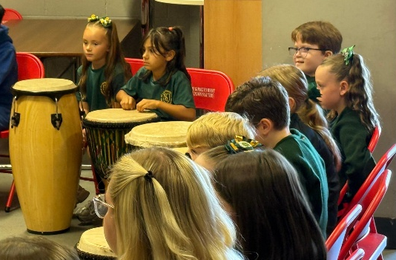
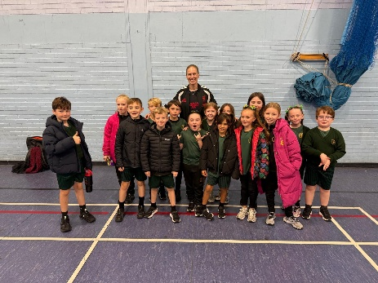
Black History Month
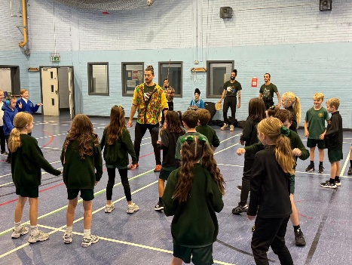
We would like to congratulate the group of children who recently represented our school at the Black History Month event organised by the LFC Foundation. Throughout the day, they took part in a range of engaging music and drama activities, learning more about an important aspect of our shared history and the experiences of others. The children were a credit to our school, demonstrating excellent behaviour, enthusiasm and respect throughout the event. They gained valuable knowledge and understanding about a significant issue, while also having a fantastic time. We are very proud of the way they represented our school and the positive example they set for their peers.

No Dodgeball or Girls Football next week
A reminder to parents and carers that there will be no Dodgeball Club or Girls’ Football Club on Monday next week due to staff attending other school events. We apologise for any inconvenience this may cause and appreciate your understanding. Both clubs will resume as normal following this cancellation. Thank you for your continued support and cooperation.

Dates for the Diary
Wed 14th Oct | Class 1G phonics parent drop-ins – 2pm
Wed 14th Oct | School Photographs – Individual & Family
Thur 15th Oct | Year 6 Liturgy 2.45pm
Mon 19th Oct | School Photographs – Class
Wed 21st Oct | Class 1B phonics parent drop-ins – 2pm
Fri 23rd Oct | School closes for half term at 3.15pm

School Clubs
Monday
Tuesday
Wednesday | Choir: Years 3 – 6 (lunch)  12.25pm – 12.55pm  (Mrs Faulkner)
Thursday | Football: Years 5 & 6 Boys  3.15pm – 4.15pm  (Liverpool Foundation & Mr Grant)

Weekly Award Winners


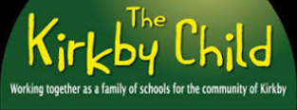


 | Star of the Week | Kirkby Child | Gospel Values
Nur | Harper Cox | Arlo Fox | Myla Ainsworth
RK | Daisy Cave | Cleo McIver | Skyler O’Connell
RLM | Tommy Kendrick | Koby Williams | Harlow Dempster
1B | Isla Deane | Hanoch Bibby | Florence Jones
1G | Brody Blackall | Emilia Cox | Lucia McVeigh
2O | Lola Fuller | Jace Waite | Freya Shaw
2R | Shaya Rafferty | Nancy Twigg | Carter Coyle
3MB | Lucas Doran | Halle McPadden | Cienna Rafferty
3R | Jack Martindale | Iris McGorian | Abigail riley
4B | Harley Fiocca | Harper Hughes | Cleo Christie-Scotland
4G | Jaxx-James Siner | Lillian Sproule | Noah Jones
5F | Ivy Spencer | Billy Chrystal | Freddie Reid-Watkinson
5P | Huner Arnold | Leah Carey | Sophia Konieczna
6H | Isabella Doran | Mason Riley | Layton Hoy
6K | Jason Chean | Mason Sutherland | Marcie Horrocks

Kirkby Child Award highlights children who are: respectful, honest and truthful, show a positive attitude, resilient, confident, a good communicator, polite, committed and hardworking, aspirational and ambitious.

We hope you have a fantastic weekend, and we will see you all bright and early on Monday morning

From St Laurence’s staff

