
Living Statues
Have you heard of a living statue? They are people who pose as statues. They often wear statue-like make-up and can stand very still! Look at the pictures of some living statues below.

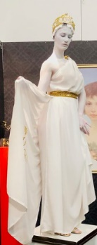
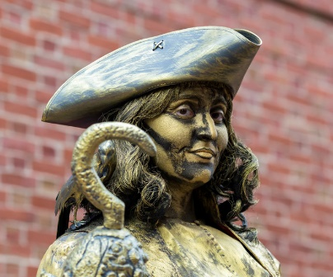
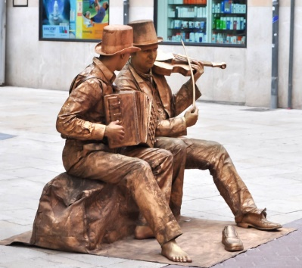



Source: E Rinaldi
Photographs or drawings of your statue poses

- Can you pretend to be a statue?
- What will you wear?
- What position will you stand in?
- How long can you remain still for?
- Can you time it?

Source: J Hoey
Source: M Verch

