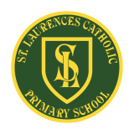
St Laurence’s Catholic Primary School Newsletter – Friday 14th November

Website: www.stlaurences.co.uk
Email: stlaurence@knowlsey.gov.uk
Instagram: www.instagram.com/stlaurencescps
Telephone: 0151 546 4733

Developing our gifts and talents for the good of all
This week at St Laurence’s
One of the wettest Fridays of the year brought this week to a close – however, if you look at the photos at the end of this newsletter, you’ll see it did nothing to dampen spirits at St Laurence’s. As always, the children here are learning, having fun and enjoying the wonderful atmosphere our staff provide. This week has seen year 4 learning about electricty, year 6 swimming in their pyjamas and that faithful St Laurence’s servant – Mr Kenny – getting a well deserved pie to his face. Lots of other important information so please read on and get those wellies ready for a wet weekend!


Parents in School
As part of our continual review of policies and procedures, I would like to take this opportunity to remind parents and carers of an important safeguarding point. As you know, the safety of all children and staff at St Laurence’s is our highest priority, and we are proud that this was recognised in our most recent Ofsted report. To help us maintain these high standards, please ensure that you only enter the school building through the main entrance. We also kindly ask that, when you arrive at the front entrance, you remain in the small entrance area – even if the automatic doors open for a child or member of staff entering or leaving the building. Thank you for your continued support and cooperation in keeping everyone safe.

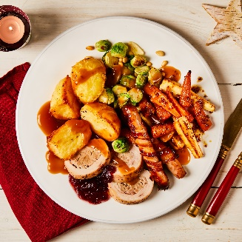
Christmas Lunch
On the 10th and 11th of December, we will be serving Christmas lunch for children in Key Stage 1 and Key Stage 2 respectively. On each of these days, the children in the opposite key stage who usually receive a hot meal will be provided with a packed lunch. Please be assured that the packed lunches are nutritious, balanced and more than enough to satisfy even the hungriest of children. We wanted to give parents and carers advance notice so that everyone is aware of the arrangements for these days. Thank you for your understanding and support.
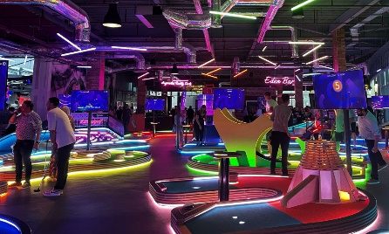
Max Attendance for Gravity Max (©Mr Cushion)
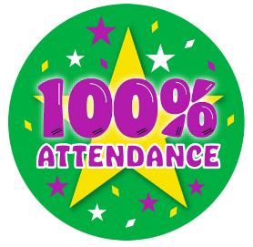
St Laurence’s is excited to announce a special attendance competition! We are giving away two Golden Tickets for an action-packed visit to Gravity Max, which can be used any time up to and including 31st December. Each child who attends school for a full week will earn one ticket for the prize draw, this means every child can collect up to four tickets during the competition. The more full weeks they attend, the more chances they have to win! Gravity Max, located in Liverpool One, offers a fantastic range of activities for children. Each Golden Ticket gives three free activities out of five, including bowling, VR experiences and crazy golf. We all know how important good attendance is, and through this fun competition we hope to see lots of our amazing children achieving 100% attendance. So, in the words of Mr Cushion … let’s aim for max attendance and max fun!
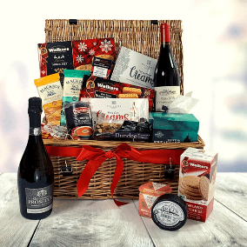
Christmas Fridays
Over the next three Fridays we will have an ‘Own Clothes Day’ as we collect items for our Christmas Hampers – all of which will be given away as prizes during raffles and bingo events over the coming weeks. Please see below the donations we are asking for over the coming weeks – and for the first of many times, thank you so much for your generosity. It is genuinely appreciated and goes a long way to ensuring we can provide the best education possible for your children. If anyone has a few extra Festive Hamper Goodies (gift sets, cakes, crackers, stuffing etc) then feel free to pop them into the main office any time over the next few weeks as well!
- Friday 21st November – Bottles
- Friday 28th November – Toiletries
- Friday 6th December – Chocolates

First Holy Communion Preparation
Fr Sean has asked us to pass on the following message to any parent/carer of a year 4 child who intends to make their First Holy Communion this year. Those families are invited to the start of their preparation Masses and meetings for the living out the sacraments. You are welcome to attend St Joseph & St Laurence’s Church for Mass either:
- 7pm Friday 28th November
- 11am Sunday 30th November
- 6pm Sunday 30th November

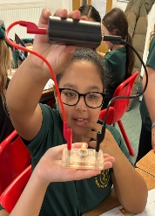
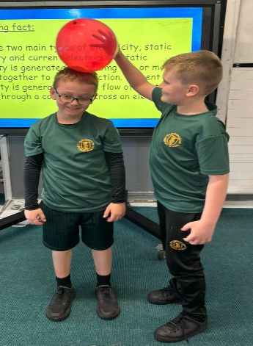
Year 4 science
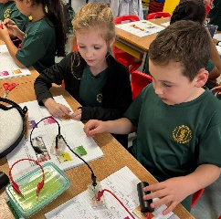
As I have mentioned before, science is a brilliant subject throughout a child’s education – learning all about the world around us really lights a spark in every learner. Mrs Purchase’s class is no different. This week the children have been investigating circuits, learning all about batteries, input and output, and using that most famous of primary school resources – crocodile clips. You can always tell when children are feeling happy in school by their faces, and to look at this group it shines through on every picture. When children feel this way, their ability to learn shoots through the roof. Well done to all of you!

6S swimming
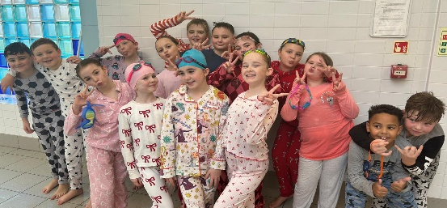
6S completed their swimming lessons this week and have made amazing progress across the last two weeks. So much so that yesterday they took part in a rite of passage for every child – they swam in their pyjamas. We are extremely proud of all the children who represented our school so well during their lessons, and as always they have made fantastic progress. Well done everyone.


Admissions Policy
As a Catholic School we have been advised by the archdiocese that we have to consult with you, as parents and carers, over our Admissions Policy. This year we organise admissions for the academic year 2027 – 2028. The proposed policy is currently on our website under the admissions section. If you are able, please take to time to read through the policy and if you have any thoughts or comments then let us know via email or a letter to school. Thank you.
Children in Need Celebrations
I imagine most of us are well versed in the amazing work this charity does day after day around the country. Our children spent time today learning all about this work and having a bit of fun too. No more explanation from me needed. Feast your eyes on the images below to see what went on today!
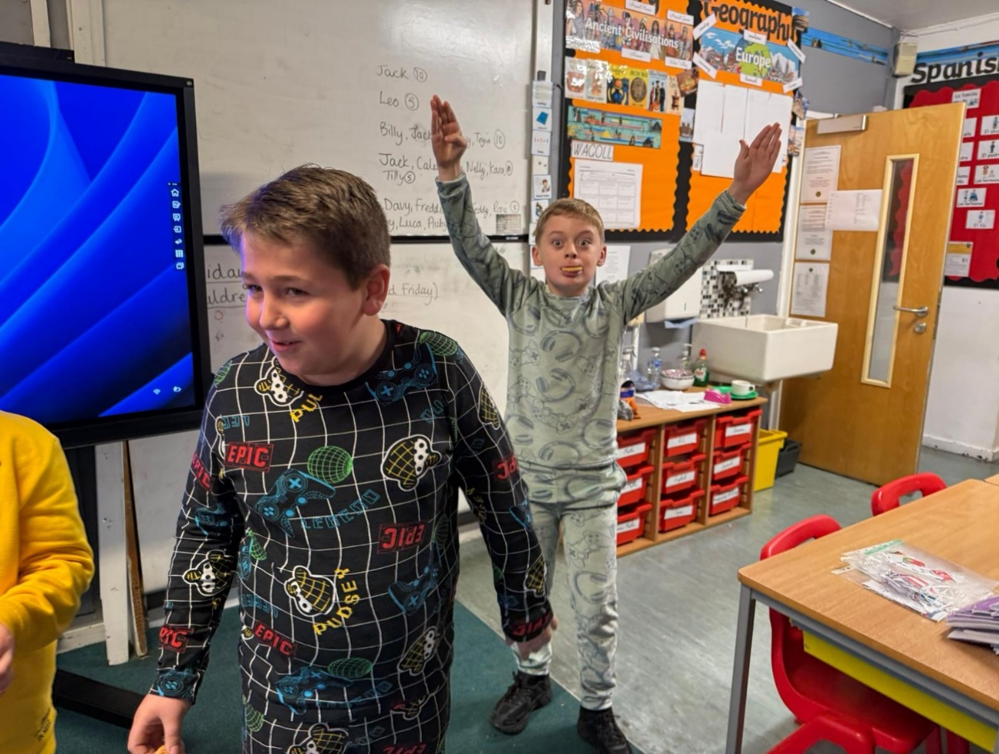
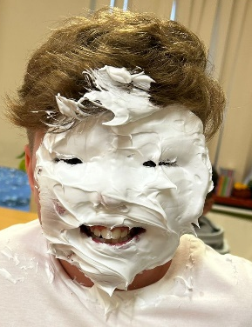
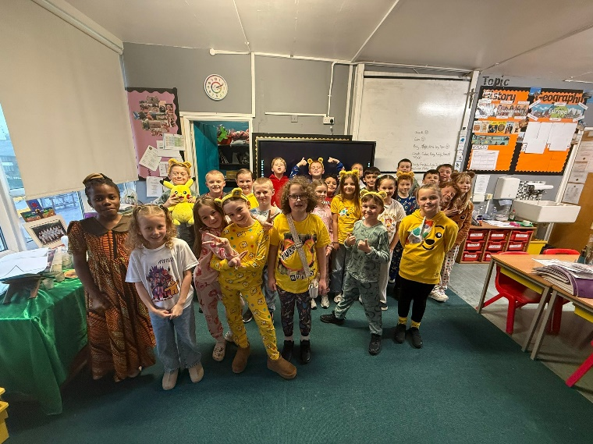
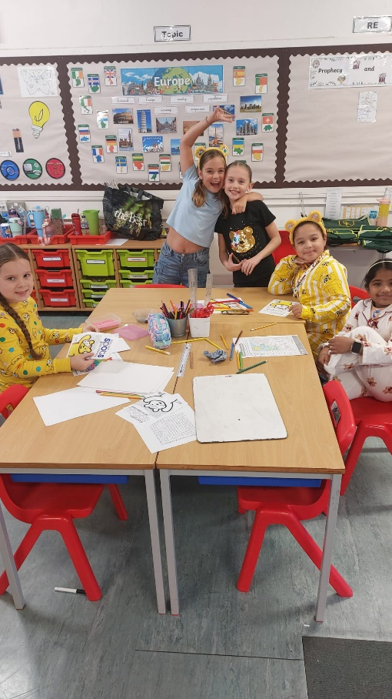
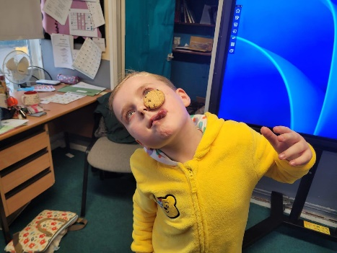
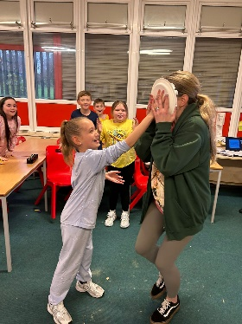
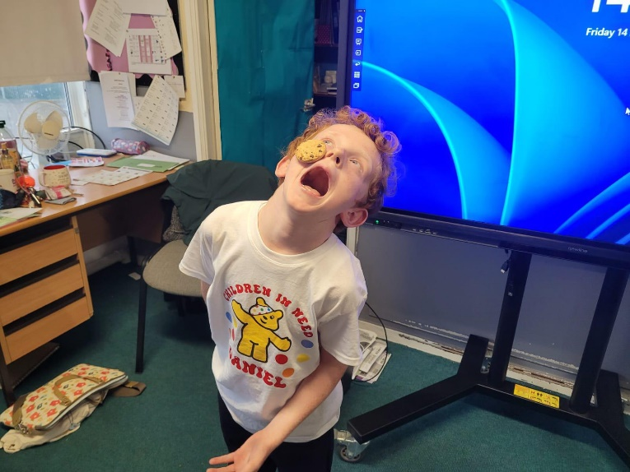
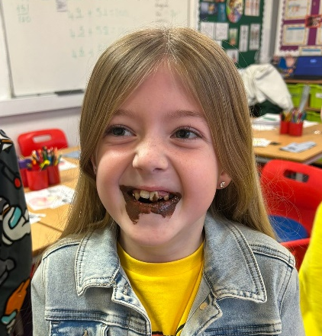
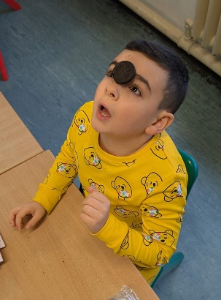
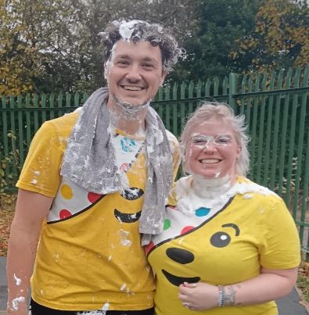
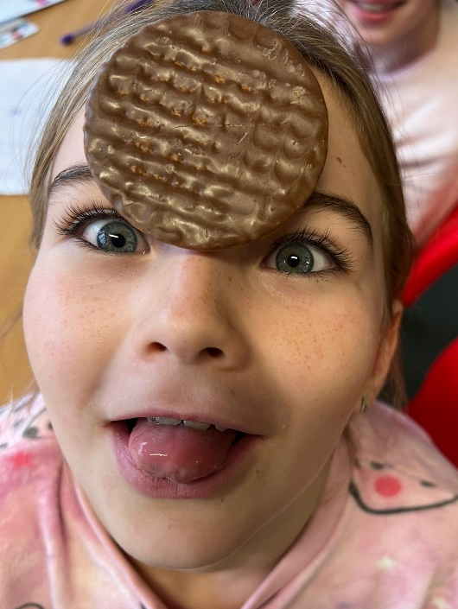
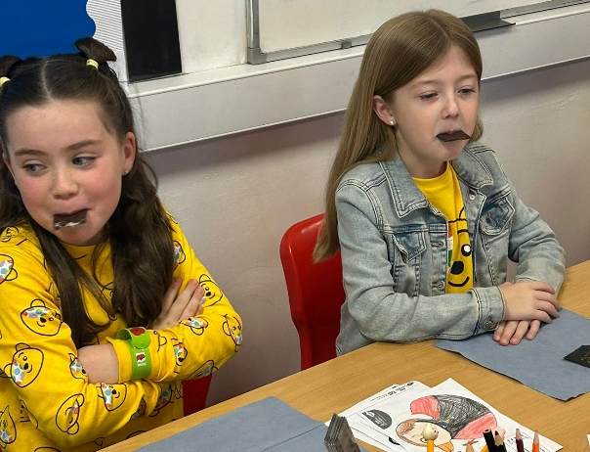
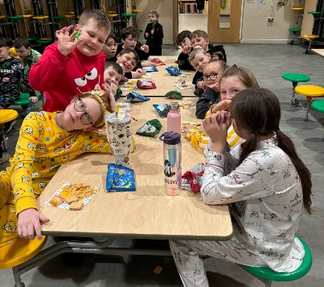

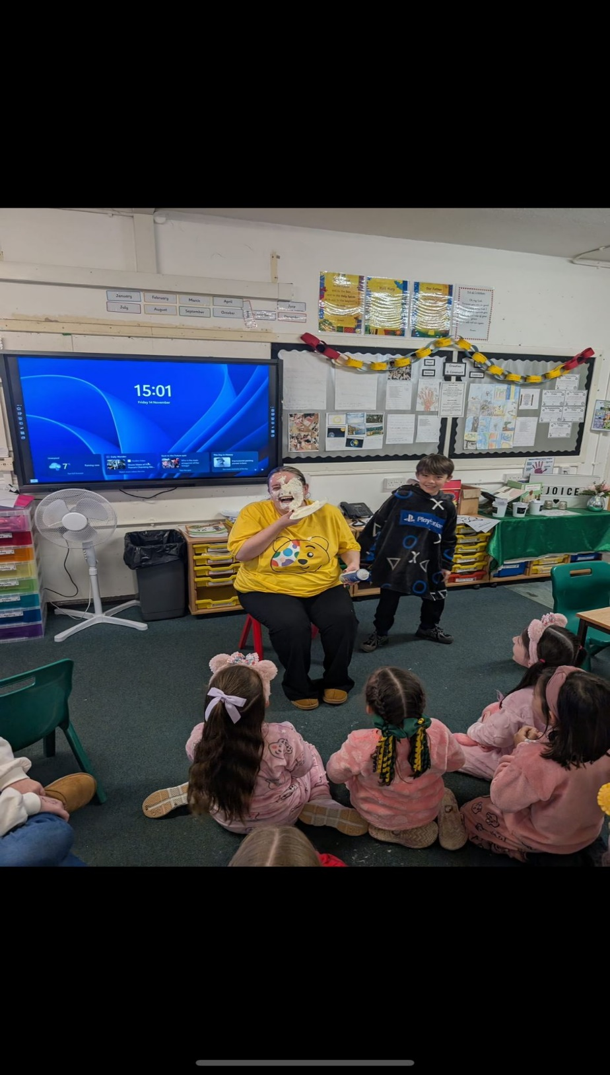

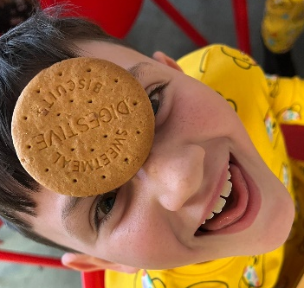






Weekly Awards

 | Kirkby Child | Star of the Week | English Star | Maths Star | Attendance
Nur | Annie Reid-Watkinson | Billie Bagan |  |  | 90.4%
RS | Kai Sullivan | Nevaeh Brennan | James Farish | Jordan Ross | 94%
RL | Chisom Obi | Jude McNabb | Finley Gallagher | Olivia Stott-Currie | 95.3%
1S | Nicholas Placedino | Rosie McGorian | Lola Fuller | Alfie Carroll | 97%
1L | Rosie Clarke | Nancy Twigg | George Seasman | Rosie Molyneux | 92.4%
2S | Renesmee Slade | Sienna Smith | Thomas Davies | Oliver Kenny | 99.2%
2L | Maggie Jones | Cater Thompson | Lucas Doran | Leo Crelin | 99.2%
3S | Noah Jones | Savannah Farrell | Dax Faulkner | Nancy Walsh | 94.5%
3L | Harper Hughes | Logan Sutherland | Harlen Farrell | Scarlett Ainsworth | 92%
4S | Piper Farish | Luke Davies | Abigail Bibby | Sienna Downey | _{89.2%}
4L | Flynn Anderson | Davy Baines | Daniel Powell | Annie Quinn | 96.9%
5S | Thomas Reid | James Dunn | Kendal Hamid | Lewis Slade | 91.6%
5L | William Powell | Mason Sutherland | Reuben Shaw | Marcie Horrocks | 92%
6S | James Murray | Mason Wainwright | Leticia Queiroz Valli | Louie Soon | 93.3%
6L | Christian Bonea | Maggie Craig | Darcy McCarthy | Charlie McSween | 92.3%

Kirkby Child Award highlights children who are: respectful, honest and truthful, show a positive attitude, resilient, confident, a good communicator, polite, committed and hardworking, aspirational and ambitious.

We hope you have a fantastic weekend, and we will see you all bright and early on Monday

From St Laurence’s staff

