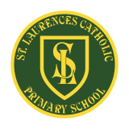
St Laurence’s Catholic Primary School Newsletter – Friday 7th November

Website: www.stlaurences.co.uk
Email: stlaurence@knowlsey.gov.uk
Instagram: www.instagram.com/stlaurencescps
Telephone: 0151 546 4733

Developing our gifts and talents for the good of all
This week at St Laurence’s
It’s been great to see the children return after their holiday, refreshed and ready for another half term of fun and learning! We’ve begun with a bang in year 6 as they started their swimming lessons, this week has also saw year 5 exploring meteorites and craters in their science lessons, and we’ve got more good news for two different members of staff as well! Attached with this weeks newsletter are the key dates for your diary up until Christmas, so please make a note of any that will effect you. It’s great to see you all back, the countdown to Christmas has now officially begun!

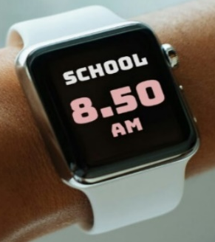
Thank you!
I want to start this week with a big thank you to all the families who have managed to get their children in to school by 8.50am this week. As we mentioned before, those first minutes in school are so important and it has been great to see so many of our children settling in at the same time as their friends. Over time, as the children complete more and more of their key skills work, we will really begin to see the benefit in their academic work as well.

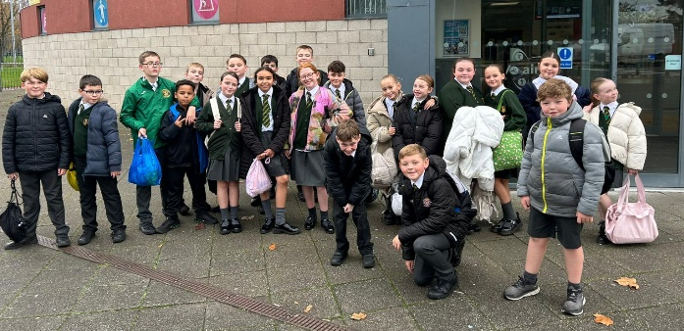
Year 6 swimming
As part of the PE curriculum, all classes from year 3 upwards will spend two weeks swimming. This week saw the first of our classes complete this, and from what I’m led to believe, 6S have been fantastic – as we knew they would be. Their effort, behaviour and the progress they have made have already been noted by the staff at the pool. Each week there is an award for the ‘Swimmer of the Week’, and that was given to Nancy Jones and George Chyrstal in week one - well done! Next week is 6S’s last week of swimming, from Monday 17th November it will be 6L who go to the pool.

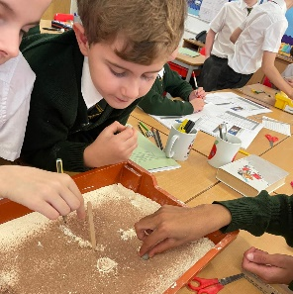
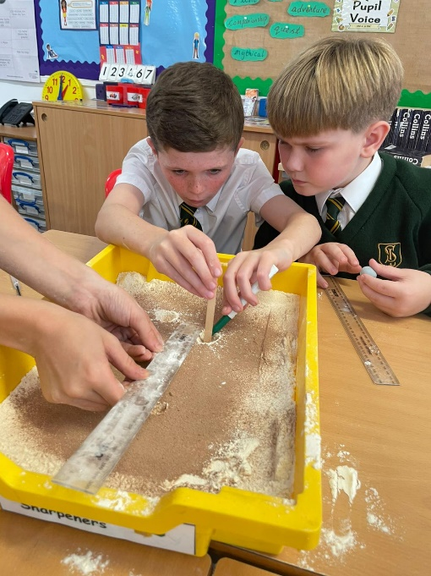
Super science lessons in year 5
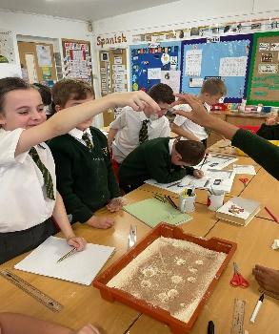
Science is often a really interesting subject for our children as they get to discover the world all around them.

This week, Mr Folksman took science to the next level with an amazing lesson on meteorites and craters. The children created their own meteorites using blue tac and dropped them into a tray of sand to cause a crater. As you can see, this was really enjoyed by the children and I know a huge amount of learning takes place during activities like this. I can’t wait to see what happens next!

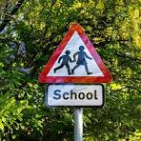
School crossing
Part of the parental survey responses was a request for a proper crossing to be installed outside school. I think we can all agree that the number of cars and children, both at the start and end of the school day, is large and can make it difficult to get across the road safely. I have contacted the local authority to see if it is possible to get a zebra crossing or set of traffic lights either on Leeside Avenue or on Wellfield Avenue. The current response was that this was not possible due to the number of residential driveways and side roads around our school site. I will continue to try and find a solution to this problem and will keep you all updated as I gather further information.


Celebration of Achievement
As a new Headteacher in Kirkby, it was wonderful to be part of the annual Celebration of Achievement at All Saints this week. Each school in Kirkby nominates a child from each year group who has stood out during the year. It may be an amazing academic performance, it may be overcoming adversity or simply a child who gives their best every single day. We are so proud of the children who won the awards from our school this year, and I know that all of our staff are already on the look out for next year’s winner. Congratulations to Alfie Carroll, Leo Brady, Nancy Walsh, Esme Williams, Freya Appleton, Archie Jones, Lottie O’Keefe and James Dunne.

Congratulations to Miss Gibbons and Miss Cowell
We are delighted to announce more good news for two of our amazing members of staff at St Laurence’s this week. Miss Cowell got engaged over the half term and this weekend Miss Gibbons is getting married – years of blissful family life await both young ladies.

Congratulations to you both, and everyone at St Laurence’s wishes you every happiness in your engagement and marriage!

Key Dates for Autumn 2
November
14th Children in Need Day
17th 6S Swimming week for 2 weeks (Except Fridays)
17th Year 5 Liturgy – Love – 2:30pm
19th Year 5 – Calderstones Park Trip
24th Inset day school closed
25th Movie Night 3:30 – 5:15

December
2nd Year 2 Liturgy – Hope – 2:30pm
4th EYFS/KS1 Christmas Play – Performance 10am & 2pm
9th Nursery Christmas Play – Performance 10am & 2pm
9th Christmas Bingo – 5:00 - 6:30pm
10th KS1 Christmas Dinner
11th KS2 Christmas Dinner
12th KS2 Christmas Play – Performance 9:30am & 2pm
18th Christmas Jumper Day & Christmas Party Afternoon
19th School finishes for Christmas – 1:15pm






Weekly Awards

 | Kirkby Child | Star of the Week | English Star | Maths Star | Attendance
Nur | Blake Edwards | Joni Locke |  |  | 94.2%
RS | Isla Deane | Maddie Haddley | Alayah Tomney | Caleb Shaw | 93.9%
RL | Reuben Parry | Finley Gallagher | Wren Rawlinson | Mia-Rose Neile | 96%
1S | Jace Waite | Antoni Rudnicki | Fabiana Plesca | Hattie Gorman | 92%
1L | Finley Howard | Alfie Marshall | Nancy Twigg | Taylor Sullivan | 90.5%
2S | Bobby Baines | Harley Gibney | Penelope Mooney | Fredi Brown | 96.8%
2L | Max Lawler | Georgie Reid-Watkinson | Frankie Stevenson | Nancy Tipler | 97.7%
3S | Oliver Austin | Evelyn Fitzsimmons | Annie McNamara | Maisy Mulligan | 97.3%
3L | Lacey-Mae Croxford | Jaxon Dumbell | Charlotte Lally | Flossie Regan | 95.5%
4S | Nikolas Schiopu | Leah Carey | Nancy Lovett | Amaya Reynolds | 98%
4L | Daniel Powell | Ruby Gee | Harley Farrell | Aubyn Cassidy | 98.5%
5S | Isla Rossiter | Bobby Case-Cummins | Albie Molyneux | Ronnie Baines | 96%
5L | Michael Walsh | Monica Dempsey | Hayzel Townsend | Destiny Barker | 92%
6S | Eden Fox | Una McDermott | Lucas Gibney | Daisy Evans | 90%
6L | Harvey Moss | Freddie Stevenson | Laura Concha-Veroni | Charlie McSween | 93.5%

Kirkby Child Award highlights children who are: respectful, honest and truthful, show a positive attitude, resilient, confident, a good communicator, polite, committed and hardworking, aspirational and ambitious.

We hope you have a fantastic weekend, and we will see you all bright and early on Monday 3rd of November.

From Mr Mackenzie and all the staff at St Laurence’s

