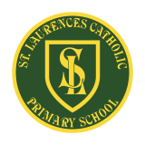
St Laurence’s Catholic Primary School Newsletter – Friday 24th October

Website: www.stlaurences.co.uk
Email: stlaurence@knowlsey.gov.uk
Instagram: www.instagram.com/stlaurencescps
Telephone: 0151 546 4733

Developing our gifts and talents for the good of all
This week at St Laurence’s
Well what an 8 weeks we’ve had here in school, and this week has been as busy as the previous 7. We’ve took part in a special Diwali Dance day as our children discovered a little bit about a different faith, lots of children enjoyed dressing up for out ‘Spooky Spell Day’ and we have experienced a tinge of sadness too as we say goodbye to one of our longest serving members of staff. I want to say a huge thank you to all of you parents and carers who have made this first half term such an enjoyable time. We really appreciate your support and we value the positive relationships we are able to build – when we work together we can make such a big difference to our children. We wish you all a very happy half term, enjoy lots of time with your families and we will see you all again on Monday 3rd November as we build up to Christmas!


8.50am School Gate Closes
Another quick reminder that when we do return on the 3rd our school gates will be closing at 8.50am. The learning that takes place first thing in the morning is extremely important and we want all children in class during this time. It also helps to settle the children into the day when they arrive at the same time as their classmates. Please make sure you give yourself an extra 5 minutes in the morning to get to school, with your support we know this will make a big difference to all of our children’s education and wellbeing.

Parking outside school
We have recently received a number of complaints from our local residents about their driveways being blocked during drop-off and pick-up times. While we understand how busy these times of day can be, we must remind all drivers that parking in front of a resident’s driveway is not allowed under any circumstances. There is also a stretch of double yellow lines near the school. Please remember that parking here is not allowed. At any time, a resident may need to leave their home quickly, perhaps in an emergency, and being blocked in can cause serious problems. We kindly ask everyone who drives to park further down Leeside Avenue, before the double yellow lines begin, and to leave our neighbours’ driveways clear. Parking sensibly also helps to keep our children safe, inconsiderate parking can make it harder for children to see approaching cars and for drivers to see them as they cross the road. We are all aware of the tragic accidents that have occurred outside schools as a result of unsafe parking. Thank you for your continued cooperation in keeping our school community and neighbours safe.
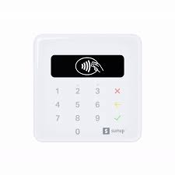
SumUp card machine
To make things easier for everyone, we’ve now introduced a SumUp card reader as a payment method which will be kept in the school office. This allows parents and carers to make card payments in person when needed. We will continue to use ParentPay for the vast majority of payments and remind you that this remains our first choice payment method for things like breakfast and after-school clubs, dinner money, trip payments and other school costs.
The SumUp card reader is simply there as a backup option for those times when ParentPay isn’t possible. We will not be able to organise and accommodate for long queues at the office so we ask that the machine is used only when absolutely necessary. This step will help us stay flexible while ensuring payments are made promptly.
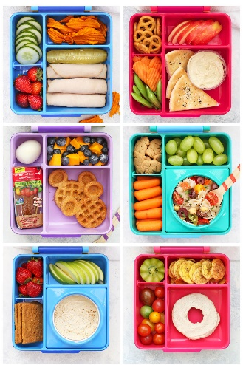
Healthy Schools
As a Healthy School, we always encourage you as parents to provide our children with healthy options whilst they are in school – water in bottles and healthy snacks for breaktime, such as fruit. Knowsley Council has now launched a new Healthy Packed Lunch Guidance page full of simple ideas for planning healthy lunches. The website gives you guidance on portion size and even provides a handy weekly planner for families to use! The council would also love to feature photos of our children’s healthy packed lunches, so if you’d like to share one, please send your pictures in! The links below take you directly to the pages.
https://www.knowsley.gov.uk/healthy-schools-packed-lunches
https://www.knowsley.gov.uk/education-and-schools

Spooky Spell Day
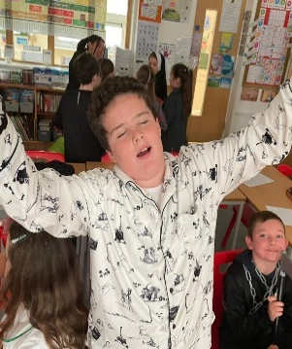
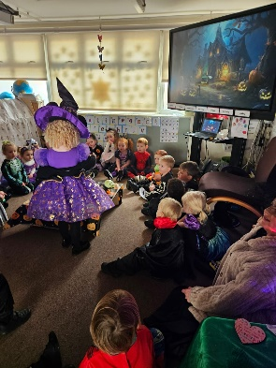
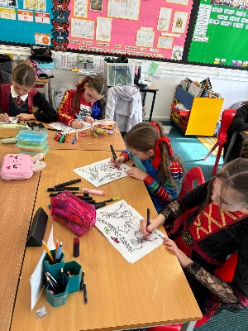
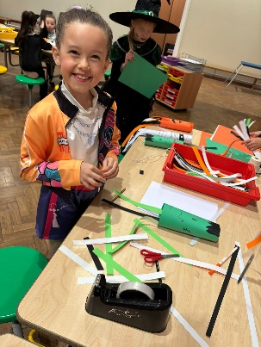
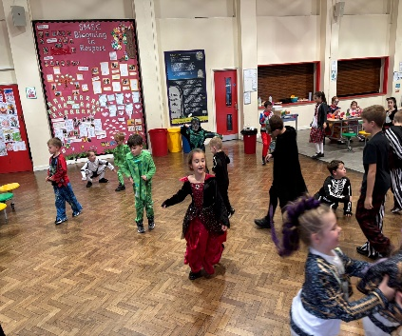
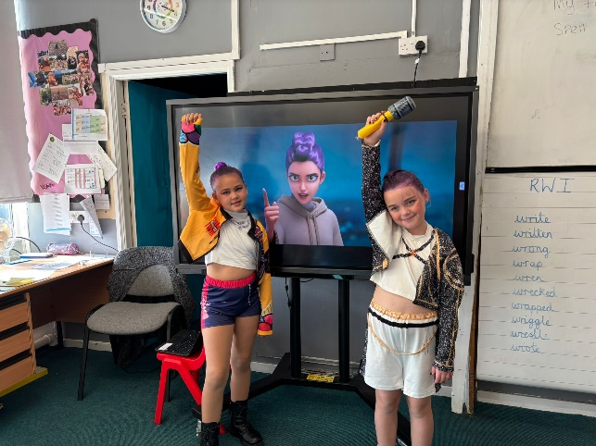
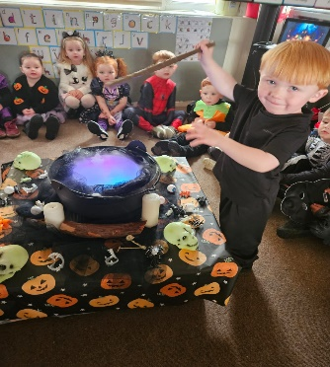
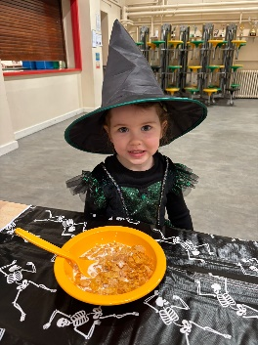
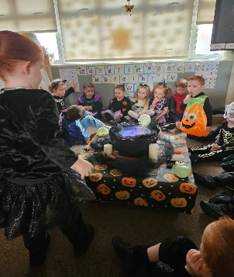
Our children really enjoyed our Spooky Spell Day celebrations on the last day of the half term. We saw lots of fantastic outfits and the children certainly had a lot of fun completing activities in class as well. There will be lots of photographs posted on Instagram from each class, but here are just a few highlights!
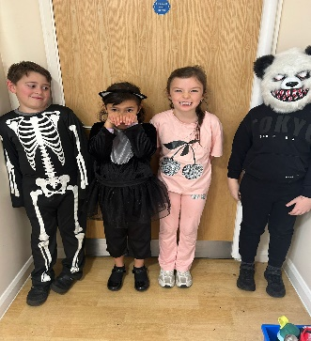
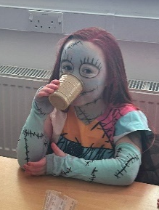
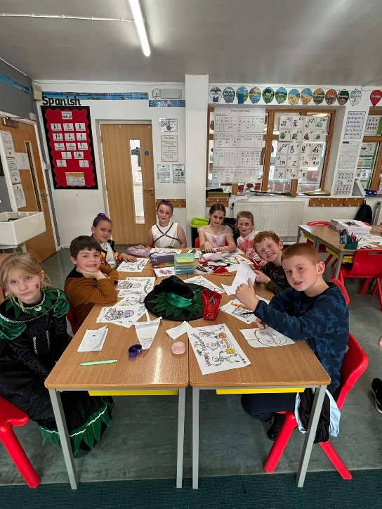
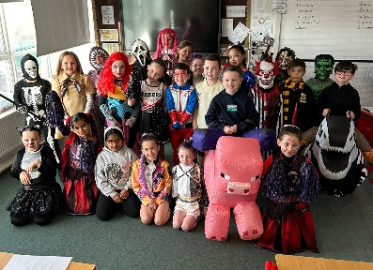

Diwali Dance
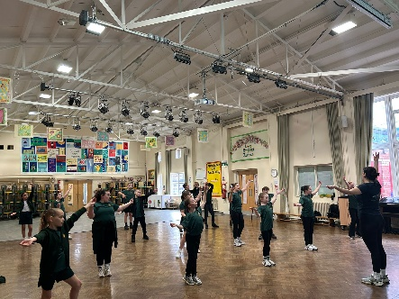
As part of our Religious Education, we make sure our children learn about other world religions. It is important that they understand that while people may have different beliefs and traditions, we share many similarities too. This helps our pupils live out our Catholic ethos and our British values such as acceptance, respect and understanding. This week, the children learned about the Hindu festival of Diwali. The week began with an assembly introducing why the festival takes place and ended with the children learning a traditional dance linked to the story of the Ramayana.
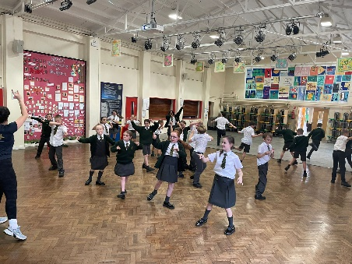
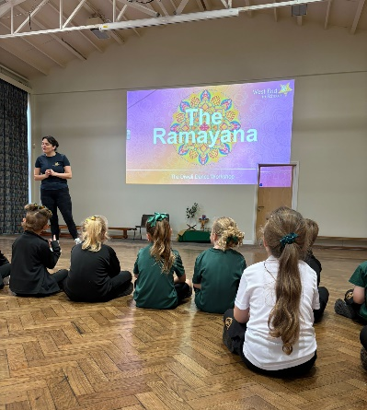
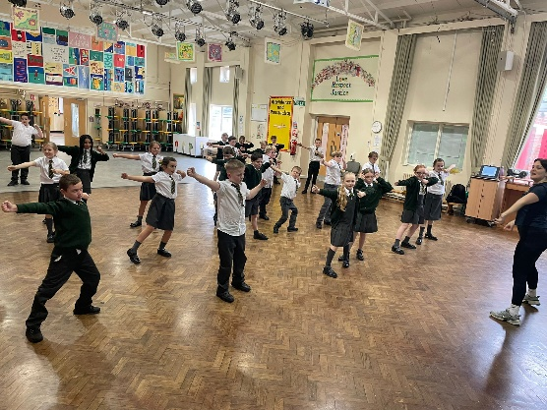
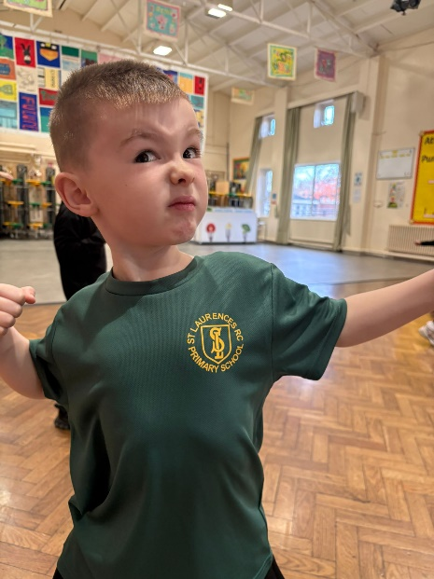

Goodbye Mrs Simpson
Sometimes, a person comes along who is so committed and happy in their job that they give their whole career to one place. Step up Mrs Simpson! After 28 years of service to St Laurence’s, Mrs Simpson is finally taking a step back and having a well earned rest.

She has been, and will always be, an important part of our school family having inspired generations of Kirkby residents sharing her warmth, kindness and creativity. Classrooms lucky enough to have her present have always been filled with laughter, imagination and care; every child who has been taught by her will remember her sparkle and her belief that every child can shine brightly.
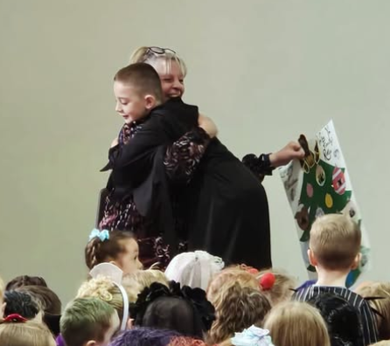
She has brought so much joy to school life, from her infectious Christmas spirit to her endless positivity and dedication. It’s hard to imagine our corridors without her cheerful smile and encouragement.

Although we’ll miss her enormously, Mrs Simpson will always be part of our school family, and our door will always be open for her to visit, share a cuppa and a laugh, and catch up with the children and staff who love her so much.

Thank you, Mrs Simpson, for everything you’ve given to our school community. Enjoy the lie-ins, the laughter, the glitter and of course, have a very merry Christmas!






Weekly Awards

 | Kirkby Child | Star of the Week | English Star | Maths Star | Attendance
Nur | Elsie Keating | River Roe |  |  | 99.2%
RS | Arna Shiers | Cecilia Stelfox | Kai Sullivan | Elsie Bowers Jones | 90.4%
RL | Violet Seasman | Oluwatosin Omotosho | Brodie Blackall | Wren Rawlinson | 90.7%
1S | Pheobe Manning | Amelia Walsh | Lola Fuller | Jack Reynolds | 96%
1L | Elsie Bagan | Emma Madden | Teddie Harpur | Kara Austin | 91.9%
2S | Thomas Davies | Indie Regan Nicholson | Elia Caulfield | Fredi Brown | 84.8%
2L | Leo Brady | Star Balmer | Irish McGorian | Maggie Jones | 89.2%
3S | Nancy Walsh | Nancy Williamson | Stella Kitamura | Tyler Greaves | 96.8%
3L | Lily Walsh | Faith Bruen | Rosie Walker | Rosa Flaherty | 93.3%
4S | Kadi Gibbons | William Scott | Oliver Sproule | Mia Maria Goodwin | 97.6%
4L | Aubyn Cassidy | Kara Cassidy | Kaden Carr | Hallee Marr | 96.2%
5S | Amayah O’Korode | Grace Postlethwaite | Duggy Faulkner | Isla Rossiter | 96%
5L | Aria Farrell | Ella Ross | Moncia Dempsey | Leo Nalon | 96.8%
6S | Manson Wainwright | Reuben Croxford | Daisy Evans | Leticia Queiroz-Valli | 88.3%
6L | Laura Veneroni | Archie Jones | Darcy McCarthy | Charlie McSween | 91.5%

Kirkby Child Award highlights children who are: respectful, honest and truthful, show a positive attitude, resilient, confident, a good communicator, polite, committed and hardworking, aspirational and ambitious.

We hope you have a fantastic weekend, and we will see you all bright and early on Monday 3rd of November.

From Mr Mackenzie and all the staff at St Laurence’s

