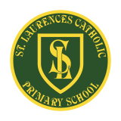**St Laurence’s Catholic Primary School Newsletter – Friday 10th October**

**Website**: [www.stlaurences.co.uk](http://www.stlaurences.co.uk)

**Email**: [stlaurence@knowlsey.gov.uk](mailto:stlaurence@knowlsey.gov.uk)

**Instagram**: [www.instagram.com/stlaurencescps](http://www.instagram.com/stlaurencescps)

**Telephone**: 0151 546 4733

**Developing our gifts and talents for the good of all**

**This week at St Laurence’s**

As we hurtle towards the half term, our staff and children at St Laurence’s continue to work hard and thoroughly enjoy their time in school each and every day. This week has seen the children enjoy their reading during National Library Week, something every educator will tell you is the key to success in any school. We’ve had one young boy take on all comers in a national karate championship, bringing home not 1, not 2, but 3 medals to show us all in school! And just as we congratulated Mrs Evans last week, we have some fantastic news regarding another member of staff this week. As always, keep an eye on instagram for the full hit of photos and information (including a visit from two LFC players) but read on here for other important stuff too. Have a great weekend everyone!

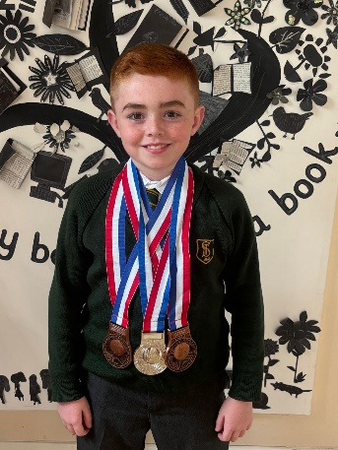

**Archie Jones – Karate Champion!**

Congratulations to one of our talented year 6 children – Mr Archie Jones – who recently competed at a Shotokan Karate competition in Sunderland, bringing home an amazing three medals – two bronze and one silver! He won silver in the under-16 brown belt kata (a series of carefully practised movements), bronze in the children’s team kata, and another bronze for individual kumite (fighting). We are so proud of his fantastic effort, teamwork, individual skill and commitment – next stop LA 2028!

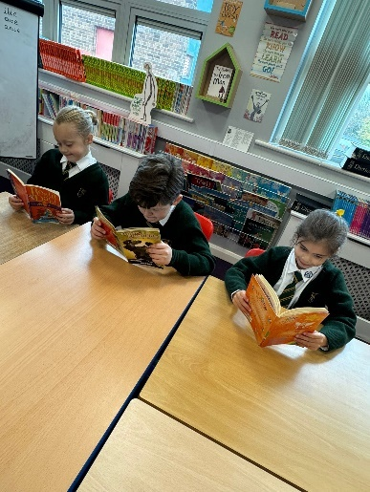**National Library Week**

This week has been National Library Week and the children have spent some time enjoying the wonderful world of books! A big thank you to Miss Rimmer for planning and delivering an amazing assembly for all of our children on Monday, it was a great way to start the celebrations off. Liverpool FC and Everton FC have both donated a large amount of books to school to help us continue the party throughout the week, lots of amazing story books for the young and old. As always, any reading you can squeeze in at home as part of your child’s homework is of huge benefit to them – and what better way to spend a rainy weekend than curled up with a good book!

**Parents Evening – Thank You**

A huge thank you to all those parents and carers who came along on Wednesday evening to meet your teacher. I heard a lot of positive messages being given by teachers and proud parent and carers, just as we expect here at St Laurence’s with our fantastic children who come along each day. These short meetings are simply a chance to get some feedback on how your son/daughter has settled down, if any of you have any other concerns please remember to call school to make an appointment. It is when we work together that we can really make a big difference to your child’s education.

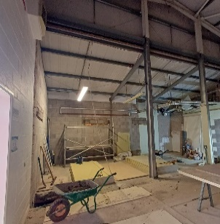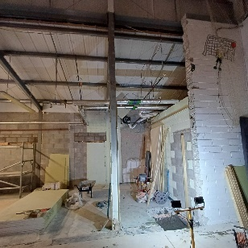**Building Work Update**

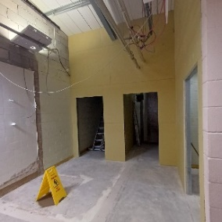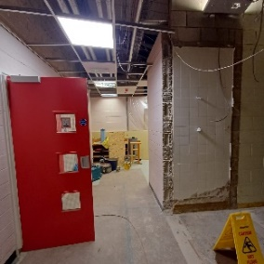To keep you up to date with how things are progressing, please see the photographs below. I am assured that the work will be completed on schedule (before we finish for Christmas) and then we can begin to get back to normal once again. It certainly has been very noisy down that end of the school, Mrs Barr has had the soothing sounds of drilling to help her focus over the last month or so, and 2L have also had to put up with a fair amount of noise as well. Nearly there now though!

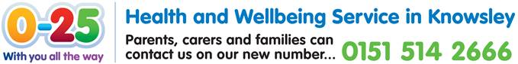**School Nurse Visit**

Our school nurse team will be offering a telephone drop-in session this half term on Thursday 23rd October from 12:30pm to 2:30pm. Although they are unable to attend school in person at this time, parents and carers can still access support and advice over the phone. If you would like to speak with the school nurse during this session, please let the school office know by Wednesday 22nd October – we need to know your child’s name, date of birth and your contact number.

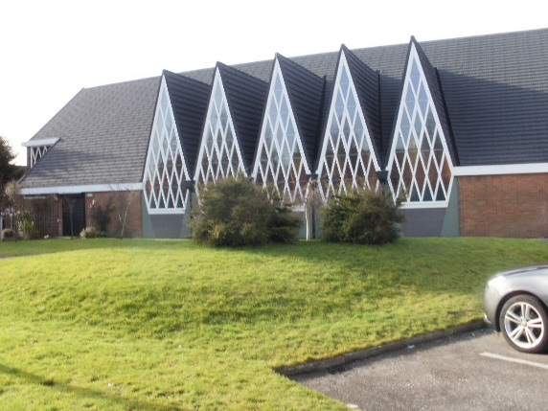**Parish Newsletter**

From this week onwards, our parish newsletter will be sent out via school spider, email and will be on the school website as well. Fr Sean always sends this across and it would be great if you could take a few minutes each week to read it. The Catholic community in Kirkby is a very special part of our town, and both ourselves and St Joseph’s work really hard to make sure our RE curriculum, Catholic life and prayers within school are the best we can provide. Mass on Sunday, or through the week, is another opportunity for us all to come together and celebrate. The newsletter also includes lots of information about events in Kirkby and so is well worth a look each week.

**Mobile phones in School**

We know that many of our Year 5 and 6 children bring mobile phones to school so that parents and carers can contact them after school for safety and reassurance – and we fully understand and support this. However, we would like to remind families that mobile phones must not be used at all while on school property. We have given this reminder in school this week, could we kindly ask that you deliver the same message to your child over the weekend, that they only make calls or send messages once they have exited the school gate. Sometimes children have said they use their phones to check if they are being collected or walking home. To help with this, please ensure your child knows their end-of-day arrangements before leaving for school each morning. These steps help us keep everyone safe and prevent any potential issues related to mobile phone use on site. Thank you for your continued support and cooperation in helping us maintain a safe and respectful school environment.

**Next Week**

A few important reminders for next week. Our year 6 liturgy takes place on Monday afternoon at 2.30pm, we have a ‘Buddy Assembly’ the following day on Tuesday at 9.15am and we have our individual photographs being taken in school on Wednesday. It would be great to see as many parents and carers as possible on Monday and Tuesday, and then get those baths and showers running ready for the photographs on Wednesday!

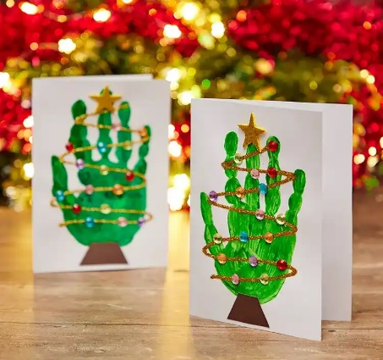

**Cauliflower Cards Deadline**

Thank you to Miss Owens for organising this for all the children in our school this year. This is a remainder that the deadline for ordering these cards is Monday 13th October, so if you want them in time for Christmas please get them sent off by that date. And please remember to bring in the artwork to school on Monday once you have done so.

**Look at the size of that rock!**

A massive congratulations this week goes to one of the very best members of St Laurence’s family – Miss Doolan. Last week our staff completed some really important training on the Friday before enjoying a well-earned rest, but not Miss Doolan. She decided to spend the Friday evening getting engaged!! Everyone in school is thrilled with this news; we wish her and her fiancé every happiness, congratulations Miss Doolan .

**Next Week After School Clubs**

|  |  |  |  |
| --- | --- | --- | --- |
| **Mon** | **Mini Vinnies**  (Miss Richardson & Miss Doolan) | **Athletics**  Mrs Purchase & Mr Folksman | **Multi Sports:** Years 3, 4 and 5  Mr Cushion |
| **Tue** | **Football**: Years 3 & 4  (Everton in the Community) |  |  |
| **Wed** |  |  |  |
| **Thu** | **Football**: Years 5 & 6  (Liverpool Foundation &  Mr Grant) |  |  |
| **Fri** |  |  |  |

**Weekly Awards**

|  |  |  |  |  |  |
| --- | --- | --- | --- | --- | --- |
|  | **Kirkby Child** | **Star of the Week** | **English Star** | **Maths Star** | **Attendance** |
| **Nur** | **Brody Clarke** | **Blake Collins** |  |  | **92.7%** |
| **RS** | **Joseph Flynn** | **Caleb Shaw** | **Florence Jones** | **Stefania Bonea** | **93.8%** |
| **RL** | **Oluwatosin Omotosho** | **Amelia Riley** | **Violet Seasman** | **Archie Stenenson** | **92.3%** |
| **1S** | **Oliver Parry** | **Fabiana Plesca** | **Sadie Cullen** | **Skye Hamid** | **90%** |
| **1L** | **Alfie Marshall** | **Hallie Pollard** | **Luca McCaig** | **Emily Duncan** | **95%** |
| **2S** | **Carter Goodwin** | **Indie Nicholson** | **Olivia Tunstall** | **Bobby Baines** | **90.4%** |
| **2L** | **Aida Rawlinson** | **Joel Keegan** | **Halle McPadden** | **Lillie Brooks Coletta** | **94.6%** |
| **3S** | **Nancy Walsh** | **Ollie Garcia** | **Noah Jones** | **Maisy Mulligan** | **95.5%** |
| **3L** | **Rosie McSween** | **Cloe Christie Scotland** | **Ewan Flynn** | **Jax Gordan** | **91.3%** |
| **4S** | **Joel Jevons** | **Mia Maria Goodwin** | **Sienna Downey** | **Sophia Rodrigues** | **88.8%** |
| **4L** | **Jack Tracey** | **Ella Richardson** | **Davy Baines** | **Caleb Rafferty** | **96.5%** |
| **5S** | **Grace Postlewaite** | **Ronnie Baines** | **Isaac Lally** | **Rylee Matthews** | **96.8%** |
| **5L** | **Jason Chean** | **Nancy Towey** | **Luke George** | **Luka Banawich** | **86.4%** |
| **6S** | **James Murray** | **Ethan Karoui** | **Jamie Dumbell** | **Sonny Tierney** | **99.2%** |
| **6L** | **Freddie Stevenson** | **Elijah Greenhalgh** | **Kiasha Reynolds** | **Willow Jevons** | **93.1%** |

**Kirkby Child Award highlights children who are:** respectful, honest and truthful, show a positive attitude, resilient, confident, a good communicator, polite, committed and hardworking, aspirational and ambitious.

**We hope you have a fantastic weekend, and we will see you all bright and early on Monday morning.**

**From Mr Mackenzie and all the staff at St Laurence’s**