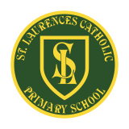**St Laurence’s Catholic Primary School Newsletter – Thursday 2nd October**

**Website**: [www.stlaurences.co.uk](http://www.stlaurences.co.uk)

**Email**: [stlaurence@knowlsey.gov.uk](mailto:stlaurence@knowlsey.gov.uk)

**Instagram**: [www.instagram.com/stlaurencescps](http://www.instagram.com/stlaurencescps)

**Telephone**: 0151 546 4733

**Developing our gifts and talents for the good of all**

**This week at St Laurence’s**

A four day week for the children seems to have the vast majority of them in good spirits today, and all week they have been working hard and taking on some really interesting challenges. We’ve had our Everton and Liverpool coaches in this week as usual, our year 3 and 4 classes continue to learn about how we can live a healthy lifestyle and year 5 had a brilliant day yesterday working with our computing experts on staying safe online. I’ve seen children getting their feet painted by one of our teaching assistants, and I must give a quick mention to Mrs Evans who managed to get her official school email account sorted this week – we’re all very proud of you! As always, keep an eye on instagram for all the best photos from the week, please read on as there lots of important messages here too. Have a great weekend everyone!

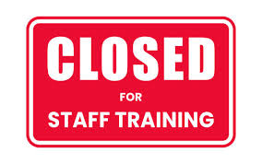

**INSET – School Closed**

Another important reminder that ***school is closed tomorrow*** as our staff undertake important professional development. Hopefully there is some good weather for you to enjoy with your children whilst we are busy working!

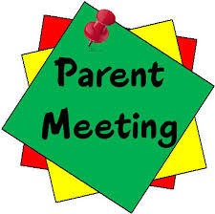

**Parent/Carer Meetings**

Once again, thank you to all parents and carers who came along this week to listen to your child’s teacher. It is so important that we work as closely as possible during the time you are here with us at St Laurence’s and coming along to these meetings is a big part of it.

We also took these meetings as a chance to raise money for McMillan Cancer Research, sadly a disease which touches many if not all of our families. Thank you for your generous donations, and thank you even more for then buying them back off us!! We’ve raised £314.30 which will be donated to this extremely important cause.

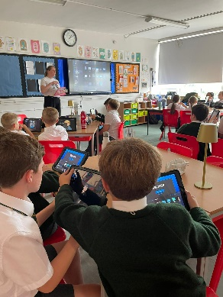**Knowsley CLC**

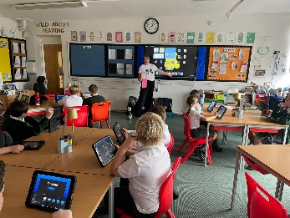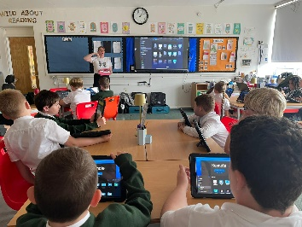We are extremely lucky to have a team of computing experts who come into school regularly to work with our teachers and deliver amazing lessons. This week it was the turn of our year 5 classes and they have been learning about how to keep themselves safe online – something which as a parent myself, I know is incredibly important in today’s world. The children in both classes not only learned some important skills about how to create online books showing off their knowledge, but they also learned about the latest dangers involved in online life today; fake AI images, messages posted online being permanent and how people can create fake profiles. Whilst dealing with a very serious topic, it was great to see our children engaged in their work and learning about real life issues.

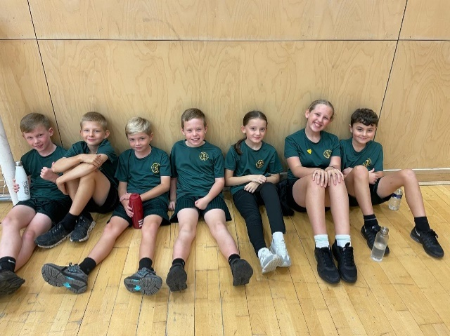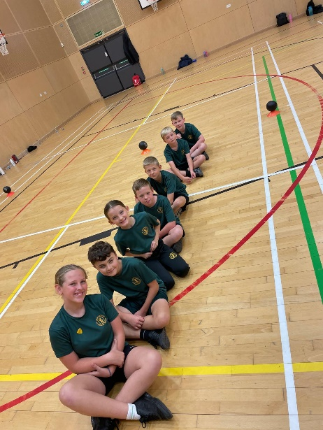**Dodgeball Competition**

Our year 5 and 6 children went to All Saints this week to take part in a Dodgeball competition. This is a fast and furious game which takes a huge amount of skill, teamwork and effort. Mr Folksman took charge of the team and came back full of praise for the children involved. Not only did our team perform amazingly throughout the event, their behaviour and attitude were exemplary – as always. Well done everyone!

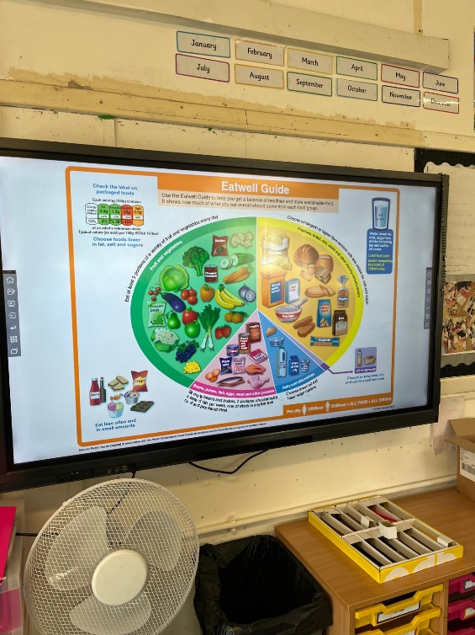**Healthy Lifestyle with Liverpool FC**

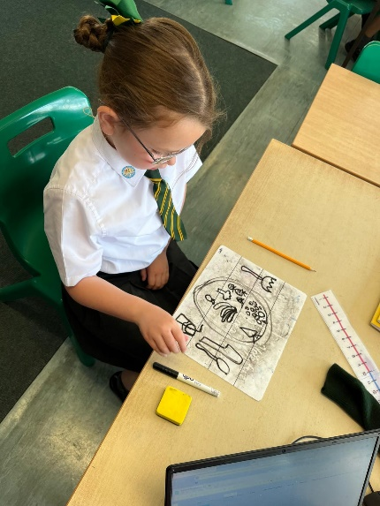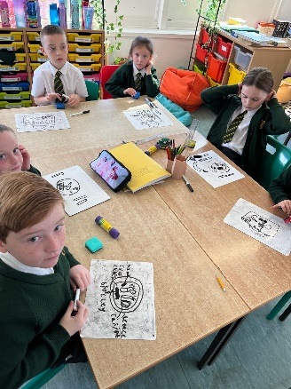Our year 3 and 4 classes are both thoroughly enjoying a 6 week topic being taught by The LFC Foundation on living a healthy lifestyle. This project fits in perfectly alongside our PSHE curriculum and provides the children with an excellent opportunity to learn from an amazing provider in The LFC Foundation. This week the children were learning about how to eat well and creating their own healthy plates of food, something which we all know is extremely important. The children are getting a lot out of this work and we look forward to more fun activities as the project continues.

**Learning with a smile**

The sheer number of photographs showing the fun our children have whilst learning that get sent my way every week is mind-blowing and I wish I could share them all. This week a few have really caught my eye and I wanted to showcase them here. I’ve said many times how amazing our staff are here at St Laurence’s, their dedication and determination to make sure that the children learn and have fun is genuinely inspiring to me. A picture paints a thousand words as the saying goes, and I just wanted to point out the obvious with these ones – just look at the smiles on the children’s faces, memories that will last a long time are being made every day here in school!

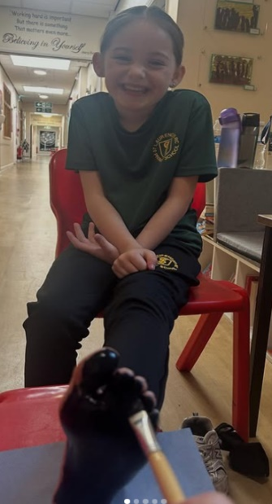

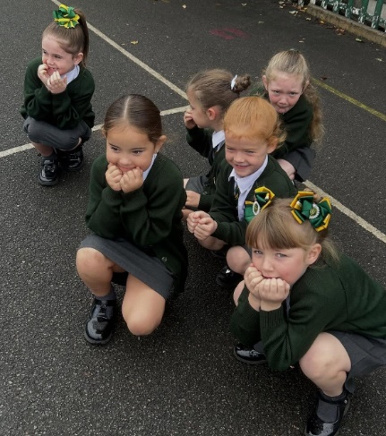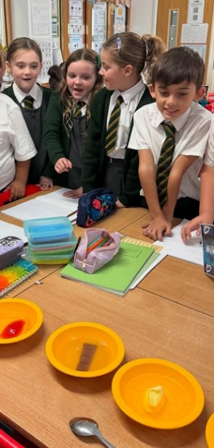

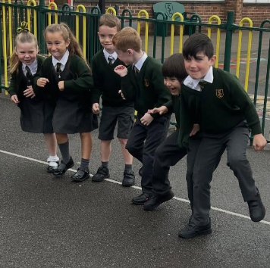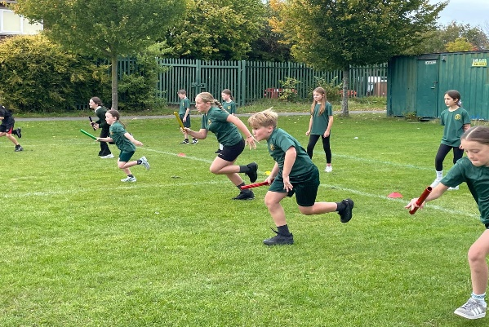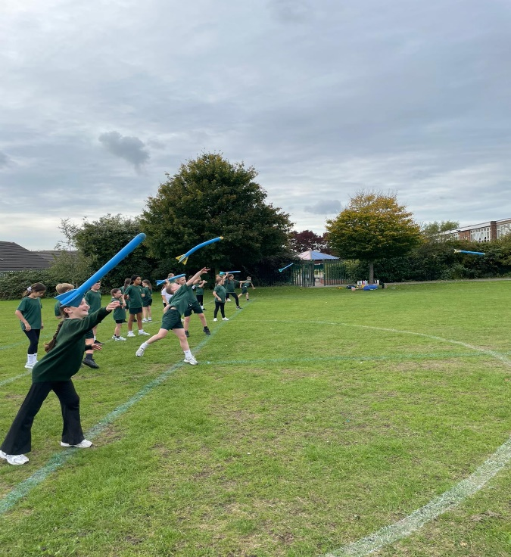

**Parents Evening**

A reminder that our first Parent/Carer Evening of the year takes place on Wednesday 8th October between 3.30pm and 6.30pm. Thank you to those of you who have already booked your appointment using School Spider, if you have not yet had the chance then please do so as early as possible. As I said last week, it is extremely important that you come along to this meeting to hear about how your child has settled into their new class and how you can help them to achieve this year. We look forward to seeing you all next week.

**Next Week After School Clubs**

|  |  |  |  |
| --- | --- | --- | --- |
| **Mon** | **Mini Vinnies**  (Miss Richardson & Miss Doolan) | **Athletics**  Mrs Purchase & Mr Folksman | **Multi Sports:** Years 3, 4 and 5  Mr Cushion |
| **Tue** | **Football**: Years 3 & 4  (Everton in the Community) |  |  |
| **Wed** |  |  |  |
| **Thu** | **Football**: Years 5 & 6  (Liverpool Foundation &  Mr Grant) |  |  |
| **Fri** |  |  |  |

**

**Weekly Awards**

|  |  |  |  |  |
| --- | --- | --- | --- | --- |
|  | **Kirkby Child** | **Star of the Week** | **English Star** | **Maths Star** |
| **Nur** | **Ophelia Devling** | **Koby Williams** |  |  |
| **RS** | **Hadassah Rinaldi** | **Isla Dean** | **Maddie Haddley** | **Dolce Carney** |
| **RL** | **Amelia Riley** | **Annie Wilson** | **Jude McNabb** | **Violet Seasman** |
| **1S** | **Max Taylor** | **Nicolas Placedino** | **Amelia Walsh** | **Kyrah Okorode** |
| **1L** | **Carter Coyle** | **Rosie Clarke** | **Sophie O’Rourke** | **Finley Howard** |
| **2S** | **Abigail Riley** | **Arlo Cassidy** | **Honey Carter-Smith** | **Sienna Smith** |
| **2L** | **Emilia Richardson** | **Max Lawler** | **Skylah-Mae Smylie** | **Georgie Reid-Watkinson** |
| **3S** | **Alfie Stott-Jennings** | **Luca McVeigh** | **Jacob Ventre** | **Gabriel Dawkins** |
| **3L** | **Jaxon Dumbell** | **Caleb Townsend** | **Bella Parry** | **Flossie Regan** |
| **4S** | **Kody Marsden** | **William Scott** | **Kadi Gibbons** | **Riley Brooks-Coletta** |
| **4L** | **Annie Quinn** | **Luca Pinnington** | **Freddie Reid-Watkinson** | **Harley Farrell** |
| **5S** | **Duggy Faulkner** | **Chloe McGorian** | **Kendall Hamid** | **Mason Riley** |
| **5L** | **Isabella McGreevy** | **Marcie Horrocks** | **Luna-Rae Linden** | **Hayzel Townsend** |
| **6S** | **Una McDermott** | **Darcey Kelly** | **Valentina Reid** | **Reuben Croxford** |
| **6L** | **Annabelle Farrell** | **Hallie Devine** | **Charlie Payne** | **Charlie McSween** |

**Kirkby Child Award highlights children who are:** respectful, honest and truthful, show a positive attitude, resilient, confident, a good communicator, polite, committed and hardworking, aspirational and ambitious.

**We hope you have a fantastic weekend, and we will see you all bright and early on Monday morning.**

**From Mr Mackenzie and all the staff at St Laurence’s**