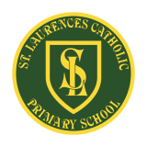
St Laurence’s Catholic Primary School Newsletter – Friday September 26th

Website: www.stlaurences.co.uk
Email: stlaurence@knowlsey.gov.uk
Instagram: @SLaurences
Telephone: 0151 546 4733

Developing our gifts and talents for the good of all
This week at St Laurence’s
Another week of amazing activities and learning at St Laurence’s is over, and as weeks go – this one was particularly busy! We’ve had Parents/Carers meetings, year group litrugies, football competitions and extra special visitors to school too (anyone in the car park on Thursday may have noticed a couple of rather large cars pulling in!) Plus this week saw our Mini-Vinnies steal the show with a heart-warming gift to a very special group of staff in school, more on that later. Lots of important messages this week too as some important dates are coming up. So enjoy the newsletter and enjoy your weekend!


Parent/Carer Meetings
Thank you to all the parents and carers who have attended your year group meetings this week. It’s great to see so many of you engaging with the year ahead at St Laurence’s. More meetings will take place next week, so please ensure someone can attend to hear key information and help us work together to support your child’s success. One point I want to emphasise is attendance and punctuality. Your child should be in school every day – not just for their learning, but for the important social interactions that happen daily. Our target is 96% attendance, and you’ll receive updates on your child’s attendance at parents’ evening. School starts at 8:40am, and learning begins straight away. Arriving on time means extra learning opportunities and a calm, settled start to the day. Thank you for your support with this.

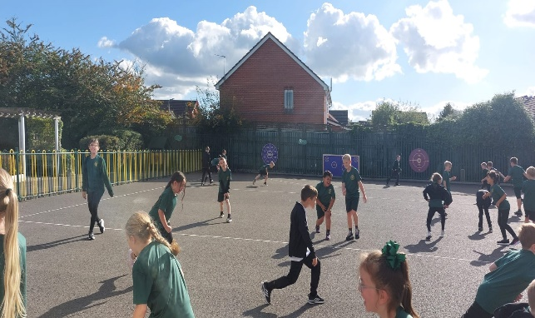
Multi-Sports Club
As always, it was great to see our multi-sport club enjoying themselves this week after school. The hugely popular group even managed to get some decent weather to practice in and thoroughly enjoyed themselves. It is so important to get some good exercise in each day but also to just have a laugh with your mates – something this group do every week. Well done everyone, and thanks to Mr Cushion for running it – much appreciated!

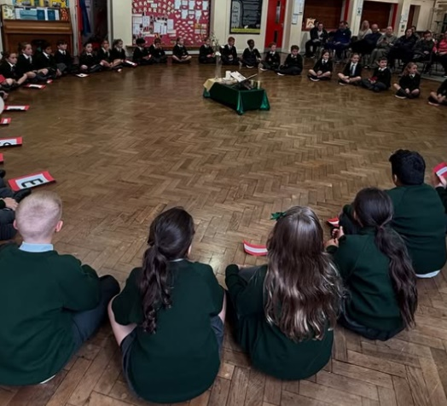
Year 4 Liturgy
Thank you to our staff for organising this lovely event, and also to you parents and carers who came to celebrate with us. The message given about respect is one we can all listen to and carry with us daily. Not only did we hear some amazing readers but also a fantastic rap to go with it! Not often you get to rap during a liturgy, but we’re all about breaking barriers here at St Laurence’s so well done year 4.

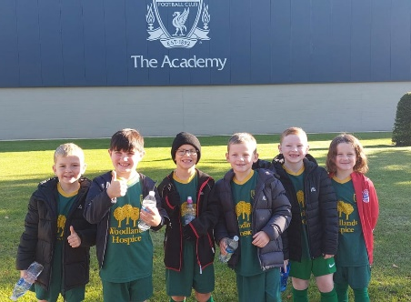
Year 2 Football Competition
The first of many football competitions took place this week with our year 2 boys taking on all comers down at LFC Academy. In keeping with our rich football heritage, the boys did themselves and the school proud with some outstanding play. In an extremely competitive group, St Laurence’s came 3rd out of all Knowsley school setting a high standard for other year groups to follow. Mr Cushion also said something that we know to be true every time a group from St Laurence’s represent us at these events – that their behaviour and sportsmanship were second to none. Well done boys, we’re all extremely proud of you!


Parents Evening
A reminder that our first Parent/Carer Evening of the year takes place on Wednesday 8th October between 3.30pm and 6.30pm. Information will be coming out next week about organising times for this, but we wanted to give an early reminder as it is so important that you attend to hear about how your child has settled into their new class, and about what you can do to help them throughout the year.

Water Bottles
Over the last week there have been an increasing number of children bringing juice into school in their water bottle. This is a polite reminder that water is allowed to be brought into school, any other liquid is not. From Monday onwards anyone bringing juice or any other liquid into school in their bottle will be asked to empty it into the sink and their bottle will be refilled with water. Previously we have mentioned the importance of healthy snacks in school and the same message applies to drinks. Thank you for your support with this.

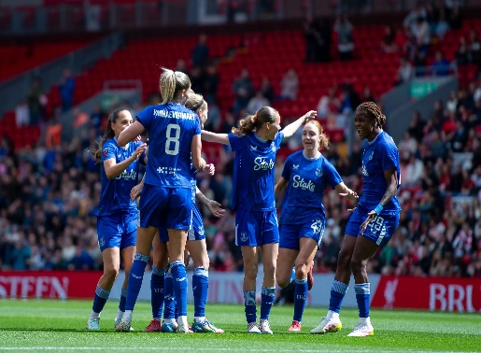
Everton Women’s Ticket
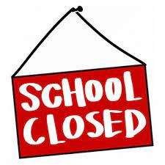
We are extremely lucky to have Everton in the Community come into school to help us deliver PE and sports clubs to a very high standard. As part of this, occasionally we get an additional bit of help too. This week, this has come in the form of free tickets to watch Everton Women v Man United Women on Sunday 12th October, 12.00pm Kick Off. If anybody wants to take advantage of this, please come to the school office and ask for as many tickets as you want. All we ask is that you make sure they are used.

INSET – School Closed
Another important reminder for next week is that school is closed on Friday as our staff undertake important professional development. Hopefully there is some good weather for you to enjoy with your children whilst we are busy working!

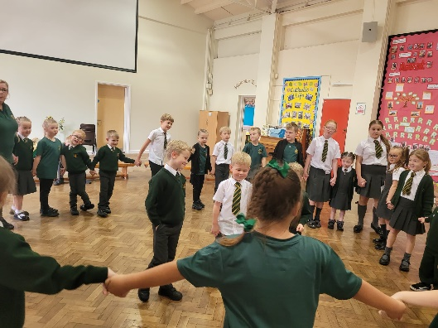
After School Club
Mrs Nairn, Mrs Connelly and Mrs Lawless do a fantastic job for our school community every day with out breakfast and after school club. No matter how many children are there and no matter what time of the day it is, those three ladies are always making sure that the children in their care are fed and enjoying themselves. This week they banged out a stone-cold classic ‘The Farmer wants a Wife’ and no matter how much times have moved on for children these days, I have been assured that they all loved it just as much as us 40+ year olds did back in the day.
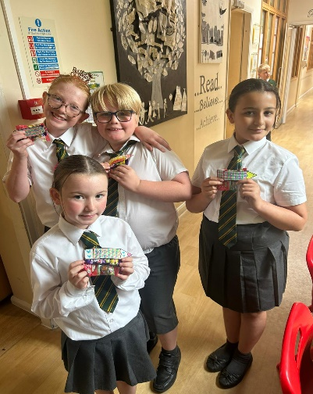
Teaching Assistant Celebration Day
This week, we want to take a moment to shine a spotlight on our incredible teaching assistants. So much of what they do happens quietly behind the scenes, but their impact is felt in every classroom, every day. From supporting pupils academically and emotionally, to preparing resources, leading groups, giving extra care and encouragement and helping keep our school running smoothly – they truly do it all. As teachers, we are so thankful for their dedication, professionalism, skill and kindness. They make such a difference to the lives of our children, and we simply couldn’t do what we do without them.

We were especially proud of our Mini Vinnies group, and Miss Richardson and Miss Doolan, who recognised this hard work by surprising our teaching assistants with a thoughtful gift this week. It was a lovely moment that showed just how valued they are by our whole school community. Thank you to all of our wonderful teaching assistants – you are truly appreciated.

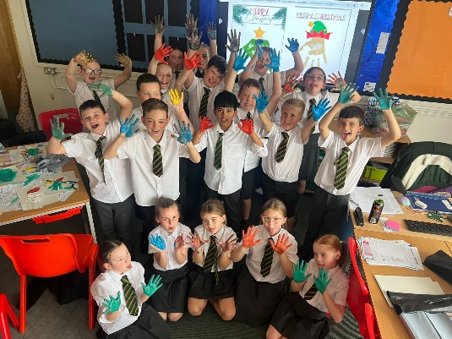
It’s beginning to look a lot like Christmas (in Mr Kenny’s class)
Lots of classes have been creating their Christmas cards this week (What?!?! It’s nearly the end of September you know!) and clearly have been having a lot of fun doing so. Thank you to Miss Owens for organising this event across the school, and I’m sure you’ll see how creative your child has been when their card comes home this week. If this bunch of children is anything the go by, our cleaners will have their work cut out for them!

Next Week After School Clubs

Mon | Mini Vinnies  (Miss Richardson & Miss Doolan) | Athletics  Mrs Purchase & Mr Folksman
Tue | Football: Years 3 & 4  (Everton in the Community)
Wed
Thu | Football: Years 5 & 6  (Liverpool Foundation &  Mr Grant)
Fri






Weekly Awards

 | Kirkby Child | Star of the Week | English Star | Maths Star | Attendance
Nur | Reeva Owen | Finley Leyland |  |  | 96.6%
RS | Romy McGreevy | Nellie Flynn | David Madubuike | Axel Hamid | 89%
RL | Brody Blackall | Poppy-Jo Perry | Reneya Halliday | Ed Hodgson | 96%
1S | Skye Hamid | Jack Reynolds | Alfie Carroll | Sonny Owen | 92%
1L | Teddie Harpur | Shaya Rafferty | Taylor Sullivan | Axel Gordon | 92%
2S | Fredi Brown | Penelope Mooney | Elia Caulfield | Carter Goodwin | 91.2%
2L | Nuala Jones | Zadie Hodgson | Leo Crellin | Cooper Bibby | 92.3%
3S | Nancy Williamson | Gabriel Dawkins | Savannah Farrell | Sydnie Yates | 96.4%
3L | Tayla Atkins | Rosie Walker | Benji Jones | Harlen Farrell | 89.3%
4S | Nevaeh Nugent | Kodi Marsden | Kadi Gibbons | Leah Carey | 95.2%
4L | Freddie Reid-Watkinson | Teddy Johnson | Billy Chrystal | Tilly Payne | 96.9%
5S | James Dunne | Thomas Reid | Harry McGrath | Albie Molyneux | 94.4%
5L | Ella Ross | Mason Sutherland | Will Powell | Monica Dempsey | 94.4%
6S | Sonny Tierney | Reuben Croxford | Eden Fox | Heidi Devine | 95.8%
6L | Laura Concha-Veroni | Hallie Devine | Darcy McCarthy | Jon-Paul Halewood-Hamid | 88.1%

Kirkby Child Award highlights children who are: respectful, honest and truthful, show a positive attitude, resilient, confident, a good communicator, polite, committed and hardworking, aspirational and ambitious.

We hope you have a fantastic weekend, and we will see you all bright and early on Monday morning.

From Mr Mackenzie and all the staff at St Laurence’s

