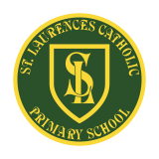**St Laurence’s Catholic Primary School Newsletter – Friday September 19th**

**Website**: [www.stlaurences.co.uk](http://www.stlaurences.co.uk)

**Email**: [stlaurence@knowlsey.gov.uk](mailto:stlaurence@knowlsey.gov.uk)

**Instagram**: @SLaurences

**Telephone**: 0151 546 4733

**Developing our gifts and talents for the good of all**

**This week at St Laurence’s**

As we head towards the end of September already, another week comes to a close at St Laurence’s – and what a week it has been! We’ve had Altru-Drama in to work with our year 6 classes to produce some amazing performances, we’ve seen science investigations, books being brought to life and Roald Dahl Day took place with a number of phizz-whizzing activities throughout school. As always the best place to see these events is on our instagram page, but read on to hear all about them in the newsletter as well. We’re hoping that the weather becomes a bit more settled next week so that we can take advantage of being outdoors whilst our building work continues. Wishing you all a very happy weekend (never 100% guarenteed on derby weekend sadly!) and see you all Monday.

**Altru-Drama in Year 6**

It was fantastic to welcome Altru-Drama into St Laurence’s this week to work with our year 6 classes. This event takes place every year and the children thoroughly enjoy themselves. It was great to see both 6S and 6L throw themselves into a major performance, full of acting, dancing, shouting and choreography. The performances were wonderful too showing just how much they look forward to moving on to senior school. I must apologise for the late notice about coming in to watch them. It is my mistake completely as I forgot to write it in the diary as soon as I booked it in – Sorry!

Please have a look on Instagram so you get a feel for what they children did and thank you to the staff for organising this event at extremely short notice!

**Roald Dahl Day**

Monday saw us celebrate the annual Roald Dahl Day in school with each class completing some fun activities based on one of our most famous authors. Whether it is ‘Matilda’, ‘The BFG’ or ‘Danny the Champion of the World’ our children love to read these stories (and let’s face it, so do the teachers too!). 3L took great delight in producing some amazing potions inspired by George’s Marvellous Medicine and as you can see from the photos below, they certainly left a bit of work for our cleaners at the end of the day.

**The Creation Story in RE**

A wonderful part of our new RE scheme in Catholic education is the focus on stories from the Bible. In RE, Class 1S have been learning about the creation story. The children went outside to explore and discover some of the wonderful things God created. They also used musical instruments to help them compose their own poem about the world and God’s creation. The children really enjoyed combining their learning with creativity and exploration.

**Reception skills to pay the bills**

This week, having read ‘The Colour Monster’, the children explored a tray filled with brightly coloured spaghetti and used tweezers, scissors and their hands to squeeze, move and cut it. Their challenge was to create their own colour monsters in cupcake cases, which encouraged creativity as well as building their fine motor skills. The children had a wonderful time experimenting, developing their coordination and bringing their colourful monsters to life. And let’s face it – made a mess! So proud of every single reception child this week, well done!

**The Lonely Beast comes to Life**

Our wonderful class 2L brought ‘The Lonely Beast’ to life with their fantastic acting skills! The children showed great expression and enthusiasm as they stepped into the roles from the story, making the characters and adventures truly come alive. It was a joy to see their creativity and confidence shine through. Thankfully they picked a dry day so were able to head out to the playground to do so. Well done 2L.

**Year 4 Science Experiments**

This week saw 4L enjoying their second science lesson of the year with a fun and informative experiment all about solids, liquids and gases. The children were fascinated by the aptly named “Dancing Raisins” investigation, which gave them a clear and memorable way to see science in action. It was a fantastic way to build curiosity and excitement for their new topic! Well done everyone, it definitely looks like you had a brilliant time on this one.

**Head Boy and Girl – Deputy Head Boy and Girl**

One of the most enjoyable events of the school year took place last week and this week, it also leads to one of the toughest decisions we make in school. Our Year 6 children impressed us all with their fantastic presentations as they put themselves forward for the roles of Head Boy and Head Girl. Each pupil spoke with confidence, sharing thoughtful and creative ideas for how they could help to lead our school (though we may have to think carefully about one suggestion of it being a paid role!).

We are so proud of every single child for having the courage to speak up and for the enthusiasm they showed and even if you haven’t been selected you will form part of the leadership teams we will have in school this year, helping us to run the school this year. A special well done goes to our newly elected Head Boy and Girl, and our Deputy Head Boy and Girl.

**Head Boy**: Mason Wainwright

**Head Girl**: Nancy Jones

**Deputy Head Boy**: Frankie Flaherty

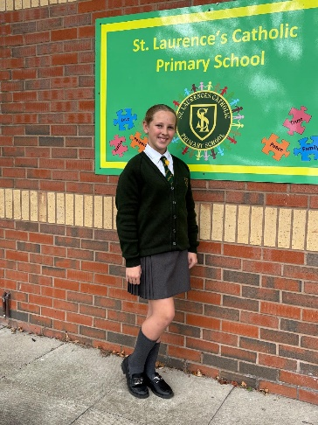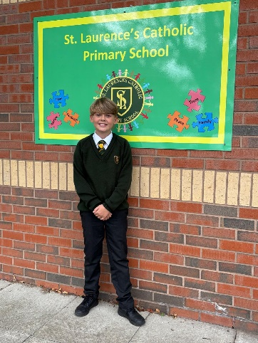**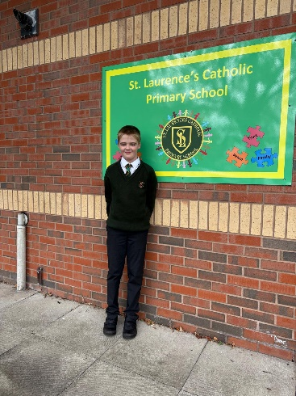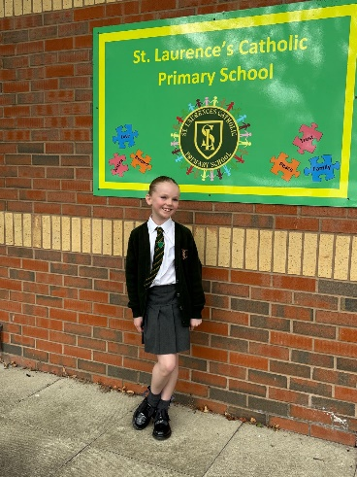Deputy Head Girl**: Harper Farrish

**Next Week After School Clubs**

|  |  |  |  |
| --- | --- | --- | --- |
| **Mon** | **Mini Vinnies**  (Miss Richardson & Miss Doolan) | **Athletics**  Mrs Purchase & Mr Folksman | **Multi-Sports**: Years 3, 4 & 5  Mr Cushion |
| **Tue** | **Football**: Years 3 & 4  (Everton in the Community) |  |  |
| **Wed** |  |  |  |
| **Thu** | **Football**: Years 5 & 6  (Liverpool Foundation &  Mr Grant) |  |  |
| **Fri** |  |  |  |

**

**Weekly Awards**

|  |  |  |  |  |  |
| --- | --- | --- | --- | --- | --- |
|  | **Kirkby Child** | **Star of the Week** | **English Star** | **Maths Star** | **Attendance** |
| **Nur** | **Maya O’Brien** | **Jude Gledhill** |  |  | **87.2%** |
| **RS** | **Coban Kearns** | **Peyton Fergus** | **Ivy Jones** | **Frankie Brougham** | **92.4%** |
| **RL** | **Dottie Lockwood** | **Sydnee Taylor** | **Emilia Cox** | **Alisha Woodhouse** | **91.3%** |
| **1S** | **Lola Fuller** | **Alfie Carroll** | **Lucia Banawich** | **Freya Shaw** | **93%** |
| **1L** | **Kara Austin** | **Rosie Molyneux** | **Alfie Marshall** | **George Seasman** | **98.4%** |
| **2S** | **Conlan Armstrong-Cook** | **Renesmee Slade** | **Oliver Kenny** | **Jaxon Kearns** | **90.4%** |
| **2L** | **Maggie Jones** | **Ethan Mawdsley** | **Charlie Warwick** | **Leo Brady** | **96.9%** |
| **3S** | **Alfie Stott-Jennings** | **Jaxx-James Siner** | **Penelope Leyland** | **Dax Faulkner** | **92.3%** |
| **3L** | **Hollie Lindon** | **Lacey-Mae Croxford** | **Bella Parry** | **James Gdula** | **98%** |
| **4S** | **Mia-Maria Goodwin** | **Connie Richards** | **Nordhan Yesudas** | **Oliver Sproule** | **96%** |
| **4L** | **Hallee Marr** | **Omotoyin Omotosho** | **Ruby Gee** | **Isaac Reynolds** | **99.2%** |
| **5S** | **Bobby Case-Cummins** | **Gloria Laczik** | **Lewis Slade** | **Layton Hoy** | **92.8%** |
| **5L** | **Lottie-Lou Cruickshanks** | **Skye Balmer** | **Joshua Kearns** | **Michael Walsh** | **98.4%** |
| **6S** | **Leticia Queiroz-Valli** | **Louie Soon** | **Theo Lyons** | **Jamie Dumbell** | **96.7%** |
| **6L** | **Laura Concha-Veroni** | **Maggie Craig** | **Darcy McCarthy** | **Frankie Flaherty** | **91.5%** |

**Kirkby Child Award highlights children who are:** respectful, honest and truthful, show a positive attitude, resilient, confident, a good communicator, polite, committed and hardworking, aspirational and ambitious.

**We hope you have a fantastic weekend, and we will see you all bright and early on Monday morning.**

**From Mr Mackenzie and all the staff at St Laurence’s**