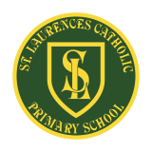
St Laurence’s Catholic Primary School Newsletter – Friday 18th July

Website: www.stlaurences.co.uk
Email: stlaurence@knowlsey.gov.uk
Instagram: stlaurencescps
Telephone: 0151 546 4733

Developing our gifts and talents for the good of all
This Week
Another brilliant week draws to a close here at St Laurence’s, and what a way to end the school year! Our amazing year 6 children marked their final days at St Laurence’s with a heartfelt Leavers’ Mass and celebration. We are so proud of the young people they have become. This week also saw huge smiles and colourful fun during our whole-school Colour Run – I’m not sure our cleaning staff were too impressed with the building at the end of Wednesday though! Thank you to all our staff who make these moments so special, and to our parents and carers for your fantastic support throughout the year. Your involvement makes a real difference, and we are truly grateful.

There’s a bit of information here about a couple of changes we’ve made in response to our parental questionnaire, updated entry and exit points for some year groups and a few final photos too.

As we close the school gates for the summer, we wish all our families a peaceful, restful holiday. We especially send our best wishes and prayers with our wonderful Year 6 leavers as they take their next steps. Thank you again for all your support – we look forward to seeing everyone in the new school year.

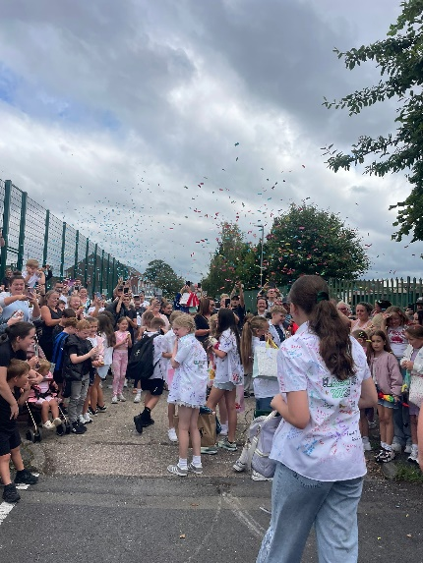
Year 6
What can I say that hasn’t been said these last few weeks about our leavers? They have been a credit to themselves, to you parents and carers, and to St Laurence’s school. They’ve had to deal with a huge amount during their time here, not least of all a pandemic, and have done so with commitment, honesty and kindness. From their academic skills to their arts and drama, from their kindness and caring nature through to their sporting prowess – we really do see them as a special group of people, and we will miss them when we come back. From all of the staff here at St Laurence’s, thank you, and good luck in year 7 and beyond – make sure you come back to see us so you can let us know how you’re getting on.

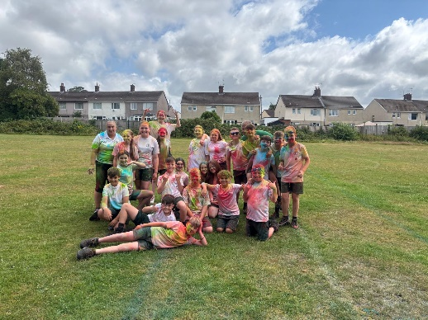
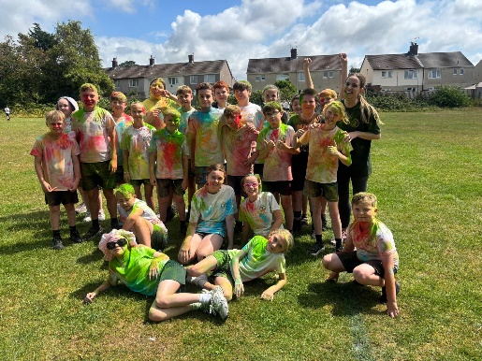
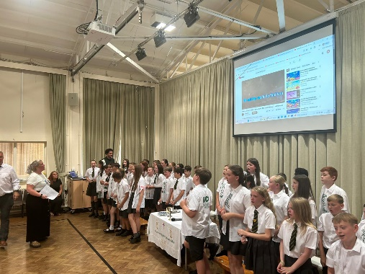

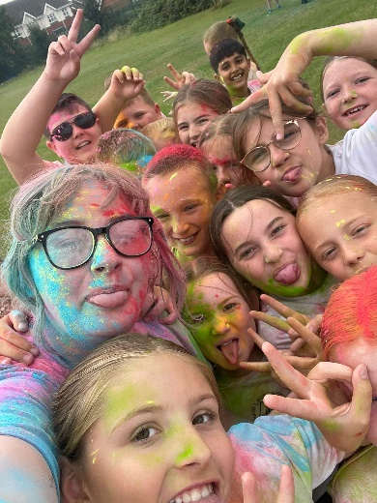
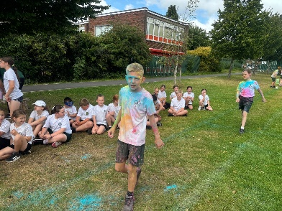
Colour Run
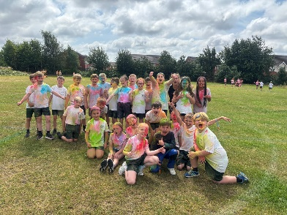
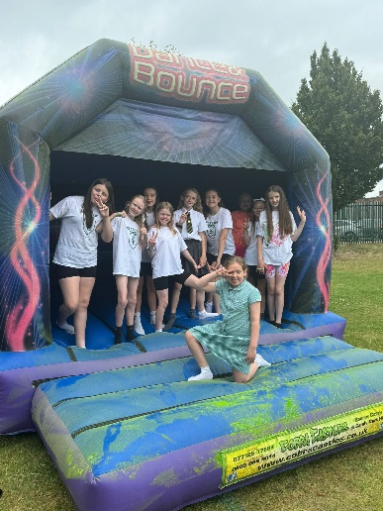
This was my first experience of a colour run and I’ve got to say my apprehension was fully justified, because this event was messy fun of the most extreme nature! To see our children running around, huge smiles, covered in paint and raising money at the same time was a real joy to see. Thank you to all the staff who took part and helped make this event so special, and to all you parents who kindly donated money too. The children absolutely loved it and as the photos show, they were an absolute mess come 3pm! Already counting the days until next year’s event!


Entry and Exit Points
We have put together a list of where each class will enter and exit the school in September and it is attached at the end of the newsletter. Following the letter that was sent out earlier this week regarding building works, this information is where we will come in and out of the building through until Christmas. If there are any changes parents and carers will be told in plenty of time.


Parental Questionnaire Response Part 1 – Improving Communication
Communication with parents and carers was raised as an area we could improve in several questionnaires, and we’ve listened. From September to ensure clear and consistent messages are given, Seesaw will no longer be used to share work or communicate, and on Instagram comments and replies will be disabled. Going forward, all communication from school will come through the weekly newsletter and School Spider so please ensure you can access both of these services. All communication to school from parents and carers must go through the school office - either in person, by phone, or via email – and to try and make this even simpler we are looking into a text messaging option through School Spider as well, we will share more details once confirmed.

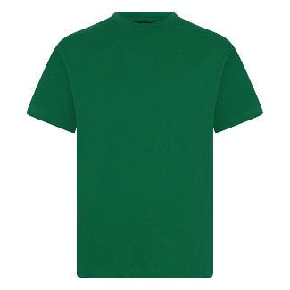
Parental Questionnaire Response Part 2 – PE shirts
Another point shared by numerous parents was how difficult it can be to keep white PE shirts clean – as a parent of two white t-shirt wearing girls, I completely understand! To help with that from next year, all children will move to a bottle green PE t-shirt with the school logo, all other school uniform will remain the same. We have already contacted two local suppliers – Liver Print and Kids Kirby Schoolwear – who will be stocking the new green PE tops. This change will be introduced gradually over the next 12 months, so please don’t feel any pressure to replace uniform straight away. If your child still has a white PE shirt that fits – especially if you’ve only recently bought one – they are very welcome to continue wearing it for the coming school year so that you get your money’s worth! Please only make the change to green when it’s time to replace their current shirt – there is no no need to spend money unnecessarily.
Final Photos
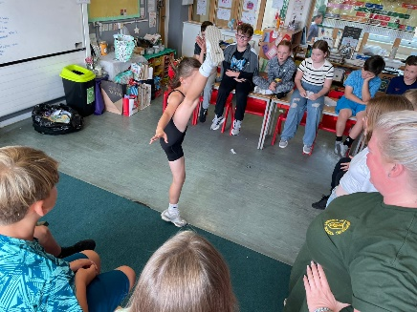
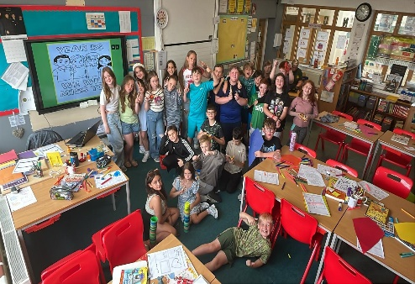
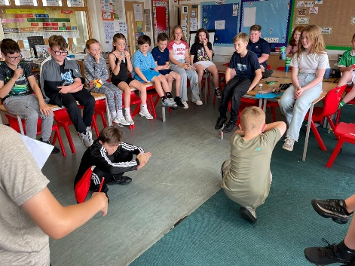
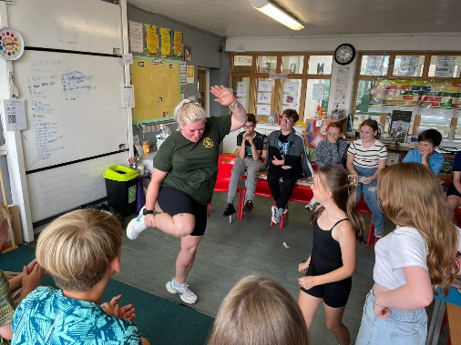
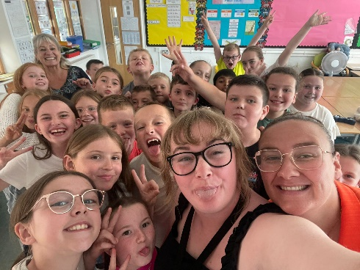
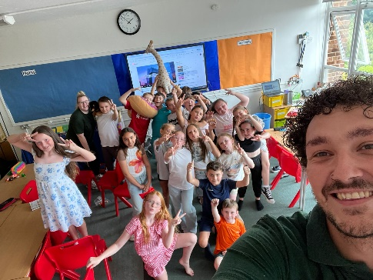
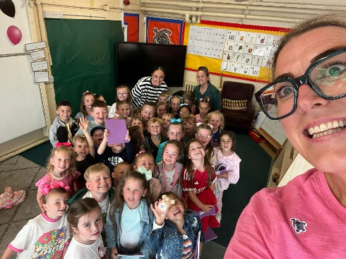
Here are a few final photos of the school week for you to enjoy!
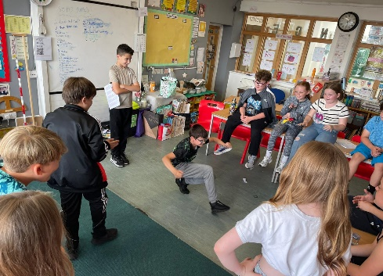
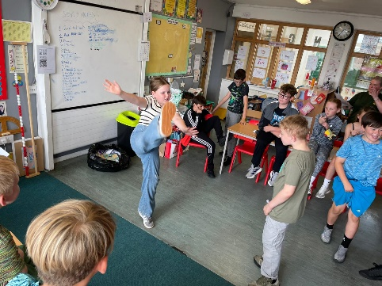
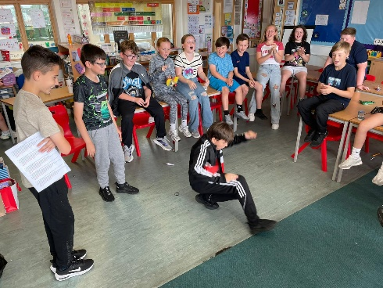
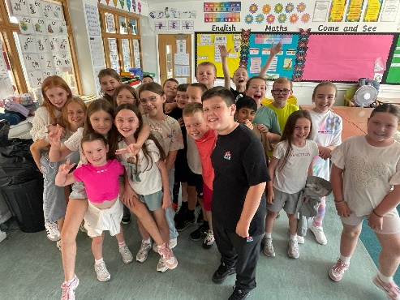

2025 – 2026
Finally, a quick reminder that school begins again for the children on Tuesday 2nd September at 8:40am. During the final week of the summer holiday we will be in touch with you all with a few reminders and key dates for the year. So until then, all of us here at St Laurence’s wish you all a very happy and peaceful summer holiday.

See you all in September!

