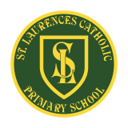
St Laurence’s Catholic Primary School Newsletter – Friday 11th July

Website: www.stlaurences.co.uk
Email: stlaurence@knowlsey.gov.uk
Instagram: stlaurencescps
Telephone: 0151 546 4733

Developing our gifts and talents for the good of all

This Week
Another brilliant week draws to a close here at St Laurence’s, and what a week it’s been! Our Year 1 and Year 3 children had fantastic educational visits to Farmer Ted’s and the Catalyst Museum, enjoying hands-on learning experiences that brought their classroom topics to life. Year 5 became young scientists, taking part in an exciting investigation that sparked curiosity and teamwork, while our Year 6 pupils made lifelong memories on their residential trip to Ormside, showing independence, resilience and friendship throughout. We also celebrated a very special milestone as our Nursery children graduated, marking the end of their early years journey with smiles, songs and a few happy tears! Thank you to all our staff for making these moments possible - don’t forget to check Instagram for pictures and updates. Have a restful weekend and enjoy the sunshine, see you all again on Monday for the last week of the school year!


Illness in school
We’ve had a noticeable increase in illness among both staff and children this week, and we want to do all we can to keep everyone well as we head towards the summer holidays. If your child is feeling unwell, especially with symptoms such as a high temperature, diarrhoea or vomiting, please keep them at home until they are fully recovered. Taking their temperature and monitoring for other signs of illness can help prevent the spread of bugs across the school. Thank you for your continued support in helping us look after the health and wellbeing of our whole school community.

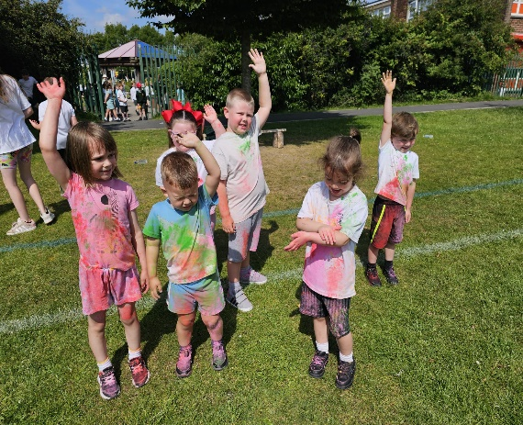
Nursery Graduation and Colour Run
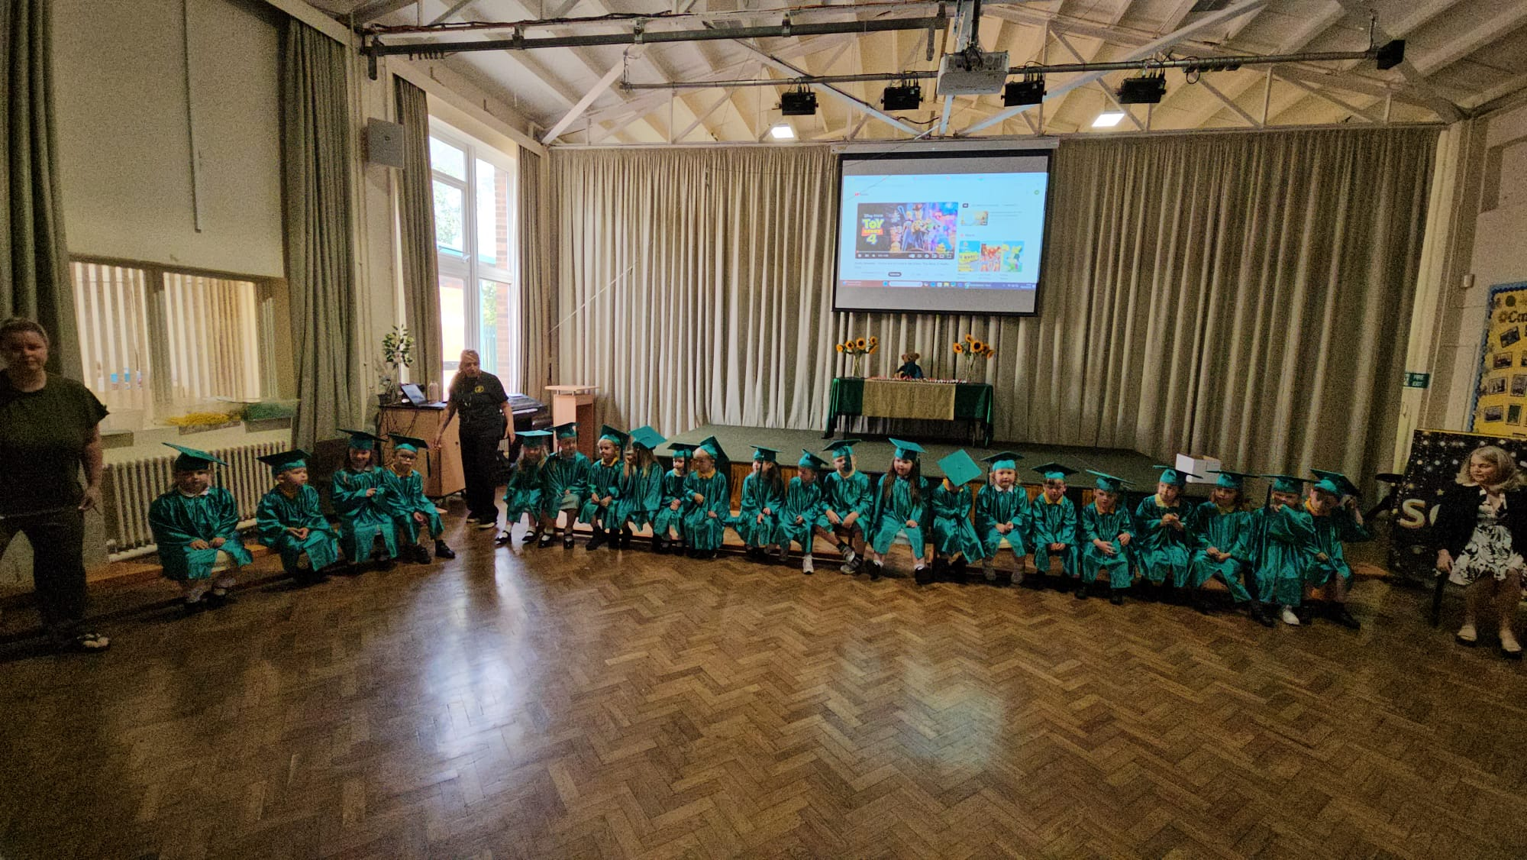
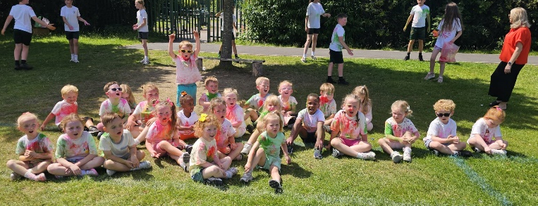
Having worked so hard all year, it was fantastic to see our nursery children celebrating this week and enjoying a well-earned bit of fun with their colour-run. Mrs Middleham, Mrs Powell and Mrs McVey have all told me during this term that the girls and boys in nursery are an absolute pleasure to have and bring lots of fun and laughter to every day. Each of the children really enjoyed their graduation celebration, and as you can see, they also loved their colour run. Thank you to our staff who work so hard each day to provide an amazing education, and to all of you mums, dads, grandparents, aunties and uncles for your support this year.
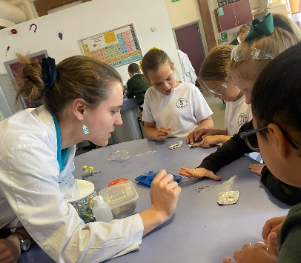
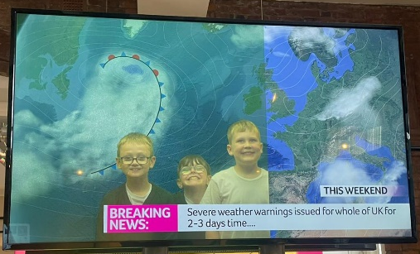
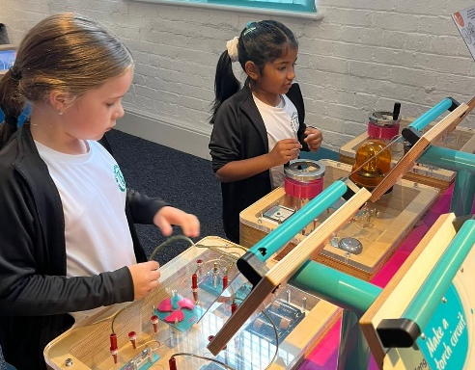
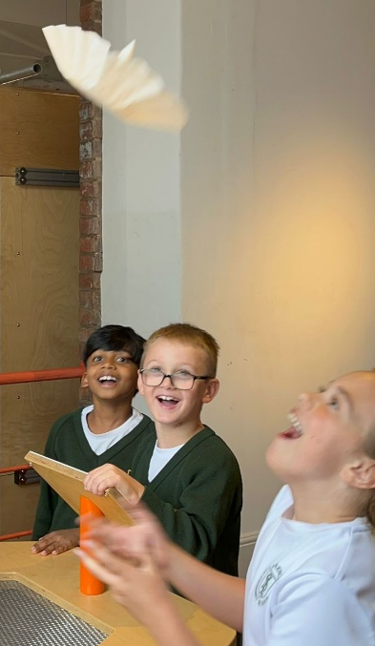
Year 3 Trip to the Catalyst Museum
Our Year 3 children had a fantastic day at the Catalyst Science Discovery Centre in Widnes, exploring hands-on science through a range of exciting activities. They took part in interactive workshops linked to our science curriculum, learning more about materials, chemical reactions and forces in a fun and engaging way. The children loved the opportunity to experiment, ask questions, and explore the exhibits with curiosity and enthusiasm. Their behaviour throughout the day was excellent, showing great respect and interest in everything they did. A big thank you to everyone who organised the trip and went along with our school for making the day so enjoyable and educational for everyone involved.

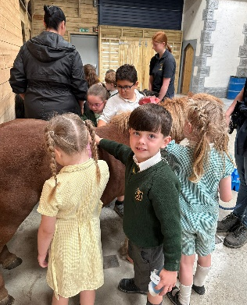
Year 1 Trip to Farmer Ted’s
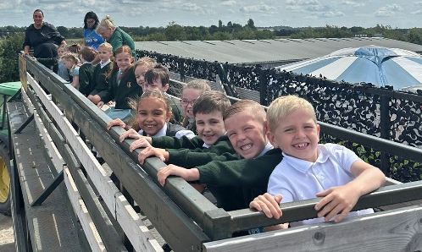
Our Year 1 children had a wonderful day out at Farmer Ted’s, filled with fun, learning, and lots of fresh air! As part of our science and geography curriculum, they explored animal habitats, learned how to care for farm animals, and talked about the seasons and food production. The children especially enjoyed the petting area, tractor ride, and adventure play zones, which gave them plenty of opportunities for hands-on learning and exploration. Their behaviour was fantastic, and they represented our school beautifully with their kindness and enthusiasm. A big thank you to all the staff at Farmer Ted’s for a brilliant and memorable day.

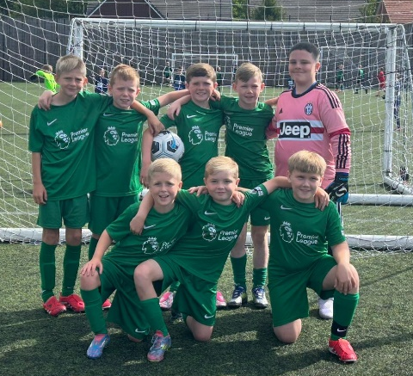
Year 4 football tournament
Having recently secured The Treble, our mighty year 4 football team took to the field of battle on Monday this week. Led by Mr Grant the boys once again marched their way into the final, only to be beaten by Malvern Primary in a keenly contested game. We couldn’t be prouder of our sporting girls and boys in St Laurence’s – across all sports, but I believe this group in particular is highly skilled and although we tasted the bitterness of defeat here, we’re all extremely proud and are sure that years 5 and 6 will bring further success to group already weighed down by medals! Well done boys, onwards and upwards.

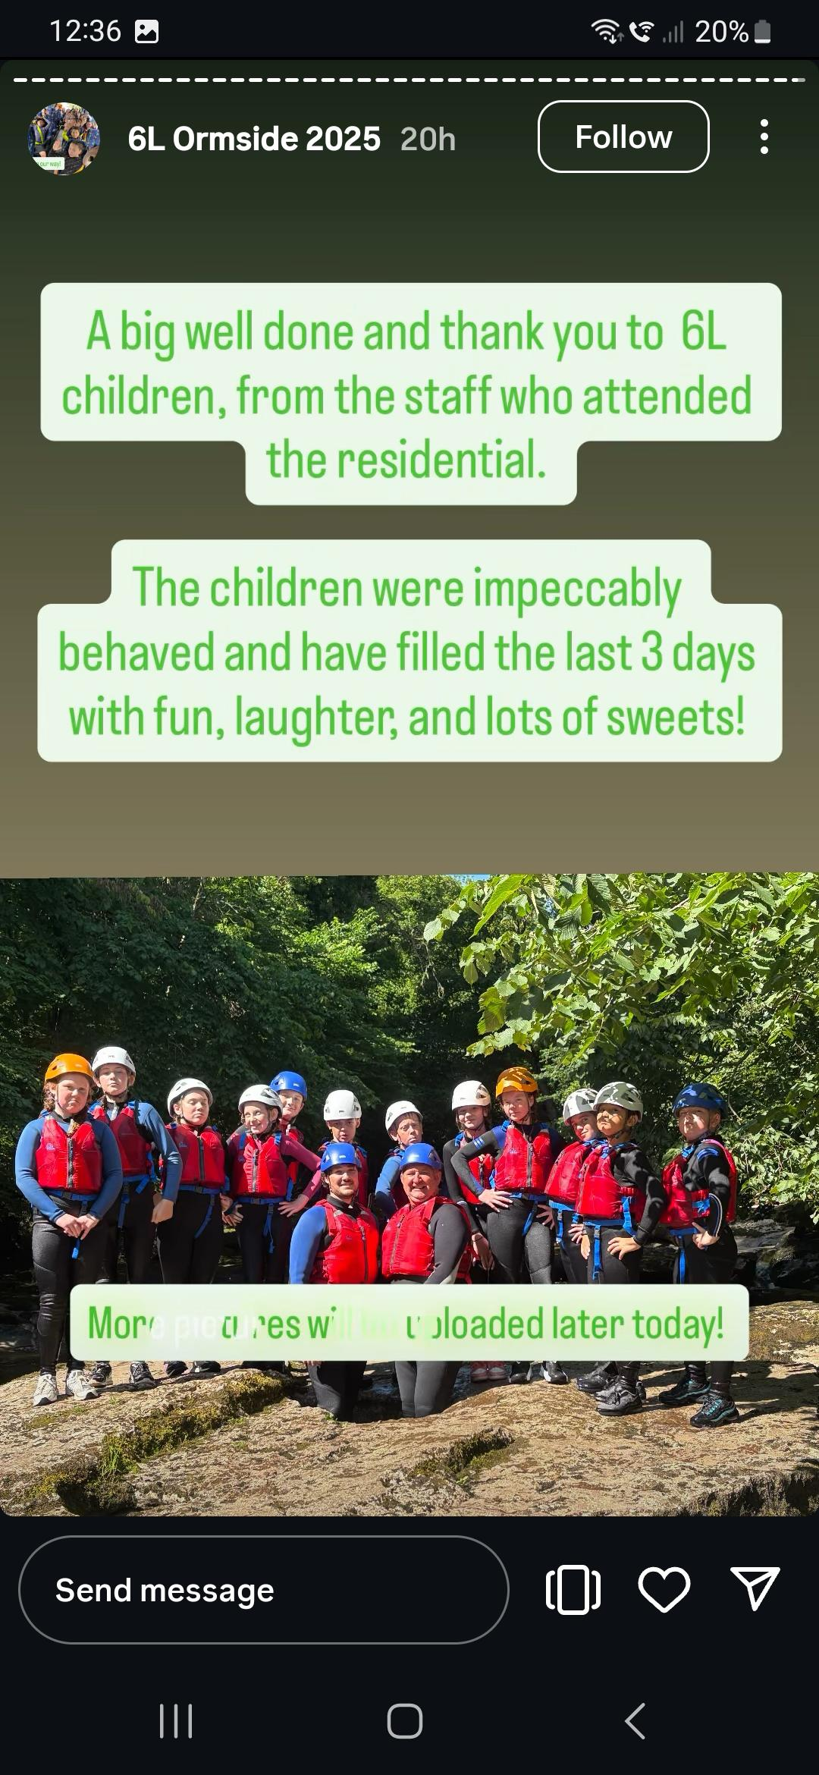
Year 6 Trip to Ormside
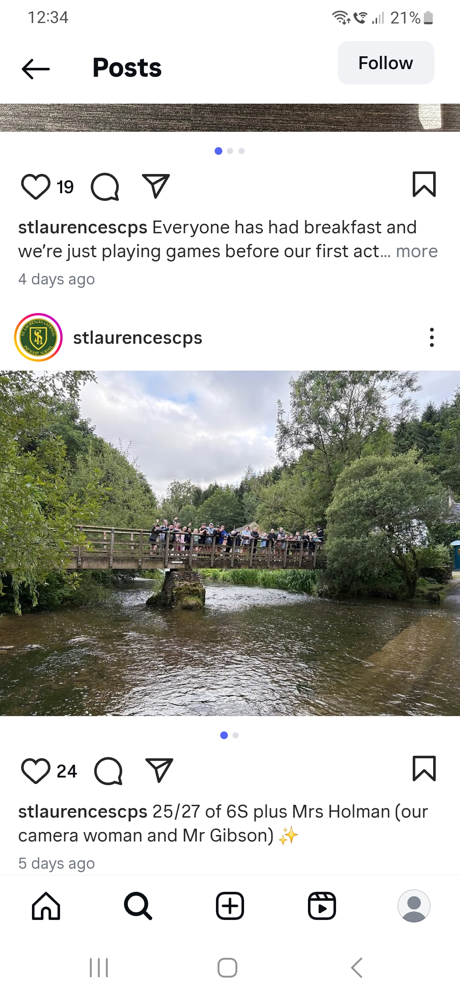
Firstly, I want to say a huge thank you to the staff who went alongside to Ormside, giving up their time to ensure the children had a safe and enjoyable few days. Also, to the staff who stayed back in school filling in on the daily jobs we need to make St Laurence’s the great school it is. If you look on our Instagram page you’ll see all the photos from both trips, so I’ll just say again how much they enjoyed their break (I’m sure you parents/carers did too!) and that, as Mr Kenny told me, these events are a fantastic part of our job.

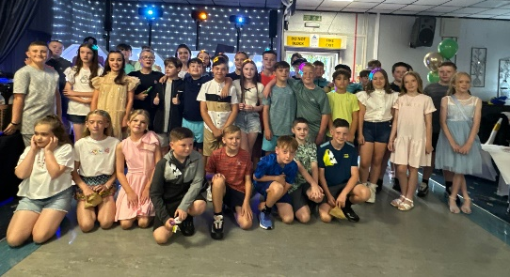
Year 6 Prom
We recognise that school have nothing to do with the end of year party our year 6 enjoyed last weekend, but looking at the photograph here I can see just how fantastic it was. So from all the staff in St Laurence’s, thank you to the parents and carers who organised and managed the event – from what I heard in school the whole thing was a roaring success!

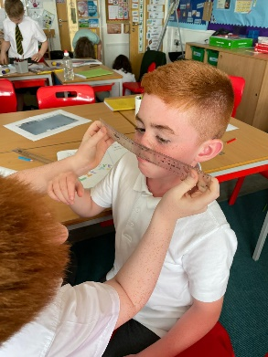
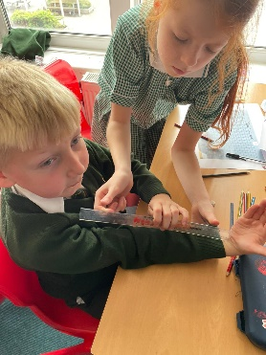
Year 5 Science Investigation
Ever the hard working professional, whilst other classes were off on trips and doing outdoor adventure activities, Mr Folksman had year 5 doing good old-fashioned classroom work. Learning all about the importance of data gathering and analysis, year 5 had a great time working with their friends and measuring numerous different features of the human body. A fine way to end the summer half term! We’re hopeful that no noses were injured in the making of this photograph.

Instagram Information
Over the past week, we’ve had quite a few messages sent to school via Instagram, so I wanted to kindly remind everyone of how we use this platform. Instagram is a lovely, optional extra that our staff offer to give you a glimpse into school life showing your children learning and having fun. It’s not something we have to do, and our staff do this in their own time, so please understand we can’t always feature every child or catch a perfect smile every time! Instagram is not a way to communicate with staff, so I’ve instructed them not to reply to messages or comments. We love being able to share these moments with you and hope to continue doing so. Thank you so much for your understanding and continued support.

After School Clubs
Tuesday | Football  Year 2  Mr Gibson | Sports Club  Years 3 and 4  EFC in the Community
Thursday | Choir  Years 3, 4, 5 and 6  Mrs Faulkner | Mini Vinnies  Mr Folksman

Dates for next week
- Tuesday 15th, 3:30pm: Talent Show
- Thursday 17th, 9:30am: Leaver’s Mass
- Thursday 17th, afternoon: Colour Run for reception – Y6
- Friday 18th, Party Day & non-uniform day
- School finishes at 2pm on Friday 18th

The awards and attendance table will be updated on Monday morning and shared with parents via School Spider!

We hope you have a fantastic weekend, and we will see you all bright and early on Monday morning.

From Mr Mackenzie and all the staff at St Laurence’s

