
St Laurence’s Catholic Primary School Newsletter – Friday 4th July

Website: www.stlaurences.co.uk
Email: stlaurence@knowlsey.gov.uk
Instagram: stlaurencescps
Telephone: 0151 546 4733

Developing our gifts and talents for the good of all

This Week
Another busy and brilliant week comes to a close here at St Laurence’s! Across the school, our children have been making the most of every moment – from exciting Sports Days filled with fun and friendly competition to the laughter and joy of our Nursery Fun Day complete with bouncy castle! We’ve celebrated the achievements of our children in our End of Year Awards, recognising hard work, kindness and perseverance throughout the year. We’ve had children learning how to keep themselves safe throughout Road Safety work, and of course our footballers who brought the Walter Tomlinson trophy home! There’s also a special mention to one of our pupils for an incredible individual achievement in taekwondo – we are all so proud! As always, keep an eye on Instagram for photos and updates, and enjoy a restful weekend before another week of fun begins.

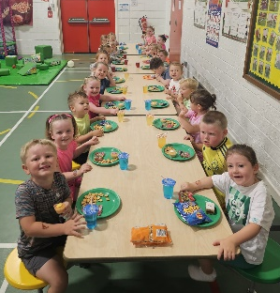
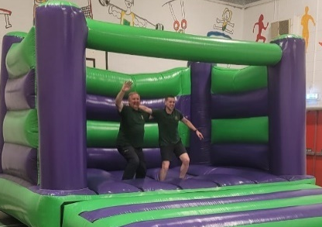
Nursery Fun Day
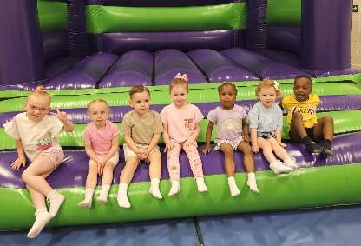
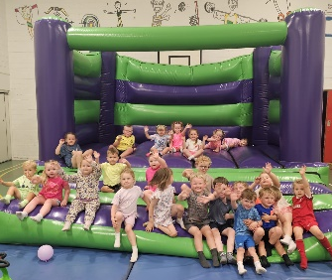
Wednesday saw our fantastic nursery children enjoy a well-earned fun day in the sports hall. Having been safety checked by the ever-professional Mr Grant and Mr Gibson, the children had a bouncy castle, adventure equipment and bikes to play on, and my word did they take advantage! It was great to see all of our morning and afternoon children having fun with their friends and making memories of their time as a group. Thank you to our staff for organising this event, and I’m sure the children are extremely thankful too looking at their happy faces on these photos!

Sports Days
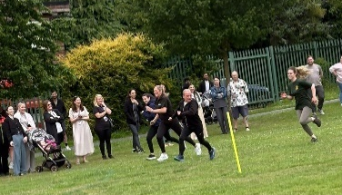
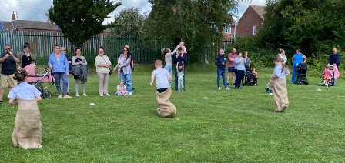
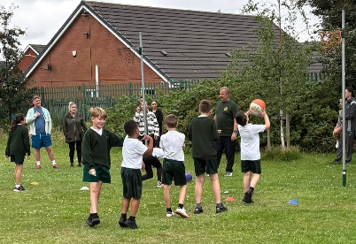
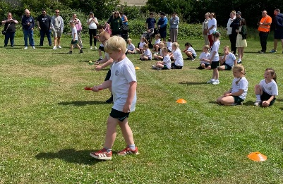
It was brilliant to get the sports days for years 1, 2, 5 and 6 all completed this week. We know our children at St Laurence’s really enjoy completing lots of sporting games and activities, and some of the talent on show was first class. Thank you again to staff for your hard work setting it all up, and to all you parents and carers for coming along to cheer the children on. I will be speaking to Mrs Hill regarding her unacceptable sprinting seeing as how she has been left trailing behind in the mum’s race. However, these days are always a memorable event for the children, and we can see from the photos and red faces that they certainly got the most out of their time on the field!
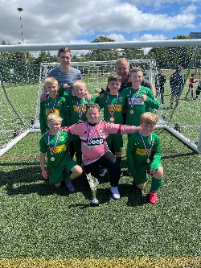
Father Ryan & Walter Tomlinson
We had teams representing St Laurence’s at the annual Father Ryan and Walter Tomlinson competition on Saturday just gone. Firstly, can I thank Mr Grant and Mr Gibson for giving up their Saturday morning to take our teams through the competition – hugely appreciated. But also of course, enormous congratulations to both teams who competed amazingly and represented the school with real character and teamwork. For the third year on the spin, the Walter Tomlinson trophy will reside in our school as St Laurence’s beat a well drilled Millbrook in the final.


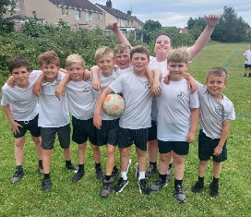
Year 4 Times Tables Party
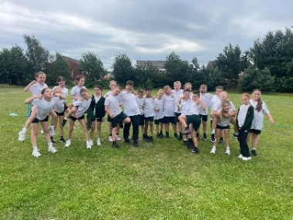
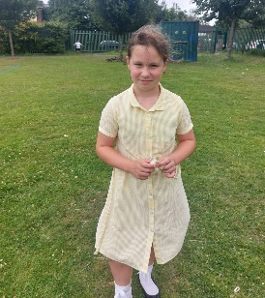
Our year 4 children have worked incredibly hard this year across the curriculum, in one specific area that has been evident – and this afternoon saw the pay off. A well-earned party took place, complete with Costco Cake, to say a huge well done to each and every member of year 4. Many of our children scored 25 out of 25 which is truly outstanding, but also it is only fair to say that no matter what score your son or daughter achieved, the amount of progress made in year 4 times table knowledge is nothing short of astonishing. We are proud of you all year 4 – congratulations!

EFC in the Community

Jacob Lannigan and Frankie Walker represented St Laurence’s at a special event recently. Everton in the Community, who deliver PE within our school, held a football event and both boys could not have done any better than they did. Not only were their immense football skills on show for the spectators, but their sportsmanship, good manners and excellent behaviour were commented on by staff and other schools alike. Anybody who works in a school will tell you that there are not many better compliments than another school talking positively about our school, and Frankie and Jacob have both had just that. Proud of you both boys – thank you!

Year 6 reminders: Ormside and SATs results
A quick reminder that our Ormside trips take place next week; Monday to Wednesday for 6S and Wednesday to Friday for 6L. You’ve had all of the information you need for this trip so please make sure you arrive in good time on the day you leave school. Our children’s SATs results are released next week

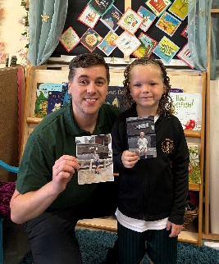
Pudding Lane Y1 child
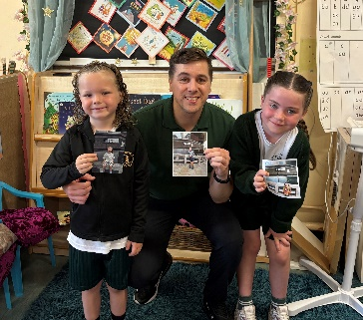
As part of our year 1 history curriculum, the children learn all about The Great Fire of London. Well we’ve got a couple of children, Leo Brady and Penelope Leyland, who have not only learnt about this event in school, but have also took their education further by visiting the famous starting point – Pudding Lane. Even Mr Gibson has been and has clearly perfected the ‘photo lean’ pose. It is always great to see our children going beyond what we do in class!
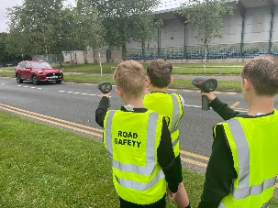
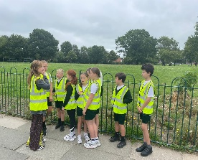
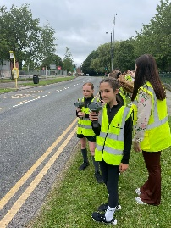
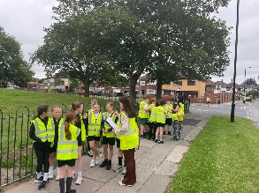
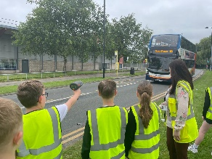

Road Safety (written by Marcus John-Greaves, 4S)
Lots of our classes took part in Road Safety learning this week and we found out about lots of important things like: people shouldn’t be parking on the kerb because that’s where we walk, lots of cars which sometimes surround kids makes them feel unsafe and really important is that some cars are going too fast and can hurt children. We loved learning and road safety, it was really interesting and useful because it keeps us safe by the roads.

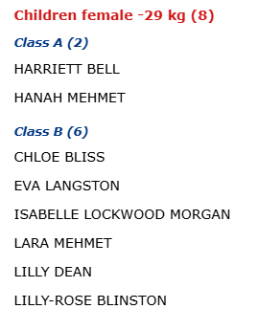
Taekwondo Champion
A few weeks ago, a very special member of our school took part in not one, but two different taekwondo competitions in the UK. Lily Dean, as always, was a credit to herself and her family in these special events and of course she only went and won them both, bringing medals, glory and a black eye back with her at the end of the day. Massive well done to you Lilly, we are all so proud of you and we’re sure you will continue to take the Taekwondo world by storm!


End of year report
Today, your child will be bringing home their end-of-year report. We encourage you to take some time to read through it and celebrate the wonderful achievements they have made throughout the year. Our staff regularly share how proud they are of the effort, progress and resilience shown by all our pupils – and we truly mean it. If you do have any questions, please feel free to get in touch and thank you, as always, for your continued support.

End of Year Awards
One of the nicest parts of our job is being given the chance to celebrate the achievements of our children, and this week saw us take that opportunity. I’m going to direct you all to Instagram to get the full effect as teachers have put on lots of photos and videos there. If I tried to get them on the newsletter, we’d be looking at a 50-page document! Suffice to say we are all thrilled to recognise the achievements of the children who have worked so hard to earn them all year – congratulations everyone!
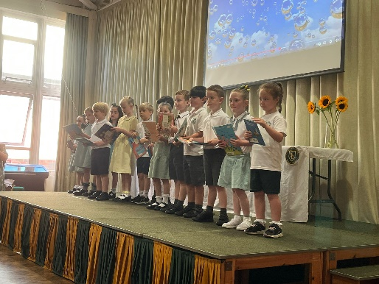
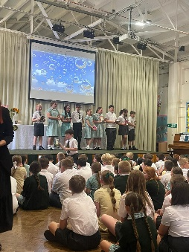
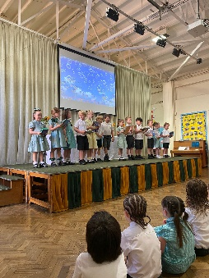
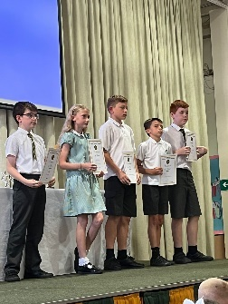

After School Clubs
Monday
Tuesday | Football  Year 2  Mr Gibson | Sports Club  Years 3 and 4  EFC in the Community
Wednesday
Thursday | Choir  Years 3, 4, 5 and 6  Mrs Faulkner | Mini Vinnies  Mr Folksman
Friday

Dates for next week
- 6S Ormside Trip Monday – Wednesday
- 6L Ormside Trip Wednesday – Friday
- Wed 9th Nursery Graduation 10am & 2pm
- Thurs 10th Colour Run for Nursery 10am & 2pm
- Fri 11th Nursery finish

Attendance
As we’ve just celebrated our end of year awards, we will just provide the attendance data for this week, please find this below.
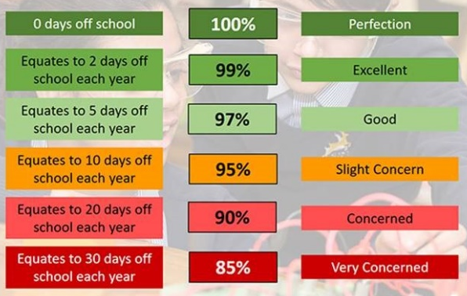
 | Attendance
Nursery | 98%
Reception | 92.3%
1S | 96%
1L | 98.5%
2S | 98.5%
2L | 93.8%
3S | 93.6%
3L | 96.6%
4S | 94.4%
4L | 93.2%
5S | 99.2%
5L | 91.2%
6S | 97.8%
6L | 96.8%

Attendance – Target is 96%
Attendance and punctuality are both vital to your child’s success in school – every minute really does count, as learning begins promptly at 8:45am. Being in school every day, and on time, helps your child to settle quickly, build good routines, and get the most out of every lesson. Thank you to all of our parents and carers who work hard each day to make this happen – your support makes a big difference, and it is very much appreciated.

We hope you have a fantastic weekend, and we will see you all bright and early on Monday morning.

From Mr Mackenzie and all the staff at St Laurence’s

