
St Laurence’s Catholic Primary School Newsletter – Friday June 27th

Website: www.stlaurences.co.uk
Email: stlaurence@knowlsey.gov.uk
Instagram: stlaurencescps
Telephone: 0151 546 4733

Developing our gifts and talents for the good of all

This Week
Another eventful week in St Laurence’s comes to a close. All our children enjoyed a transition day where they got to meet their teacher for next year and take part in some lovely activities – keep an eye on Instagram for pictures and videos! We’ve also had educational visits to Knowsley Safari Park, some of our Sports Days were able to take place and sadly a few had to be postponed due to classic English summertime weather. However, the fun never stops here in school and all our hardworking staff and amazing children have continued to learn, continued to enjoy time with their friends and with the summer holidays in sight, I’m sure they will spend the next three weeks in a state of excitement and anticipation. Enjoy your weekend everyone, and we’ll see you all on Monday morning.

School Spider
We want to take a moment to thank all our parents and carers for working in partnership with us and for always supporting school events and updates. Please can we gently remind everyone that School Spider is our main method of communication. It’s really important that every parent and carer has access to it and regularly checks it, especially during busy times or when plans may change at short notice.

For example, this week, due to the unpredictable weather, we shared updates through School Spider regarding changes to Sports Day. Despite this, we still received a large number of phone calls asking for clarification. While we are always more than happy to support you with any questions or concerns, we kindly ask that you check School Spider before calling, particularly if the information has already been shared there. If a message has gone out from school, there is no need to phone to double-check – it is correct.
We truly appreciate your support with this. Our aim is simply to keep communication clear, timely, and manageable for everyone. Thank you for your understanding.

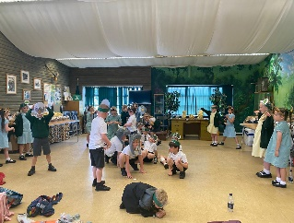
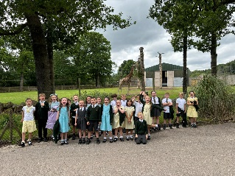
Knowsley Safari Park
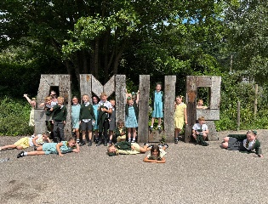
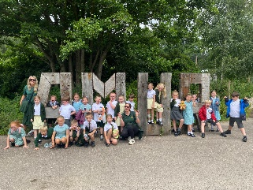
As part of their science work on ‘Animals and their habitats’ year 2 children spent the day learning about lots of different animals (and their habitats) during their visit to Knowsley Safari Park. Rhinos, sealions and ostriches were just a few of the animals the children observed and learned about during the day. Having listened to the stories as they returned to school, the whole year group clearly had an amazing time. Thank you to all our fantastic staff for organising the trip and going along, and of course to our parent helpers who came along too – we really appreciate the help!

Transition Day (and Ice Pop Friday!)
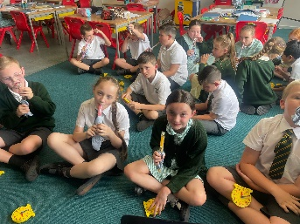
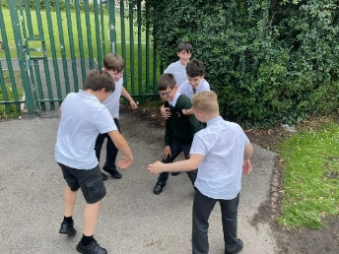
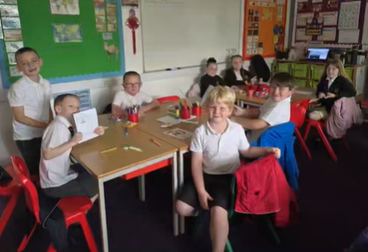
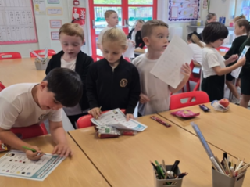
Every year children are excited to find out who their teacher will be when they come back in September, and today the children spent the morning in their new classroom with their new teacher. It was great to see them all having fun and getting used to their new surroundings. I know the teachers and teaching assistants were so impressed with the children, clearly they are all ready for the next stage in their education. Keep an eye on Instagram for a few photos and videos of the activities they completed.

Awards Assembly
Our annual end of year awards assembly takes place next Thursday, see the ‘Key Dates’ section for the exact times. Parents and carers of those children who will receive awards have been contacted about the arrangements and we look forward to welcoming you next week. We are immensely proud of all our children and throughout the year every child in celebrated for their achievements. At the same time, those children who are receiving awards have caught our eye across the last 9 months and thoroughly deserve the recognition they will get next week.

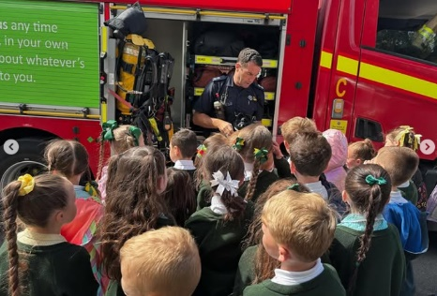
Fire Service Visit
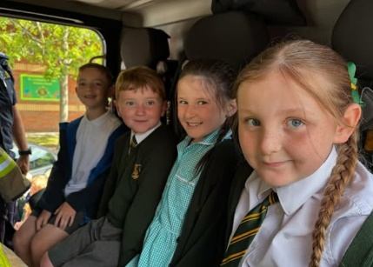
As I witnessed a throng of viewers congregate by our school photocopy machine earlier this week, I knew instantly what was taking place on our front car park. It was year 2’s turn to benefit from the wisdom of the fire service during the week, and they certainly learned a lot about how our firefighters keep people safe, the importance of the equipment they use and how to keep themselves safe at home. These events are such an important part of the children’s education and provide them with lasting memories of their time at St Laurence’s.

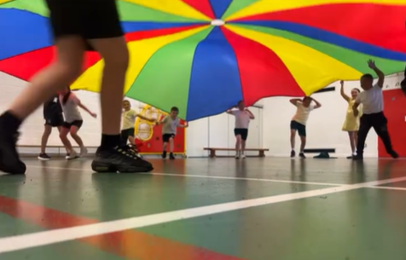
‘Chute, there it is!’ ©Mr Folksman
I’m always happy to plagiarise other people’s good work, and this lyrical masterpiece from Mr Folksman on Instagram is certainly worth repeating! It is brilliant to see children enjoying themselves in school, and to see children being children – revelling in a simple game and recalling the fun they had when they were a little younger. I know the whole class thoroughly enjoyed their retro PE lesson this week building on their teamwork skills, encouraging one another, and having lots of fun. The activity was a great way to keep fit while working together and sharing plenty of laughter along the way!


Parental Survey Feedback
Thank you to everyone who gave in their parent views on our questionnaire this week. The responses we received were overwhelmingly positive and confirmed what we believe too – St Laurence’s is a good school. As soon as we have collated all the responses, we will send out a letter to let you know exactly what has been said, we will celebrate the positives and try to work with you parents and carers to improve where we can (one such suggestion has already to acted on below with Key Dates section!) Thank you again, and we look forward to working with you all in the coming weeks and months.

All Saints Year 5 Fun Day
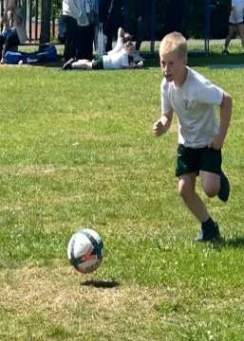
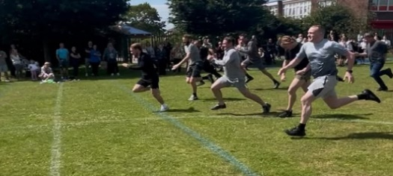
Sadly, this event which was scheduled for next Friday has had to be cancelled due to the measles outbreak in Kirkby. Don’t worry though year 5 parents and carers, I know there are lots of opportunities for you to get a feel for our local Catholic secondary school and we will be in touch in the future as these events are planned. Thank you for your understanding.
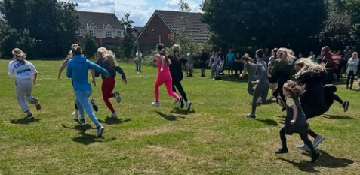
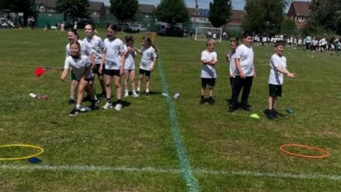
Sports Days
We were lucky enough to get a few of our Sports Days in this week while the weather held out. As always, thank you to all parents and carers who came along to support and cheers on your children. And also to our staff who go the extra mile day after day to make these events so much fun for our children. It was great to see so many children being active and having fun. Having watched the videos of the mums and dads races too, I feel it only fair to congratulate those of you who managed to complete these races without the dreaded pulled hamstring!!
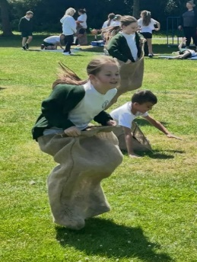
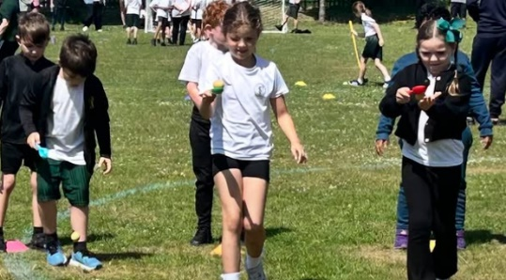
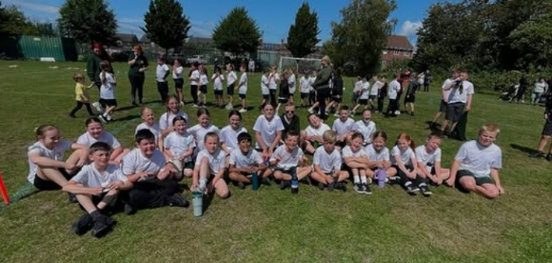
Key Dates
2:00pm Tuesday 1st July: Y5 & Y6 Sports Day – Field behind school
2:00pm Wednesday 2nd July: Y1 & Y2 Sports Day – Field behind school
9:15am Thursday 3rd July: reception, Y1 &Y2 Awards Assembly – Main Hall
2:00pm Thursday 3rd July: Y3, Y4, Y5 & Y6 Awards Assembly – Main Hall
8:45am – 3:15pm Friday 4th July: Y1 Farmer Teds Trip
8:45am – 3:15pm Friday 4th July: Y3 Catalyst Museum Trip

After School Clubs
Monday
Tuesday | Football  Year 2  Mr Gibson | Sports Club  Years 3 and 4  EFC in the Community
Wednesday
Thursday | Choir  Years 3, 4, 5 and 6  Mrs Faulkner | Mini Vinnies  Mr Folksman
Friday

Weekly Awards






 | Kirkby Child | Star of the Week | English Star | Maths Star | Attendance
Nursery | Reuben Parry | Emilia Cox |  |  | 90.6%
Reception | Freya Shaw | Rosie Clarke | Skye Hamid | Hattie Gorman | 94.3%
1S | Noah Prince George | Indie Regan-Nicholson | Abigail Riley | Carter Goodwin | 96.4%
1L | Charlie Warwick | Joel Keegan | Cienna Rafferty | Leo Crellin | 96.9%
2S | Millie Haddley | Lilly Walsh | Noah Jones | Rosa Flaherty | 95.4%
2L | Harlen Farrell | Logan Sutherland | Leo parry | Jax Gordon | 95%
3S | Nelly O’Brien | Esme Evans | Caleb Rafferty | Freddie Reid-Watkinson | 97.3%
3L | Nancy Lovett | Jasper McNabb | Piper Farish | Kody Marsden | 97.2%
4S | Bobby Case-Cummins | Isla Rossiter | Kendall Hamid | Ronnie Baines | 90.4%
4L | Skye Balmer | Nancy Towey | Isabella McGreevy | Luka Banawich | 88%
5S | Luis Da Silva | Charlie Payne | Halle Carter-Smith | Layla Cooper | 98.4%
5L | Theo Lyons | Heidi Devine | Lucas Gibney | Louie Soon | 91.2%
6S | Georgia Sproule | Steven Hogg | Lilly Dean | Sonnie Clarke | 94.8%
6L | Lennon Carey | Ryan Langstaff | Amelia Smylie | Jacob Ainsworth | 93.6%
Kirkby Child Award highlights children who are: respectful, honest and truthful, show a positive attitude, resilient, confident, a good communicator, polite, committed and hardworking, aspirational and ambitious.

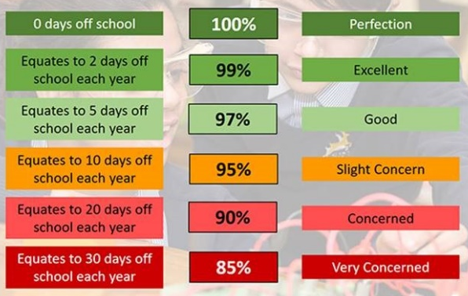
Attendance – Target is 96%
Attendance and punctuality are both vital to your child’s success in school – every minute really does count, as learning begins promptly at 8:45am. Being in school every day, and on time, helps your child to settle quickly, build good routines, and get the most out of every lesson. Thank you to all of our parents and carers who work hard each day to make this happen – your support makes a big difference, and it is very much appreciated.

We hope you have a fantastic weekend, and we will see you all bright and early on Monday morning.

From Mr Mackenzie and all the staff at St Laurence’s

