
St Laurence’s Catholic Primary School Newsletter – Friday June 20th

Website: www.stlaurences.co.uk
Email: stlaurence@knowlsey.gov.uk
Instagram: stlaurencescps
Telephone: 0151 546 4733

Developing our gifts and talents for the good of all

This Week
Another scorching hot week has come to a close here at St Laurence’s, and yet again there has been a huge amount of learning and fun activities going on from nursery right through to year 6. Our nursery had a hugely enjoyable time at their Sports Day, our year 5 classes enjoyed a day out at Croxteth Park, year 6 led us through a lovely liturgy on being truthful and year 4 came into school today dressed in their Holy Communion outfits to celebrate as a class. We had the pleasure of meeting faces old and new at our reception intake meeting on Wednesday night, all of our staff are thrilled to meet families who will begin their journey through St Laurence’s starting in September. Enjoy reading our newsletter, enjoy the weather over the weekend (remember that factor 30!!) and we will see you all again bright and early on Monday.


We’re now on Instagram!
Our new Instagram account is now live – follow us at www.instagram.com/stlaurencescps/. Thank you to those of you who have followed us already, we hope you are enjoying the photos and videos our dedicated staff are adding. If you haven’t had the chance to follow us yet, why not set yourself up over the weekend so that you can see exactly what your child’s class is up to.

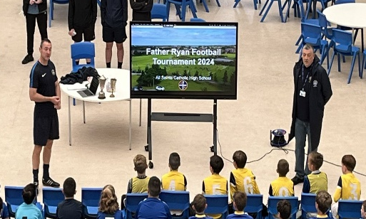
Father Ryan & Walter Tomlinson Primary Football Tournaments
Next Saturday morning is the annual Father Ryan & Walter Tomlinson football tournaments which will take place at All Saints. Can all children who have been selected please ensure you are at All Saints for 8:50am completely ready to take part. Kits will be given out on the Friday to take home, so arrive with them on plus boots, shinpads and water bottles. With our proud sporting history, I am sure our school will do extremely well. Good luck everyone!


Parental Questionnaire - your voice makes a difference
Thank you to those of you who took the time to complete our questionnaire this week. It is enormously helpful to get your input and ideas as to how we can celebrate what we do well, and make improvements where we are able. Monday is the last date we can accept these so please complete the form and send it in – if you are perfectly happy, fill the form in and let us know that is how you feel! Next week, our Senior Leadership Team will collate the responses and a letter will be sent to all parents and carers before the end of the academic year to let you know how we got on!

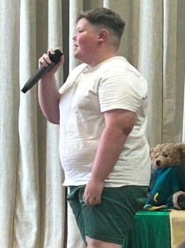
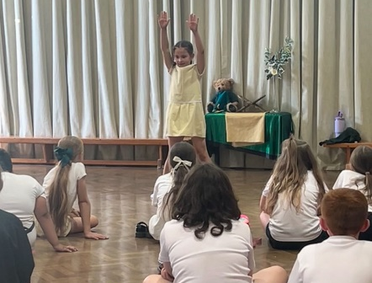
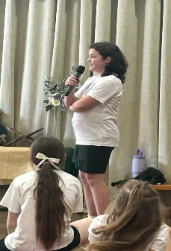
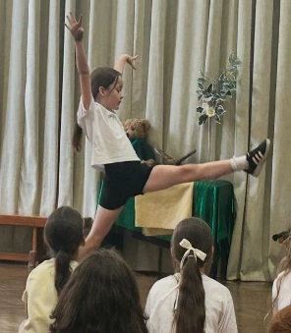
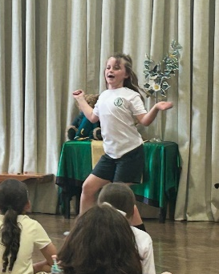
Talent Show Practice
Having experienced a fairly large number of primary school talent shows over the last 20 years, I feel I’m in a good position to say that what a few lucky people witnessed in the school hall on Thursday 19th June will go down on a par with The Beatles in The Cavern Club ’61–’63 and Bowie’s Ziggy Stardust Tour of ‘72/’73. The talent on offer was nothing short of stellar! Thank you to Mrs Faulkner for running the show, to all the staff who stayed behind to support and last, but certainly not least, to the fantastic children who performed so amazingly – without a doubt, we have the superstars of the future right here in St Laurence’s. Well done everyone, we are so proud of you and in awe of your talents!

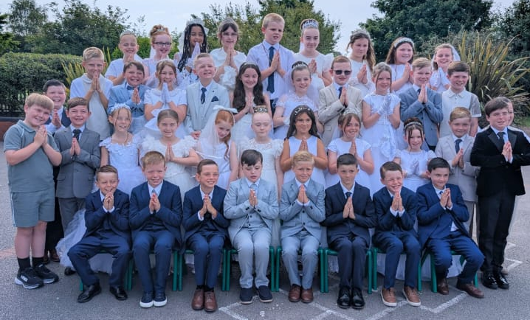
Year 4 Holy Communion
It was wonderful to see the children who have made their First Holy Communion come into school today dressed in their communion outfits. Girls looking stunning in their dresses and jewellery, boys looking just as good in their Sunday Best. The photos taken will be available for you to order, look out for more information on how to do this next week. The children also enjoyed their party this afternoon too, thank you to all staff who organised and led this – what a wonderful way to end this important step on their faith journey.

Year 5 Croxteth Park Trip

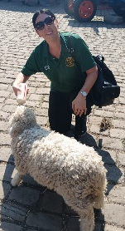
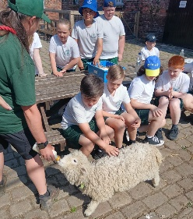
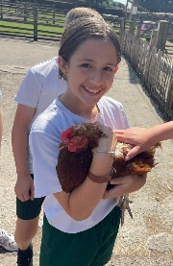
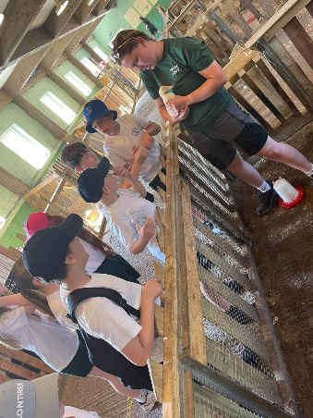
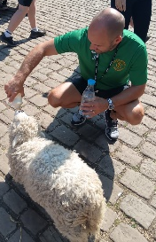
Mr Folksman and Mr Kenny picked the hottest day of the year so far to arrange a trip to the park! The children in both classes really enjoyed their day, feeding animals, playing games and learning about different animals. After working so hard all year in class, it was a well-earned break and one which I know the children thoroughly appreciated. Thank you to all our hard-working staff who went along to support this trip – I must say there were more than a few red faces when they returned to school yesterday!

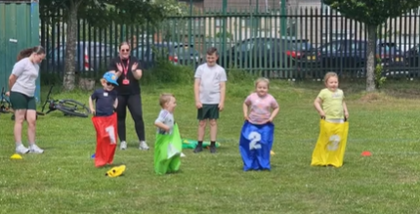
Nursery Sports Day and Reminders
Thank you to our staff and to the spectators who turned up today to watch our amazing nursery children take part in their Sports Day. The next 100m gold medallist is certain to come from our ranks, it was like watching a blur! I know the children all enjoyed their races and had lots of fun cheering on their friends. Well done everyone!

Next week sees Sports Days taking place across the school, a message was sent out earlier this week reminding everyone of the different year groups specific day. Make yourself aware of when your child’s class have their Sports Day and remember they will take place on the field next to school. Keep an eye out for the weather as I believe we are in for sun and showers, so you may need to dress for both! If you are watching your child and want to take a photo or video you are very welcome to do so, all we ask is that you do not post them on social media accounts but keep them private for you and your family to enjoy.


Year 2 Trip Knowsley Safari Park
On Wednesday next week our year 2 classes will be visiting Knowsley Safari Park for their end of year trip. Can we ask that on the day your child comes into school in their usual uniform, again please keep an eye on the weather reports and make sure sun-tan lotions/raincoats are available if needed. Any child who brings in a packed lunch should do so in a plastic bag that can be thrown away and please write your child’s name on the bag so we know which one belongs to your child. The children will leave and return within the normal school day, so please just make sure they are in school at the correct time so we can leave promptly.


Celebration of Achievement
Wednesday next week also sees the Celebration of Achievement Award Ceremony taking place at All Saints. Parents and carers have already had the information they need about this special event, so please make sure you read through it carefully. As always, we are incredibly proud of all our children here at St Laurence’s, but it is also true to say that children selected for this event have really caught our eye throughout the year. Congratulations to those of you who have been picked, and we look forward to a very special celebration with you all.


Transition morning Friday 9:15am – 11:30am
Next Friday, our Year 6 leavers will take part in their transition day at either All Saints or Kirkby High School. To mirror this important step, all pupils at St Laurence’s will also take part in a transition day here in school. We are currently finalising the class arrangements for the 2025/2026 academic year. In some cases, classes may be reorganised slightly, with a small number of children moving from one class to another. This is necessary due to the physical size and capacity limits of some classrooms, which we must follow in line with legal requirements. Please don’t be concerned if your child has been moved. As you know, St Laurence’s is a warm and nurturing school where all children are valued and cared for. We are confident that your child will continue to thrive and feel happy wherever they are placed.

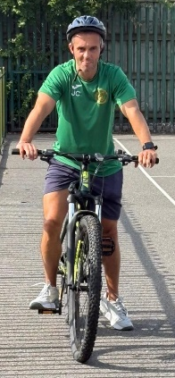
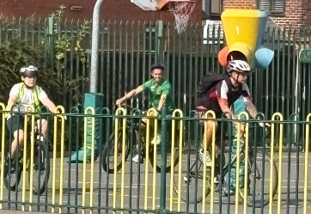
Bikeability
The last few children who had work to do to complete their Bikeability training did so this week, once again displaying a maturity and level of skill that impressed the instructors. Thank you to all you parents and carers for supporting us in this, and congratulations to the children who are now fully qualified to use their bikes safely around our streets. One particular youngster did very well today, looking so smart in his shiny helmet and listening perfectly to his teacher, although sadly the instructor said his left turns still need work – well done Mr Cushion.

Breakfast and After School Club
Please remember we offer wraparound care in school if needed from 7:45am to 5:30pm. Breakfast Club costs £4 and After School Club costs £6.50.


Weekly Awards





 | Kirkby Child | Star of the Week | English Star | Maths Star | Attendance
Nursery | Cecilia Stelfox | Jude McNabb |  |  | 93.9%
Reception | Axel Gordan | Skye Hamid | Finley Stephen | George Seasman | 93.5%
1S | Lewis Rossiter | Conlan Armstrong-Cook | Levi Kitamura | Arlo Cassidy | 96%
1L | Iris McGorian | Charlie Warwick | Georgie Reid Watkinson | Max Lawler | 96.9%
2S | Gabriel Dawkins | Evelyn Fitzsimmons | Stella Kitamura | Tyler Greaves | 86.9%
2L | Sydnie Yates | Cloe Christie -Scotland | Faith Bruen | Florence Regan | 91.5%
3S | Toyin Omotosho | Ella Richardson | Aubyn Cassidy | Harley Farrell | 98.6%
3L | Nordan Yesudas | Kadi Gibbons | Pheobe Richards | Harrison Warwick | 97.2%
4S | Lewis Slade | Duggy Faulkner | Harry Barnbrock | Isaac Lally | 96.4%
4L | Ella Ross | Luke George | Jacob Sproule | Lotti Lou Cruickshanks | 90.4%
5S | Kaisha Reynolds | Lorenzo Cortez | Freddie Stevenson | Maggie Craig | 92%
5L | Harper Farish | Daisy Evans | Eden Fox | Harlow Noon | 91.2%
6S | Daniel O’Rourke | Callum Miller | Shay Jenkins | Franky Walker | 87.8%
6L | Eddie Wilson | Sophia Mawdsley | Florrie Callen-Still | Nathan Rawsthorne | 96%

Kirkby Child Award highlights children who are: respectful, honest and truthful, show a positive attitude, resilient, confident, a good communicator, polite, committed and hardworking, aspirational and ambitious.

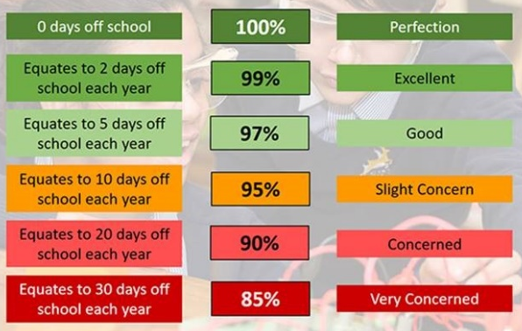
Attendance – Target is 96%
Attendance and punctuality are both vital to your child’s success in school – every minute really does count, as learning begins promptly at 8:45am. Being in school every day, and on time, helps your child to settle quickly, build good routines, and get the most out of every lesson. Thank you to all of our parents and carers who work hard each day to make this happen – your support makes a big difference, and it is very much appreciated.

After School Clubs
Monday
Tuesday | Football  Year 2  Mr Gibson | Sports Club  Years 3 and 4  EFC in the Community
Wednesday
Thursday | Choir  Years 3, 4, 5 and 6  Mrs Faulkner | Mini Vinnies  Mr Folksman
Friday

We hope you have a fantastic weekend, and we will see you all bright and early on Monday morning.

From Mr Mackenzie and all the staff at St Laurence’s

