
St Laurence’s Catholic Primary School Newsletter – Friday June 13th

Website: www.stlaurences.co.uk
Email: stlaurence@knowlsey.gov.uk
Instagram: stlaurencescps
Telephone: 0151 546 4733

Developing our gifts and talents for the good of all

This Week
Welcome back! It’s been lovely to see our children return to school this week, all smiling and happy, as they get to see friends and spend time together again. This week has seen us hit the ground running with all sorts of fun being had alongside some really important learning. We’ve had Bikeability in year 6, times tables checks in year 4, phonics test in years 1 and 2, as well as fantastic educational experiences such as an NFL Day and a trip to Martin Mere (well done for picking a good weather day for these events teachers!) As always, our amazing staff have worked brilliantly to make sure you children are learning and enjoying each and every day whilst they are with us here in school. We hope you enjoy reading the newsletter, and please take note of the parental questionnaire and Instagram notices in particular. We hope you all have a brilliant weekend!


We’re now on Instagram!
Our new Instagram account is now live – follow us at www.instagram.com/stlaurencescps/ to keep up with the latest from St Laurence’s. This account is dedicated to sharing a window into daily school life – from exciting events and special celebrations to learning highlights across the school. It will be updated regularly to showcase the joy, creativity and achievements of our children. We’d love for parents, carers and our wider community to join us and stay connected.

Year 6 Bikeability

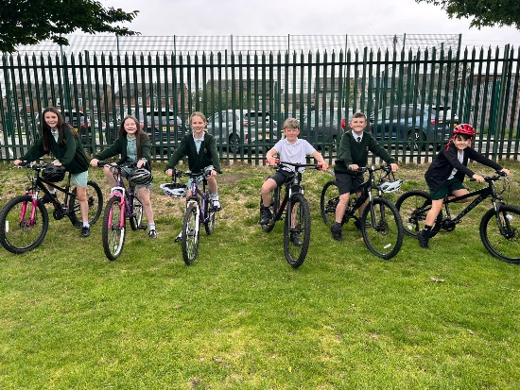
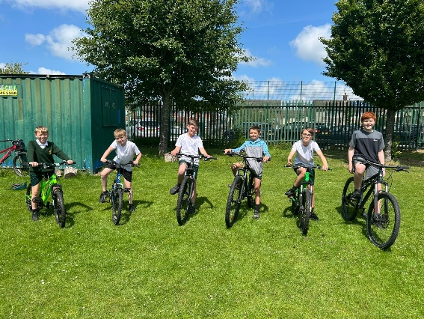
Congratulations to all of our Year 6 children who have successfully completed their Bikeability training this week. The children have shown great enthusiasm and resilience as they developed their cycling skills, road awareness and confidence. Through Levels 1 and 2, they have learned how to carry out safety checks, control their bikes with precision, signal clearly, and navigate junctions safely. Next week, Level 3 will build on this further with more advanced road skills. Thank you to all parents and carers for your continued support in making this possible – from ensuring bikes were roadworthy to encouraging your children each day. We are very proud of what they’ve achieved.


Times Tables Check – Completed!
A huge well done to all of our Year 4 children who have now completed the multiplication tables check! Speaking to both class teachers they have absolutely smashed it – as we always knew they would. We are so proud of the effort and determination they have shown in preparing for this. An enormous thank you to our Year 4 staff team for all their hard work in supporting the children through regular practice and encouragement, and to parents and carers for your continued support at home. Whether it was through TT Rockstars, Hit the Button or You’re Brainy, every bit of practice made a difference – thank you!

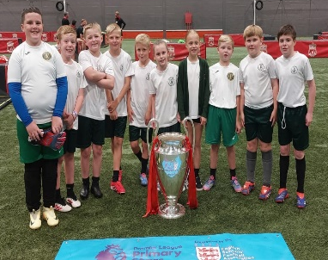
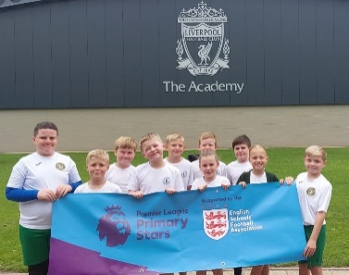
Football Festival at The Academy
Our Year 4 children had a fantastic time at the LFC Football Festival this week, taking part in a range of fun, non-competitive football activities – including the highlight for many: Zorb football! The event was all about teamwork, enjoyment and trying something new, and our pupils threw themselves into every activity with enthusiasm and a positive attitude. Their excellent behaviour and sportsmanship throughout the day were a real credit to them and a shining example of what our school stands for – well done, Year 4!


Parental Questionnaire - your voice makes a difference
On Monday next week all parents and carers will receive a questionnaire to complete. Please take a few minutes to complete it and send it in by Friday at the latest. The final question on the survey is especially valuable, as it’s open-ended and gives you the opportunity to share your opinions on what we’re doing well and where we could do even better. All responses will be carefully considered and used to help shape our School Development Plan for the next academic year.

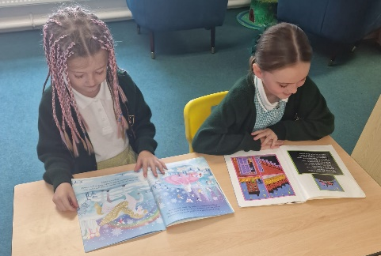
Phonics Screening Check
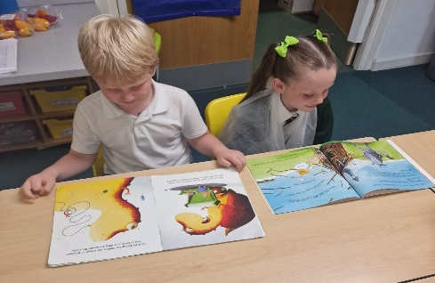
Well done to all of our Year 1 and Year 2 children who have now completed the Phonics Screening Check this week! We are incredibly proud of the focus, effort and confidence they have shown throughout the year and particularly this week when completing the test. A huge thank you to our dedicated staff for preparing the children so well and to all parents and carers for the part you’ve played at home – whether it was reading together, practising sounds, or using online resources, your support has made a real difference!


Dates for your diary
Please see the attached letters regarding important dates for the remainder of this academic year and the school term dates for next academic year. Please note that the last day of each term in 2025 - 2026 will finish at 1:15pm, and also take note of our INSET days when children do not attend school. Thank you.






Weekly Awards

 | Kirkby Child | Star of the Week | English Star | Maths Star | Attendance
Nursery | Joseph Flynn | Elsie Bowers-Jones |  |  | 90.2%
Reception | Emily Duncan | Finley Howard | Ameila Walsh | Sonny Ownes | 92%
1S | Luna McVeigh | Renesmee Slade | Olivia Tunstall | Harley Gibney | 89.6%
1L | Cater Thompson | Georgie Reid | Frankie Stevenson | Leo Brady | 93.8%
2S | Evelyn Fitzsimmons | Taylor Atkins | Jacob Ventre | Nancy Walsh | 85.8%
2L | Annie McNamara | Ewan Flynn | Charlott Lally | Rosie Walker | 91.9%
3S | Halle Marr | Flynn Anderson | Annie Quinn | Ivy Spencer | 96.4%
3L | Hunter Arnold | Luke Davies | Ella Ross | Amaya Reynolds | 97.6%
4S | Bobby  Case-Cummins | Harry McGrath | Sophie Woods | Theodore Dawkins | 89.6%
4L | Aria Farrell | Lois Martin | Ella Ross | Moncia Dempsey | 91.6%
5S | Hallie Devine | Annabell Farrell | Frankie Flaherty | Kaisha Reynolds | 90.4%
5L | Jenson Devine | Ethan Karoui | Alyssa Mawdsley | James Murray | 90.4%
6S | Georgia Sproule | Jacob Lannigan | Lewis Thompson | Lilly Dean | 94.1%
6L | Mason Melia | Abby Walsh | Ammaya Brooks-Miller | Eddie Wilson | 92.8%

Kirkby Child Award highlights children who are: respectful, honest and truthful, show a positive attitude, resilient, confident, a good communicator, polite, committed and hardworking, aspirational and ambitious.

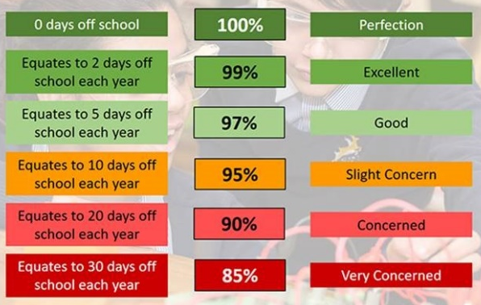
Attendance – Target is 96%
Attendance and punctuality are both vital to your child’s success in school – every minute really does count, as learning begins promptly at 8:45am. Being in school every day, and on time, helps your child to settle quickly, build good routines, and get the most out of every lesson. Thank you to all of our parents and carers who work hard each day to make this happen – your support makes a big difference, and it is very much appreciated.

After School Clubs
Monday
Tuesday | Football  Year 2  Mr Gibson | Sports Club  Years 3 and 4  EFC in the Community
Wednesday
Thursday | Choir  Years 3, 4, 5 and 6  Mrs Faulkner | Mini Vinnies  Mr Folksman
Friday

We hope you have a fantastic weekend, and we will see you all bright and early on Monday morning.

From Mr Mackenzie and all the staff at St Laurence’s

