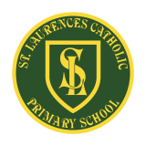
St Laurence’s Catholic Primary School Newsletter – Friday May 23rd

Website: www.stlaurences.co.uk
Email: stlaurence@knowlsey.gov.uk
Twitter: @SLaurences
Telephone: 0151 546 4733

Developing our gifts and talents for the good of all

This Week
We’ve made it – half term is upon us! I’ve written a letter of complaint to Carol Kirkwood from BBC weather as I believe we are in for a change as we head into next week; typical!! Gladly, the good weather has held out this week and we’ve made the most of it during our belated VE Day celebrations, ‘Beat the Goalie’ competition and with numerous other amazing activities that have took place.

I wanted to say thank you to all the parents and carers who have been into school this week. Firstly, for our EYFS liturgy where we were taught about the importance of friendship by a friendly beaver, and for those parents who attended our phonics meeting on Thursday after school. It is always great to welcome parents and carers in St Laurence’s.

Have a fantastic half term everybody and we will see you all again on Monday 9th June at 8:40am.
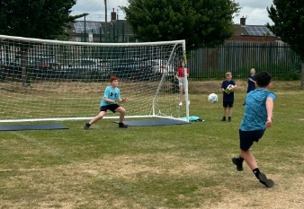
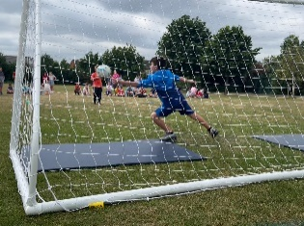
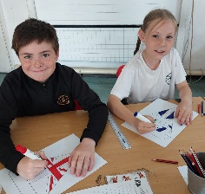
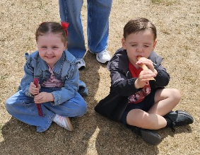
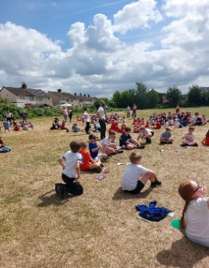
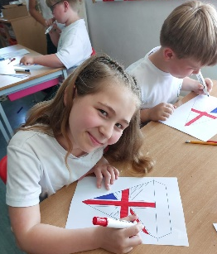
VE Day and Beat the Goalie
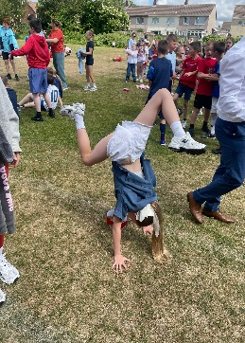
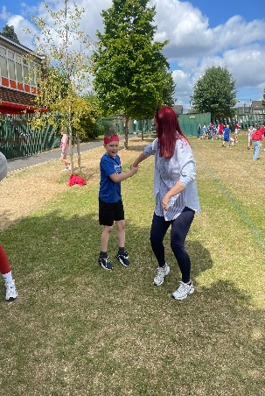
After delaying our event to make sure year 6 were well prepared for SATs, this week we held St Laurence’s VE Day celebration – and what a celebration it was! We had wonderful singing from our choir, expertly led by the extremely talented Mrs Faulkner (thank you!), the children enjoyed ice-pops in the sun and an extended playtime. We even had celebratory headwear, flags and bunting all over our school building and field. The children really did enjoy the day and learning about the significance of VE day in our country’s history.
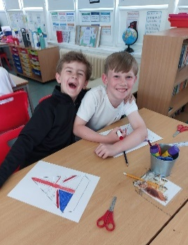
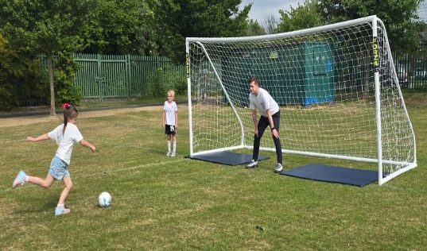
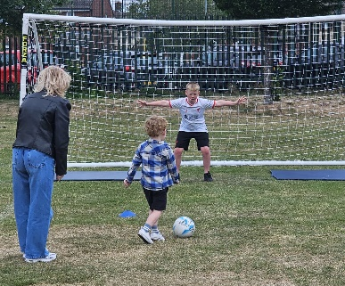


Social Media
We wanted to let you know that St Laurence’s is moving from X (Twitter) to Instagram as our main social media platform. This change is due to the way most of our families now choose to engage with online content, and we believe Instagram will allow us to share more enjoyable, informative and visual updates about school life, events and celebrations.

With Instagram’s focus on photos and videos, we can give you a better insight into what’s happening in school, helping you to connect more to your child’s learning. Once this is set up, we will inform parents of our account name to follow.
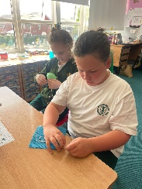
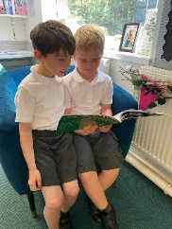
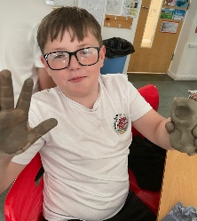
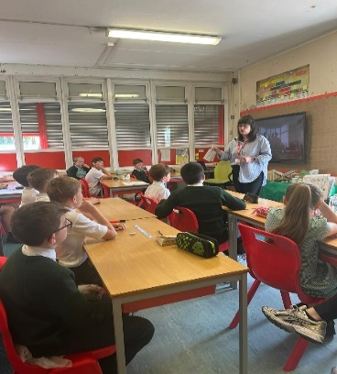
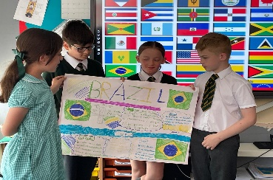
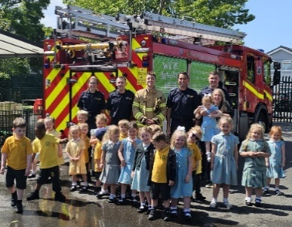
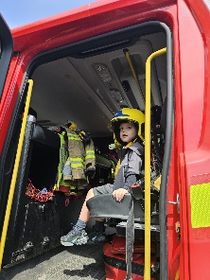
Learning at St Laurence’s
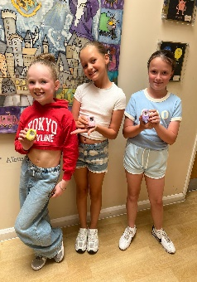
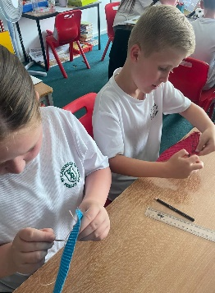
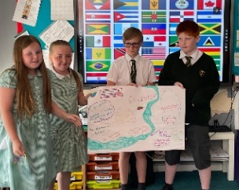
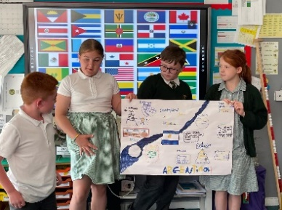
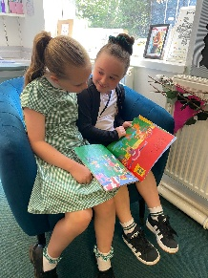
Our amazing staff and children continued enjoying their learning right to the very last second of half term. Year 5 researching and presenting an in-depth study of a South American country AND modelling Daruma dolls during a Japanese art lesson. Not to be outdone, year 4 have been learning how to sew, year 6 have had a specialist musician, Lucy Bowyer, deliver music lessons and year 2 have been enjoying their brand-new reading corner which has been fully designed and furnished by Owens & Pedder Interior Design LTD! Not to be outdone, our nursery children found time to enjoy a visit from the local fire service too, learning about how they work as a team to help our community before enjoying a well-earned spa day! The fun never stops in St Laurence’s.
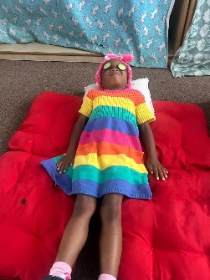
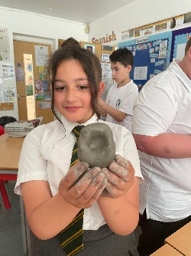
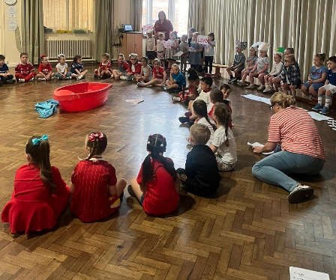
EYFS Liturgy
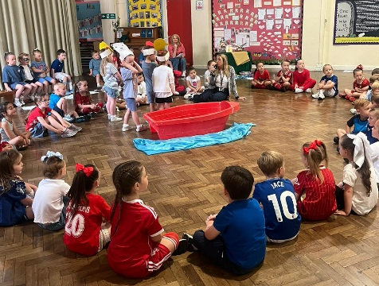
What a lovely liturgy we were led through by our brilliant nursery and reception children on Thursday morning; an important lesson about how friendships are one of the best things we can have in school. We had fantastic readers, singers, actors and actresses as well as some of the best artwork I’ve seen since Van Gogh!

Thank you to those parents and carers who came in to enjoy a cuppa and celebrate with us, we hope you enjoyed it as much as we did.
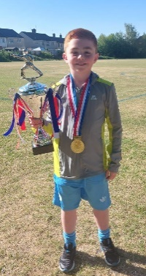
National Champion Karate
Not only do we have the best children in Kirkby at St Laurence’s, we also have one particular boy who is the best in the WHOLE COUNTRY in our year 5. A huge congratulations to Archie Jones (5S) who won a national title in a KUGB karate championships at under 16 level. What an achievement!

We are so proud of you Archie and we love to see you (and the rest of our children) continue to take the country by storm!

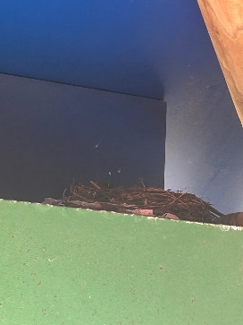
Birds on Playground
Rumours of St Laurence’s being the best school in town have begun to spread to the animal kingdom as we now have a young family of birds nesting under the gazebo on our playground. Mrs Hill had a bird fly into her classroom last week and has then noticed a small nest, complete with a family of chicks, tucked into the top corner. Some of our children have begun to see our new residents at break and lunch time, and so we thought we’d share this news with you parents and carers too! Please be careful if you are in that area of the yard as the nest and chicks need to be left undisturbed until they grow up!


Talent Show – 15th July – year 3 to 6, show off talent, practice, groups, singles
St Laurence’s Talent Show takes place during the last week of school in July, and so half term is the perfect time for children from years 3 to 6 to get practising for the big show. Whether its dance, gym, singing, comedy or any other talent – please make sure your children get plenty of practice in so that they can show off during the show.

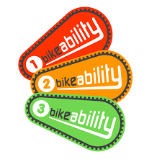
Year 6 Bikeability
Year 6 children who have signed up for Bikeability will need to bring in their bike and helmet every day when we return to school after half term, starting on Monday 9th. This is an excellent opportunity for children to learn about bike safety on the roads and I know they will get a lot out of the week. Please make sure that the bike is in complete working order as any child whose bike is not will be stopped from completing the course. Breaks and chains tend to be the main issues on bikes that may be a little older.


Year 4

A couple of important points for our year 4 classes during the first week back. Firstly, that all children will be competing the multiplication check during the first week back in school, so the half term is your last chance to get some practice in. Could parents and carers please make sure your child is on TT Rockstars, Hit the Button and You’re Brainy as often as possible (there’s bound to be a few rainy days) so that every child is ready when we return – thank you!

Also, a reminder that on the Friday we come back year 4 will have their end of year trip to Martin Mere. More information will be given out to parents in the week we return to let you know about the trip.





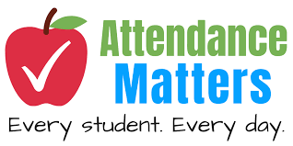
Weekly Awards

 | Kirkby Child | Star of the Week | English Star | Maths Star | Attendance
Nursery | Axel Hamid | Coban Kearns |  |  | 94.4%
Reception | Axel Gordon | Kyrah Okorode | Fabiana Plesca | Freya Shaw | 91.8%
1S | Amelia Challinor | Thomas Davies | Sienna Smith | Oliver Kenny | 87.6%
1L | Liam Ross | Aida Rawlinson | Cooper Bibby | Skylah Smylie | 95.4%
2S | Millie Hadley | Sadee-Mae Taylor | Tyler Greaves | Luca McVeigh | 96.9%
2L | Florence Regan | Charlotte Lally | Leo Parry | Benjamin Jones | 93.1%
3S | Kaden Carr | Isaac Reynolds | Tilly Payne | Rosie Bradley | 88.2%
3L | Jasper McNabb | Riley Brook-Coletta | William Scott | Sophia Konieczna | 92.4%
4S | Isaac Lally | Isabella Doran | Thomas Reid | James Dunne | 96%
4L | Luke George | Ella Ross | Luka Banawich | Lottie-Lou Cruickashanks | 92.8%
5S | Maggie Craig | Archie Jones | Darcy McCarthy | Layla Cooper | 95.6%
5L | Harper Farish | Valentina Reid | Theo Lyons | Heidi Devine | 93.6%
6S | Sonnie Clarke | Sonny McCarthy | Lotti O’Keefe | Lilly Dean | 84.4%
6L | Khaleesi Williams | Eddie Wilson | Madison Farrell | Abby Walsh | 91.2%

Kirkby Child Award highlights children who are: respectful, honest and truthful, show a positive attitude, resilient, confident, a good communicator, polite, committed and hardworking, aspirational and ambitious.

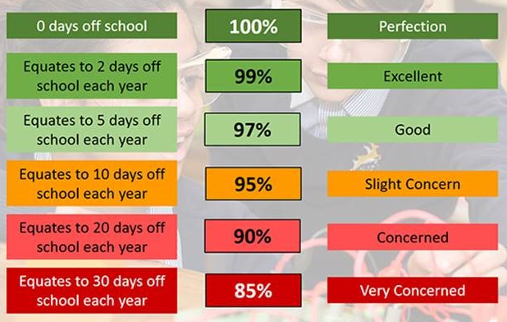
Attendance – Target is 96%
Attendance in school is so important – every minute counts as learning begins at 8:40am! Please help your child by making sure they are in school and on time every day. Thank you to all of you who do so much to make this happen already – we appreciate your help.

Year 4 complete their timestables check and Year 1 complete their phonics reading check the week beginning Monday 9th June.

After School Clubs
When we return in June, we will let parents and carers know about clubs for that week.

We hope you have a fantastic weekend, and we will see you all bright and early on Monday morning.

From Mr Mackenzie and all the staff at St Laurence’s

