
St Laurence’s Catholic Primary School Newsletter – Friday May 2nd

Website: www.stlaurences.co.uk
Email: stlaurence@knowlsey.gov.uk
Twitter: @SLaurences
Telephone: 0151 546 4733

Developing our gifts and talents for the good of all
This Week
I hope you’ve all enjoyed the lovely weather this week – fingers crossed it carries on into the Bank Holiday weekend!! The children here have certainly enjoyed being out on the field at break and lunch time, lots of red faces by the end of the day though.

This week, as always, has seen our children shine in a hundred different ways. Year 3 with an amazing class liturgy, year 4 boys football team bringing home another trophy, nursery and reception children working with local police – as well as every other class working so hard and enjoying being with the friends here in school.

We hope you all enjoy the extra long break this weekend and spend some well-deserved time with family and friends.

Bank Holiday Monday
Quick reminder that school is closed on Monday 5th May for the Bank Holiday. We will be open as normal again on Tuesday 6th at 8:40am and look forward to seeing you all then.

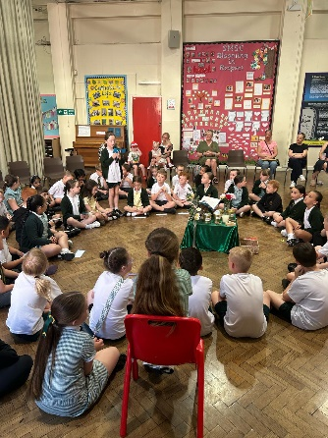
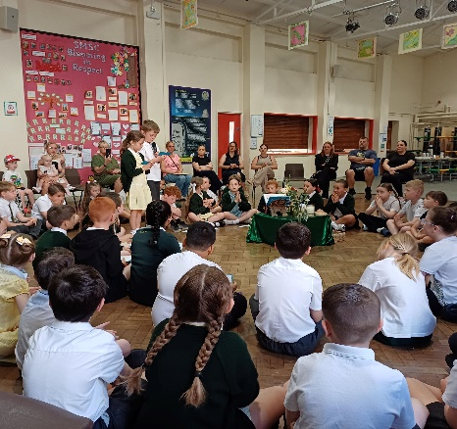
Year 3 Class Liturgy - Forgiveness
It was lovely to see so many parents, grandparents and carers in school to celebrate with our wonderful year 3 children this week. What a brilliant message we were all given about the importance of forgiveness and how it helps us in our friendships. Amazing readers, wonderful singing, dance moves that belong on Britain’s Got Talent – and even a classic Toy Story song to finish off. Well done year 3, we’re so proud of you all!!

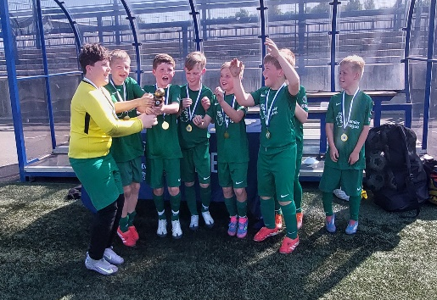
Coach Cushion guides Year 4 to a historic treble
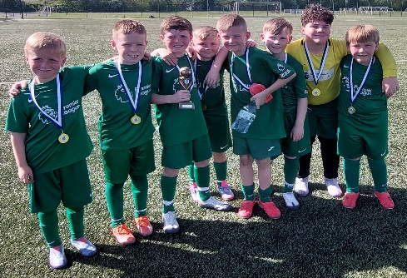
Congratulations to our year 4 football team who completed a treble of trophies, being crowned Merseyside Champions this week. Everton FC hold tournaments for schools from across Merseyside and the best teams from each tournament compete against each other. After winning the Knowsley competition earlier this year, St Laurence’s topped the league of 7 to qualify for the semi-finals. A hard-fought semi-final resulted in a 2-1 win against Helsby Primary before a 3-1 win in the final against St Andrews. Well done on your fantastic achievement!





Weekly Awards

 | Kirkby Child | Star of the Week | English Star | Maths Star | Attendance
Nursery | Dolce Carney | Violet Seasman
Reception | Shaya Rafferty | Amelia Walsh | Alfie Carroll | Oliver Parry |   96.5%
1S | Elia Caulfield | Noah Prince George | Conlan Armstrong-Cook | Honey Carter-Smith | 90%
1L | Cienna Rafferty | Leo Brady | Bella Phillips | Iris McGorian | 96.9%
2S | Luca McVeigh | Dax Faulkner | Rosa Flaherty | Dax Faulkner | 97.7%
2L | Logan Sutherland | James Gdula | Ewan Flynn | Alfie Stott-Jennings | 93.8%
3S | Esme Evans | Luca Pinnington | Nelly O’Brien | Ruby Gee | 90.9%
3L | Leah Carey | Phoebe Richards | Kadi Gibbons | Harrison Warwick | 98.6%
4S | James Dunne | Isaac Lally | Gloria Laczik | Chloe McGorian | 90%
4L | Jason Chean | Skye Balmer | Carter Roe | Nancy Towey | 90.8%
5S | Willow Jevons | Frankie Flaherty | Oscar McPadden | Annabelle Farrell |   98.4%
5L | Heidi Devine | Nancy Jones | Darcy Kelly | Jenson Devine | 90.4%
6S | Louie Reid Millen | Lotti O’Keefe | Charlie Colleran | Mason Ward | 90.7%
6L | Joseph Rutherford | Eddie Wilson | Alfie McGorian | Mason Melia | 98.4%

Kirkby Child Award highlights children who are: respectful, honest and truthful, show a positive attitude, resilient, confident, a good communicator, polite, committed and hardworking, aspirational and ambitious.

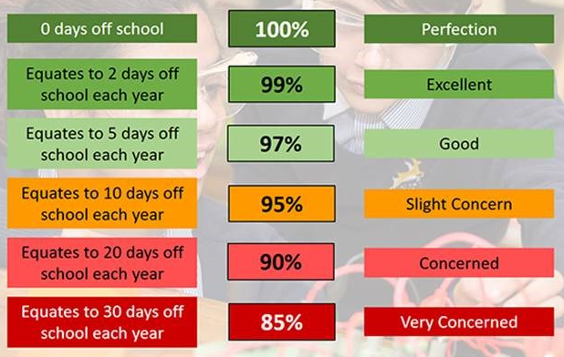
Attendance – Target is 96%
Attendance in school is so important – every minute counts as learning begins at 8:40am! Please help your child by making sure they are in school and on time every day. Thank you to all of you who do so much to make this happen already – we appreciate your help.

Years 1, 4 and 6 are all completing assessments over the next two months and so for these children it is especially important that they are in class every day, on time and ready to learn.

Year 6 SATs take place the week beginning Monday 12th May, we also complete a full practice next week.

Year 4 complete their timestables check and Year 1 complete their phonics reading check the week beginning Monday 9th June.

Police visit St Laurence’s
We were so lucky this week to have Merseyside Police visit our school and work with our nursery, reception and year 1 children. They got to see how a police car work, try the sirens and even put on the hat and high vis coats. Sadly, it looks like Mr Gibson may not have behaved as well as the rest of our children though!
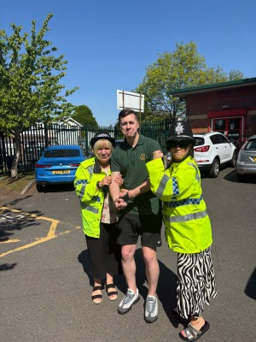
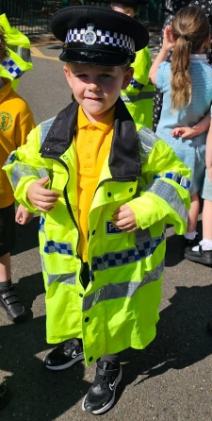
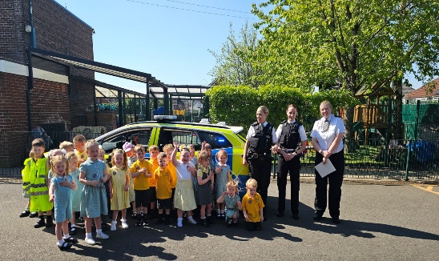

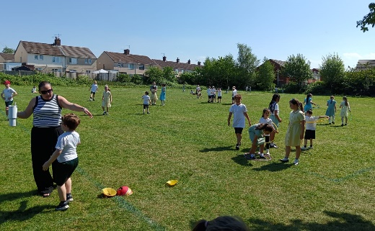
Top Attenders
Each term we have a reward afternoon for all those children with 100% attendance during the previous term. As we say each week – being in school and on time is hugely important in every child’s education as learning starts at 8:40am. I want to say a massive thank you to you parents, grandparents and carers who make sure your child is in each day, it makes a huge difference in their education. In the spring term we had 119 children who never missed a day – well done to you all, we hope you will be part of the summer celebration too!
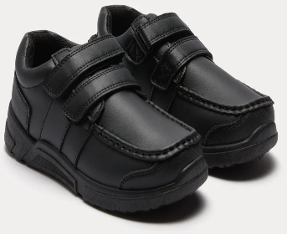
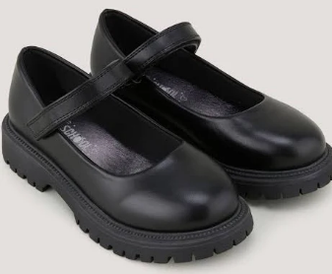
Uniform
We have noticed a few pairs of trainers in school since our return last week. As it says on our school website, all pupils must wear plain black shoes. Please make sure your child has the correct footwear each day to follow our uniform policy. Thank you.


Year 6 SATs

Next week sees our year 6 children complete a full week of practice SATs. Year 6 staff have worked tirelessly all year to prepare your child for this and it is extremely important that for the next two weeks every year 6 child is in school for 8:40am as this is when subject specific practice will begin each day. The practice week gives all children the chance to experience what SATs week is like, this helps them to get used to how the SATs are run, where they move to, which members of staff are with them. I cannot stress enough the benefit your child will get from being here and being on time next week. Thank you for your help with this.

After School Clubs

Monday | Multi-Sports  Years 3, 4 and 5  Mr Cushion
Tuesday | Football  Year 2  Mr Gibson | Sports Club  Years 3 and 4  EFC in the Community
Wednesday
Thursday | Choir  Years 3, 4, 5 and 6  Mrs Faulkner | Mini Vinnies  Mr Folksman | Cricket  Mr Grant
Friday

We hope you have a fantastic Bank Holiday weekend, and we will see you all bright and early on Tuesday morning.

From Mr Mackenzie and all the staff at St Laurence’s

