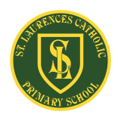
St Laurence’s Catholic Primary School Newsletter – Friday April 25th

Website: www.stlaurences.co.uk
Email: stlaurence@knowlsey.gov.uk
Twitter: @SLaurences
Telephone: 0151 546 4733

Developing our gifts and talents for the good of all
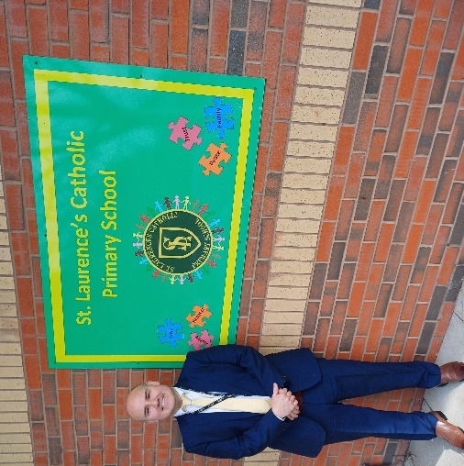

New Headteacher Introduction – Mr Mackenzie
I am delighted to introduce myself as the new Headteacher of St Laurence’s Catholic Primary School. It is a true privilege to join this wonderful Catholic school community, and I look forward to working together with you all to continue providing an environment where every child can grow in faith, knowledge and character.

As a school, we value the importance of strong partnerships between home and school, and I warmly welcome the input and support of all parents and carers. Your experiences and ideas are invaluable to us as we strive to offer the very best educational experience for your children. Please know that my door is always open, and I encourage you to share your thoughts and ideas with me, so that together we can build on the fantastic work of our staff and make sure that St Laurence’s continues to be a warm and welcoming place where every child thrives.

I am really excited to get to know all of our children, their families and the dedicated staff who have had our school such a special place. With a shared commitment to our Catholic values, I am confident we can further develop the nurturing and inspiring environment already in place, supporting the growth and development of every child.

Thank you for welcoming me into the school community. I look forward to our journey ahead and to working with you all to continue building an exceptional school for our children.


Pope Francis
We are deeply saddened by the passing of Pope Francis, a humble and compassionate leader who touched the hearts of millions around the world. His legacy of mercy, inclusiveness, and peace will continue to inspire us. As we mourn this great loss, we also look ahead with hope and faith to the election of a new pope, who will guide the Catholic Church into the future with wisdom and grace.

Value of the Month
Forgive others so God will forgive you.

Mark 11:25
As we enter May children across school will celebrate and learn about the value of ‘forgiveness’ – something vitally important throughout society today. During the last week of April our children will be learning about forgiveness






Weekly Awards

 | Kirkby Child | Star of the Week | English Star | Maths Star | Attendance
Nursery | Reneya Halliday | Lucia McVeigh
Reception | Josh Balmer | Lola Fuller | Taylor Sullivan | Amelia Walsh | 92.5%
1S | Indie Regan-Nicholson | Amelia Challinor | Fredi Brown | Jack Martindale | 92%
1L | Lillie-Rose Brooks-Coletta | Carter Thompson | Lucas Doran | Zadie Hodgson | 85.9%
2S | Tyler Greaves | Tayla Atkins | Rosie Atkinson | Gabriel Dawkins | 93.6%
2L | Mischa Matthews | Logan Sutherland | Rosie McSween | Alfie Stott-Jennings | 93.6%
3S | Harley Farrell | Ella Richardson | Ivy Spencer | Toyin Omotosho | 93.9%
3L | Amaya Reynolds | Sienna Downey | Riley Brooks-Coletta | William Scott |   100%
4S | Blake Murphy | Ryke Matthews | Grace Postlethwaite | Harry Barnbrock | 90.7%
4L | Marcie Horrocks | Joshua Kearns | Will Powell | Destiny Princess Barker |   98.7%
5S | Kaisha Reynolds | Archie Jones | Luis Da Silva | Elijah Greenhalgh | 96%
5L | Louie Soon | Jamie Dumbell | Eden Fox | Alyssa Mawdsley | 91.7%
6S | Charlie Taylor | Sonny Richards | Jacob Lannigan | Jessie Pinnington Sharkey | 93.2%
6L | Ned Lunt | Madison Farrell | Alfie Cummins | Florrie Callan Still | 94.7%

Kirkby Child Award highlights children who are: respectful, honest and truthful, show a positive attitude, resilient, confident, a good communicator, polite, committed and hardworking, aspirational and ambitious.

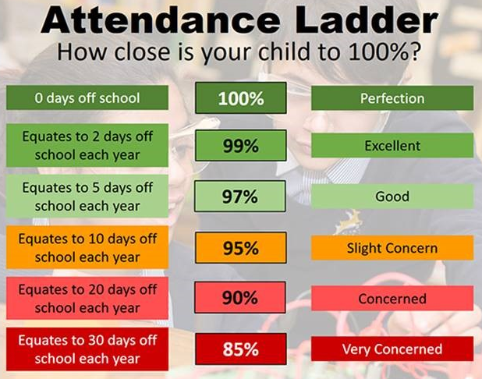
Attendance
Our target for this year is 96%. Attendance in school is so important – every minute counts as our children are learning from 8:40am throughout every class! Please help your child by making sure they are in school every day and are on time too. Thank you to all of you who do so much to make this happen each day, we really see the benefit each and every day.

Our year 1, year 4 and year 6 children are all completing important assessments over the next two months and so for these children it is especially important that they are in class every day, on time and ready to learn.
Year 6 SATs take place the week beginning Monday 12th May, we also complete a mock week the week before, this begins on Tuesday 6th May after the Bank Holiday Monday.

Year 4 complete their timestables check and Year 1 complete their phonics reading check the week beginning Monday 9th June.

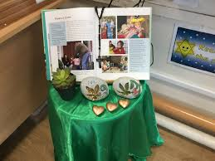
Year 3 Liturgy
Thursday 1st May will see our wonderful year 3 classes lead liturgy in the hall, parents and carers from these classes are very welcome and come along to with us. It takes place at 9:15am, if you are able please come to the front entrance after dropping your son/daughter off and we can celebrate together.

Clubs
Please see the timetable for after school clubs running this half term. Year 6 booster clubs will be on next week for the final time so make sure you take full advantage! Everton in the Community will be beginning a basketball club on May 6th. All clubs take place between 3:15pm and 4:15pm.

Monday | Multi-Sports  Years 3, 4 and 5  Mr Cushion | Boosters  Year 6  Mrs Barr, Mr Grant, Mrs Hill, Mrs Green, Mr Kenny, Mr Folksman and Mrs Middleham
Tuesday | Football  Year 2  Mr Gibson
Wednesday
Thursday | Choir  Years 3, 4, 5 and 6  Mrs Faulkner | Mini Vinnies  Mr Folksman | Cricket  Mr Grant | Boosters  Year 6  Mrs Purchase
Friday

Next Week
Next week we are delighted to have on year 4 football team competing in the Merseyside Finals taking place at Finch Farm on Wednesday, and we will welcome Merseyside Police into school on Thursday as they spend some time in our EYFS – look out for updates!

Dates for Diary
Please see the attached sheet for some important dates over the summer term. As new events are planned, we will update you so you can join us as often as possible.

We hope you have a fantastic weekend, and we will see you all bright and early on Monday morning.

From Mr Mackenzie all the staff at St Laurence’s

