
Setting description
Close your eyes and imagine you are in a forest or a wood. Use the space below to gather vocabulary and ideas.

What can you see?
Light glistening through the dense canopy.

What can you hear?
Branches creaking softly, leaves rustling like a never-ending whisper.

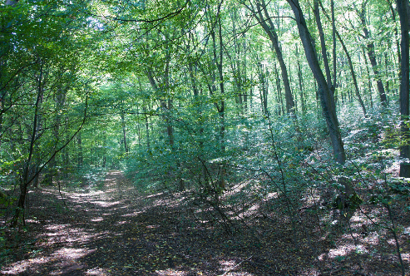



Vocabulary
colossal musty
crooked pungent
gloomy rustling
hollow shadowy
mumble tangled
murmur tranquil

Sentence openers
Astonishingly
In the distance
Beneath the dense canopy
Between the towering trees
On top of

Now use the ideas above to write your setting description paragraph. Try to include ambitious vocabulary and vary your sentence openers and punctuation.
What can you smell?
The damp, earthy ground and the sweet pine cones.

How do you feel?
A fresh, light fog seemed to envelope my body as my worries evaporated and disappeared.

