
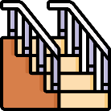

Climbing

Think about a time when you climbed up something, e.g. a mountain, a hill, a tree, a climbing frame.
- How did you feel at the bottom, looking up?
- How did you feel as you climbed?
- How did you feel when you reached the top?
- What could you see?
- What could you hear?
- What was it like coming back down?
- Did you feel tired and breathless?
- Did you enjoy the climb? Why?

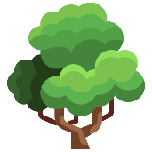

Describe your climb. You could use pictures, words and/or sentences.


Challenge yourself to include some interesting vocabulary.

summit peak breathless
approach enlivened steep
exhausted hauled explore

