

Prime Minister for the day!

Imagine you are going to be the Prime Minister for the day! Create a timetable with all the things you plan to do. Think about:

- What time will you get up?
- Will you schedule in mealtimes and breaks?
- Will you plan to change any rules or laws?
- Will you use the Voyager aircraft?
- Do you plan to address the nation?

Use the timetable below or create your own.

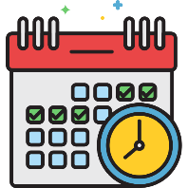

Time | What you are doing

Decide whether to record your times in 12 or 24-hour clock.

