


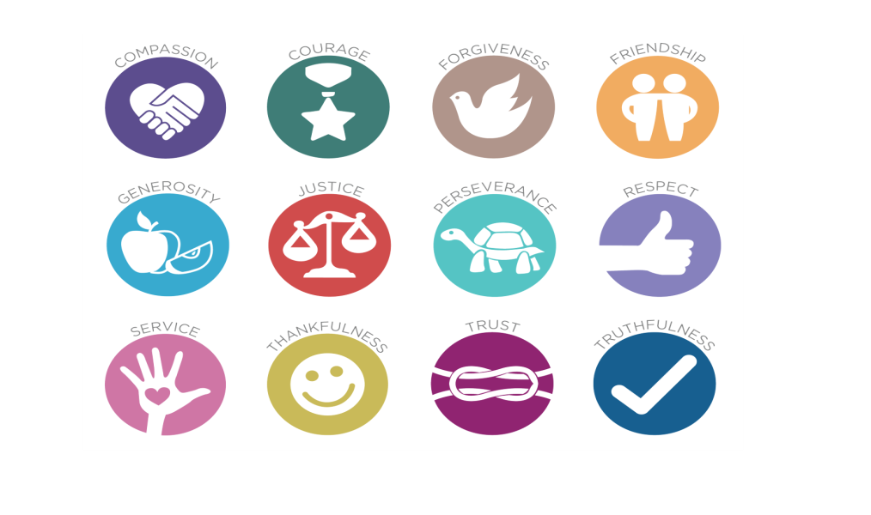
School Ethos Statement
Relationships, Sex, and Health Education Policy
June 2020
Review Date: June 2022
Our Little Heaton C.E. family nurtures a culture of Christian love and respect for each other and the world around us. Through togetherness, patience and compassion is encouraged. By providing creative experiences and challenge for all learners, children grow in resilience, learn to persevere and develop belief in themselves and build hopes and dreams for their future.
- How this policy was developed
This policy was developed by a working party of teachers form the Middleton collaborative (PiraMidd) it was then adapted to ensure it meets the ethos and values of the Church of England Schools in the Collaborative in line with the document Valuing All God’s Children. This policy also informs parents/carers what is taught through the PSHCE and RSHE curriculums here at Little Heaton CE Primary School. The policy was shared with parents, pupils, staff and governors to ensure that the views and needs of all stakeholders were taken into consideration. This policy was approved by the PiraMidd Strategic Board and the governing body of each school.
- Requirements on schools in law
Relationships and Sex and Health Education (RSHE) is compulsory in all primary schools in England from September 2020. The government published guidance for RSHE which prioritises the teaching of Relationships and Health within primary schools. We’re pleased to see that the guidance doesn’t instruct schools in telling children what to think. Its emphasis is not on agreement but rather on awareness and acceptance, no matter what the belief, gender or orientation people may have. Love is a common ground that we can all build upon and therefore at Little Heaton C.E we use Heart Smart to teach PSHCE and RSHE whilst promoting our Christian Values and the development of a growth mind-set too.
- What is Relationships and Health Education?
The children at Little Heaton C.E. Primary are encouraged to live out the school values taken from our school ethos statement both in school and at home which focuses them in on the key values which are important in them becoming good people and good citizens making the right choices for themselves and others around them. We want our children to understand that we all have a body, a mind and a heart which makes us who we are. The heart is the epicentre of who we are, the driving force of why we do what we do. There are times when we need to listen to our heart and times to lead our heart. Jesus says in Matthew 22: 36-40 that loving God and loving others and ourselves are the two greatest commandments. If we want to live well, we need to love well. This is what it means to be Heart Smart.
The Heart Smart Scheme also links to our SMSC curriculum, safeguarding and emotional well-being requirements. It also meets the requirements of the DfE Primary Relationships (and Sex) Education curriculum and the Science National Curriculum.
- What does Heart Smart teach?
Our PSHCE- Personal, Social, Health and Citizenship Education and RSHE- Relationships and Sex and Health Education curriculum provides key building blocks to support children’s understanding of developing a healthy body and mind, understanding what respectful relationships are, focusing on family and friendships whilst understanding and respecting people’s differences. We also want to ensure that our children understand that as they grow both their mind and bodies grow and change too, they need to be prepared for this and understand that it happens to everyone. We are delivering the Heart Smart programme throughout school to support children to build Love 2 learn Love 1 another resilience, emotional intelligence and active empathy. It enables children to adopt a growth mind-set whilst maintaining a healthy emotional self. Helping children build healthy relationships with others can only be a good thing and learning how to get along with people who are different from themselves is a positive step to achieve a healthy society. Both our PSHCE curriculum and Science curriculum supports our children with understanding reproduction in plants and animals as well as focusing on changes that happen in their own bodies as humans moving towards puberty. From year 4 children are taught about these changes.
Year 4 |  | Year 5 |  | Year 6
Changing Me! Key facts about the changes that take place in puberty between 9 – 11 | Risky Business Learning the facts and risks associated with smoking | Period Relay Key facts about the menstrual cycle | What am I? How to look after ourselves during puberty | Boundaries for Respect Learning how to use boundaries to establish respectful friendships | Under Construction- the teenage brain! How the brain changes during puberty
(These topics are taken from the PSHCE long term planning grids for each year group can be viewed in the curriculum section of our website which shows how children are taught about relationships and health progressively)
- When is Heart Smart taught?
Heart Smart is taught from Reception class through to Year 6. The PSHCE planning grids for each year group can be viewed in the curriculum section of our website which shows how children are taught about relationships and health progressively. Each class have an hour Heart Smart lesson each week with additional focus on relationships and Boris’ ‘High Five’ in our daily Collective Worships.
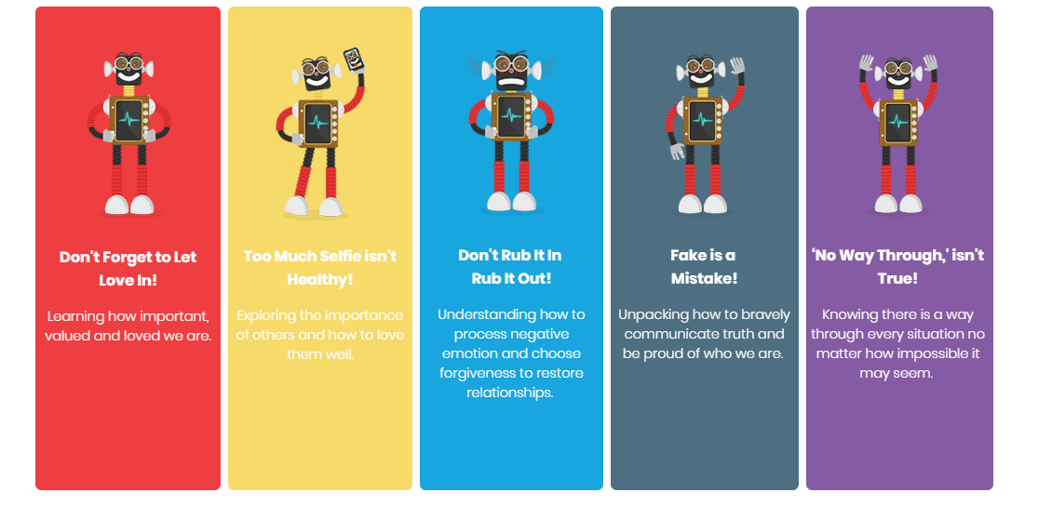
Adults will deal with any questions or issues linked to PSHCE and RHE appropriately and sensitively. There may be a time when a member of staff does not immediately answer a child’s question. However, they may speak to them on a one to one basis or refer them to speak to their parents or carer.
- How Relationships and Health Education is monitored and evaluated
Monitoring is the responsibility of the Headteacher, named Governor and Subject Leader with responsibility for RSHE. The effectiveness of the RSE programme will be evaluated by assessing children’s learning and implementing change, if required.
- How the delivery of the content will be made accessible to all pupils
As a school we ensure that the content and delivery of RSHE is inclusive of all pupils and is in line with the Single Equality and Community Cohesion Policy and SEND Policy.
- The Role of Parents and other Professionals
As a school, we believe that the primary role in children’s RHE education lies with parents and carers. We foster positive and supporting relationships with parents at our school through trust, cooperation and a mutual understanding. In promoting this we will: -
• inform parents about the RSHE policy and practice
• answer any questions parents have about RSHE
• take seriously any issues that parents raise about RSHE.
We want all our children to be fully involved in our PSHCE and RSHE curriculum. If you have any questions/concerns about this please do come and speak with the Head Teacher who will be happy to talk this through with you.
- Child Protection and Safeguarding
If a child makes a disclosure to an adult in school which suggests they are not safe the concerns and disclosures will be responded to in line with the schools Child protection and Safeguarding Policy.
Sources of Further Information
- This policy has drawn on:
- ▪ DfES ‘Sex and Relationship Education Guidance’ (2000)
- ▪ DfE Relationships Education, Relationships and Sex Education (RSE) and Health Education Draft Guidance (July 2018)
- This policy should be read in conjunction with the following policies:
- ● Inclusion Statement
- ● Child Protection Policy
- ● Anti-bullying Policy
- ● SEND Policy
- ● PSHCE Policy
- ● Emotional Well-Being Policy
Useful resources
PSHE Association RSE Policy Guidance https://www.pshe-association.org.uk/curriculum-andresources/resources/writing-your-rse-policy- guidance-pshe-association (members only)
The Sex Education Forum RSE Policy Guidance https://www.sexeducationforum.org.uk/resources/adviceguidance/sre-policy-guidance The Sex Education Forum have also provided a free resource to assist you in consulting pupils, parents and staff to inform you about what changes need to be made to your RSE policy and practice. ‘Activities for consulting about your school sex and relationships policy’. https://www.sexeducationforum.org.uk/sites/default/files/field/attachment/Consultation%20activiti es%20-%20SRE%20policy%20-%20Sept%202014.pdf
RSHE Co-ordinator: Claire Crawford
RSHE Governor:
Policy Written: June 2020
Next Review: June 2022

