Intent

Our rationale for teaching art and design

Art at Flixton Primary School provides open-ended opportunities for children to explore their ideas and personal responses to the world through a broad range of experiences. We aim for children to develop a strong visual language through high-quality teaching and for them to be able to select, use and explore with a range of media, processes, tools and techniques.
Children are stimulated by the work of other artists: architects, photographers, painters, sculptors and print-makers, and, through this study, they will gain an understanding of cultural and historical contexts in which art work has been created, as well as inspiration for their own work. Children are encouraged to develop their own ideas through speaking and listening activities and on-going evaluations.
Through the school, children will become increasingly confident to explain their choices, analyse effects and revisit work, developing their own creative responses to topics through purposeful use of a sketchbook, as well as improve their own self-esteem.

Excellence in art and design is typified by:

- Children who are passionate, persistent, resilient and show a drive for quality and continuous improvement in art and creativity. They have high-expectations of themselves and use the process of evaluate, review, revisit to satisfy their own goals.

- Children who are confident to explore their own ideas and experiment with a range of media and techniques.
- Children who can talk about their personal responses to their own and others’ works of art and, as they have more experience with media, techniques and tools, children who can make their own choices based on purpose and intent.
- Children who can explain their choices with pride and confidence, demonstrating high levels of self-esteem; they value themselves as artists.
- Children who can accept that mistake-making is part of the creative process.
- Children who strive for what is new and exciting (rather than what is safe and comfortable), whilst drawing on and selecting from prior learning.
- Children who have a good understanding of the creative process and the ways in which artists use sketchbooks; they consider and use sketchbooks as a tool in the creative process.
- Children who are able to appreciate, discuss and critique a wide range of artist and artworks, using appropriate subject-specific vocabulary.
- Children who value and respect the work of others.
- Children who work safely and accurately with a range of tools and equipment.
- Children who have an understanding of the basic principles of art and design: line, shape, form, colour, contrast, pattern, tone, texture, proportion and perspective.

Implementation
EYFS
In EYFS, art and design is identified as ‘Exploring Media and Materials’ and ‘Being Imaginative’, both of which are part of the specific area of learning known as ‘Expressive Arts and Design’. Whilst the formal structure of art learning in EYFS differs to KS1 and KS2, fundamental elements remain the same. Here, art learning lays the foundations for developing young artists who are confident to respond personally to the world around them, to explore with the range of media and tools provided in a transient art provision area and who are keen to talk about their work and respond to the work of others.
KS1 and KS2
In KS1 and KS2 art is taught at least once every two weeks and, for practical reasons, it is most likely to be taught over a double session. This regular teaching of art means that the knowledge, skills and understanding gained from each session will be regularly revisited, practised and built upon.
Progression
The school has a curriculum that allows for continual development of skills and opportunities to apply understanding of the basic principles of art and design across year groups. In KS1, children have an introduction to basic principles: line, shape, form, colour and pattern. This learning is then developed - knowledge and skills are embedded and deepened - across KS2 where the children also explore texture, tone and perspective. Children have the opportunity to apply skills learned in previous years and prior units of work in a new and purposeful way.
The progression of skills across these formal elements are outlined in the Progression of Skills Curriculum Map (to be published and shared in June 2024 as Appendix A). This will be also be used to support planning.
When teaching colour, teachers refer to the appropriate year group colour wheel (see Appendix B). This year-group appropriate colour wheel will be stuck in the front of sketchbooks for reference.
Delivery
Whilst art is taught as a discrete subject, there are opportunities for cross-curricular learning. For instance, children learn about the science of colour theory, they learn about ratio when colour mixing, they learn about history through the work of other artists, and speaking and listening plays an important role in art lessons.
Years 1-5 teach two-three units of art across the academic year, whilst Year 6 teach two. Through these topics, children are encouraged to really take notice of the world around them in a new and exciting way with the aim to inspire interest and excite the imagination. The curriculum itself has never been rigid and is continually being evaluated and adapted. There is an on-going dialogue between the subject leader, the art specialist and classroom teachers as children’s skills grow and teachers’ confidence and interests develop. Units are often revised in line with progress further down the school.
The school’s art specialist is a valuable resource in ensuring high-quality teaching and learning. Working alongside teachers to plan and deliver lessons, her excellent subject knowledge offers continued professional development for teachers, whilst exciting and inspiring the children.
The school has a wide range of materials and equipment to ensure the children have a high-quality experience of the subject. Introducing Indian ink, charcoal and different grades of pencils to year one pupils sets them up for a journey of exploring with different media, techniques and effects. Planning should also aim for the children in each year group to work with clay once a year.
Art lessons have no formal structure, but should/might typically include:
- an element of appraisal: an opportunity for children to respond personally to the work of another artist
- an element of art history
- open-ended tasks where children are encouraged to explore and experiment with ideas, media and techniques in their sketchbooks
- an opportunity to develop speaking and listening skills
- an evaluation of their own or their peers’ work, which will then lead into a chance to review and revisit their ideas
Children are encouraged to engage thoughtfully with artworks – their own and others’ – through effective teacher questioning. It is important that children talk about art and do so through appropriate use of subject-specific vocabulary, which is modelled by teachers.
In general, across the school, emphasis is placed on observation and the importance of looking, but the children are also encouraged to draw upon personal experience, imagination and memory as inspiration. Children are given an opportunity to express themselves creatively and respond personally to the world around them; the way the curriculum is delivered allows children to boost their self-esteem.
Class teachers are responsible for adapting plans based on children’s needs. They are expected to seek out support from the subject leader and/or our art specialist to develop their own confidence in delivering high-quality art learning.
Assessment
Knowledge Harvests are used at the beginning of each new unit in art to activate children’s relevant prior relevant learning. Teachers are responsible for devising appropriate and purposeful knowledge harvests through use of their professional judgement, liaising with the subject lead, discussion with prior year group teachers and referring to Progression of Skills Curriculum Map doc. As part of this, teachers may also include a pre-assessment. In art, exit points are generally opportunities for children to complete a ‘final piece’, where they apply the unit’s learning independently.
Impact:

The impact of this policy on outcomes for children is measured against our Excellence Statements for Art.

The Art subject leader monitors the impact of this policy through:
- Book scrutiny
- Pupil interview / survey
- Teacher interview / survey

Leadership team monitoring is also fed to the Art lead.

Appendix B
Colour Wheel Progression
Please ensure you are reinforcing knowledge, understanding and vocabulary (bold) from previous years when learning about and discussing colour.

Year | Colour Wheel | Knowledge & Understanding
1 | 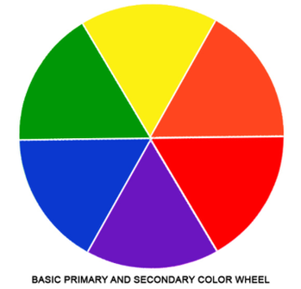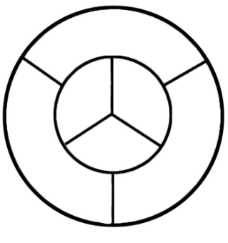 | Primary colours  Secondary  Mix secondary colours  Adding white = tint  Adding black = shade  (Not needed to be shown on Y1 on colour wheel)  Relevant unit: Colour
2 | 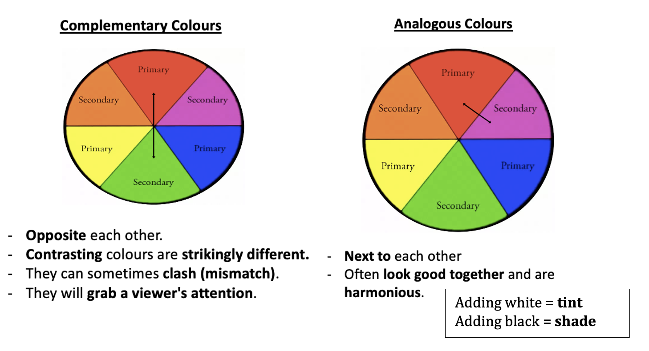 | Complementary colours (opposites on the colour wheel. High contrast)  Analogous (harmonious) colours  (next to each other on the colour wheel)  Relevant unit: Kente Cloth; Pattern and Print-Making
3 | 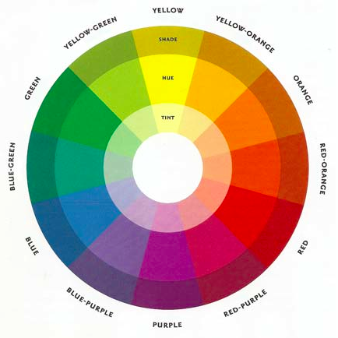 | Continued revision of Y1-2  Continue to embed Y2 learning (portraiture)  Tints (add white), shade (add black)  shown on colour wheel i.e. development from Y1  Relevant unit: [Pattern and Print-making;] portraiture
4 | 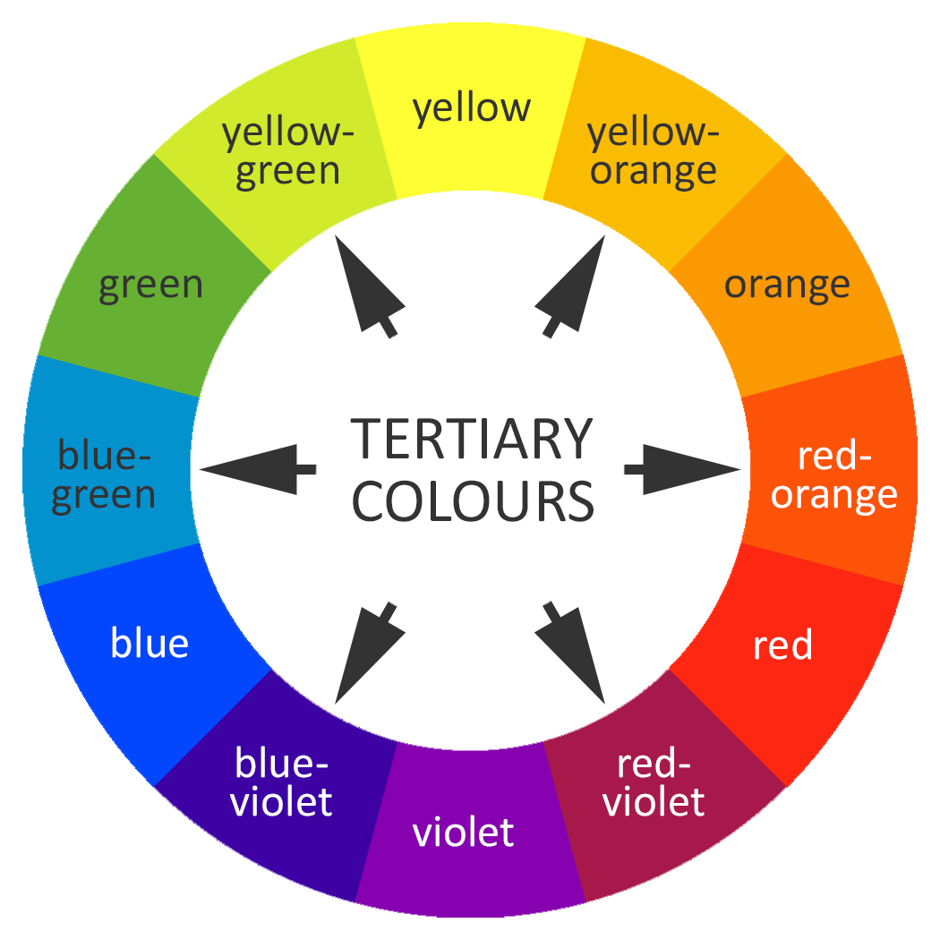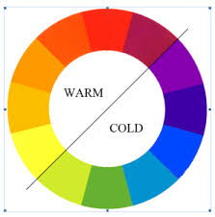 | Tertiary colours (made by mixing equal amounts of primary and secondary colour, sitting between the primary and secondary colours they are mixed from)  Warm/Cool  Relevant unit: Abstract Art
5 | 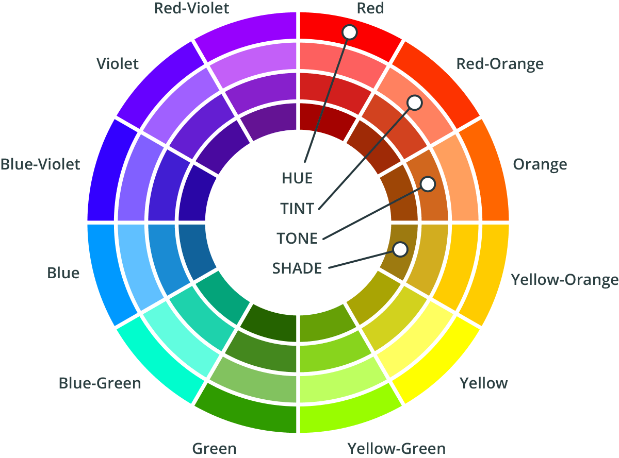 | Inc tones (add grey)  Relevant unit: Trees Through the Eyes of an Artist and Fantastical Buildings
6 |  | Continued revision of Y1-5 learning  Relevant unit: How colour changes with perspective (atmospheric perspective).

For the front of sketchbooks:
