
Internet Matters

About us
At Internet Matters, parents and professionals can find the most comprehensive and credible resources, information and support to keep children safe online.

https://www.internetmatters.org/hub/?tab=apps-platforms

Links
Below are links to explanatory videos and guidance about some of the most popular games played currently.

Fornite

https://www.internetmatters.org/hub/guidance/fortnite-battle-royal-parents-guide-keep-kids-safe-gaming/

Roblox
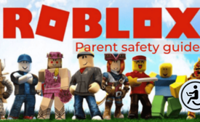
https://www.internetmatters.org/hub/esafety-news/parents-guide-to-roblox-and-how-your-kids-can-play-it-safely/

Among Us
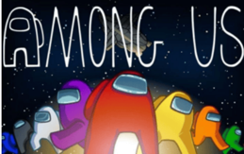
https://www.internetmatters.org/hub/news-blogs/is-among-us-multiplayer-game-safe-for-children/

Rocket League

https://www.internetmatters.org/hub/esafety-news/rocket-league-video-game-a-parents-guide/

TikTok

https://www.internetmatters.org/hub/esafety-news/tik-tok-app-safety-what-parents-need-to-know/

