
Reception Newsletter Spring 1
We are so proud of all the children and their achievements so far.

Please make sure all items of uniform are clearly named, we have had multiple jumpers with no names and don’t know who it belongs to even after asking the children. These will be placed in lost property.

Talk for Writing

.

PE
This half term we are very excited as PE will be on a Monday morning with Mrs Jones and on a Tuesday afternoon we will be doing football with Mr Tobin.

Website
Check the class page on the school website www.flixtonprimaryschool.org.uk to see what has been happening in your child’s class. Check out the ‘gallery’ at the bottom of class pages for photos.

Useful info
Any queries please use the parent contact email
parentcontact@flixtonprimaryschool.org.uk
(please put your child’s class in the subject)

Our Talk for Writing text this half term will be ‘Lost and Found’. We will be learning about extreme environments like the Artic and what it is like to live there.

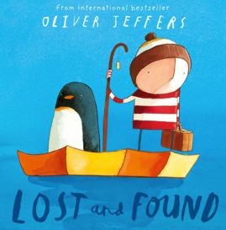

Phonics
We will be continuing our phonics learning following the ‘Phonics Shed’ scheme. We will be recapping Chapter 2 and beginning Chapter 3. Keep an eye out for a Chapter 3 sound mats in book bags. You will continue to receive a letter each week informing you which sounds we are learning. Please practice these sounds along with formation at home. It is super important to make sure the children are start8ing their letters in the right place. Key info:
Digraph = 2 letter making 1 sound
Trigraphs = 3 letters making 1 sound
We use zips (a line) underneath to highlight these in words.

Maths

In maths we will be learning how to make 5,6,7,8,9 and 10. Comparing numbers, combining amounts and building up to number bonds to 10.

We will also be exploring 3D shape which will include naming and describing properties.

Understanding the World

At the end of the Spring term, we will be learning all about Lunar New Year. The children will find out about the celebration and the story of the amazing race.
Which animal year were you born in?

As we are in the cold weather season please ensure children come to school with a warm coat, hat, gloves and scarf when necessary. Please ensure every item of clothing is clearly labelled.

Puddle suits: Please ensure your child has a puddle suit so they can access the water and mud kitchen areas of the outdoor classroom. Again, please ensure it is clearly named.

